OPERATING SYSTEMS

UNIT – I

Operating System :

Introduction to Operating System

A program that acts as an intermediary between a user of a computer and the computer hardware Operating system goals:
- Execute user programs and make solving user problems easier
- Make the computer system convenient to use
- Use the computer hardware in an efficient manner

Computer System Structure :
Computer system can be divided into four components

- Hardware – provides basic computing resources CPU, memory, I/O devices
Operating system Controls and coordinates use of hardware among various applications and users
- Application programs – define the ways in which the system resources are used to solve the computing problems of the users Word processors, compilers, web browsers, database systems, video games
- UsersPeople, machines, other computers

Four Components of a Computer System
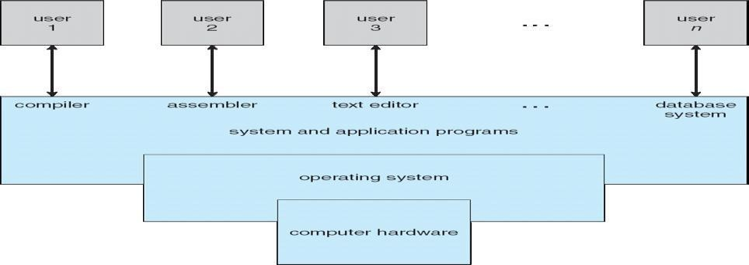

Operating System Definition
- OS is a resource allocator
- Manages all resources
- Decides between conflicting requests for efficient and fair resource use
- OS is a control program
- Controls execution of programs to prevent errors and improper use of the computer
- No universally accepted definition
- Everything a vendor ships when you order an operating system‖ is good approximation But varies wildly
- ―The one program running at all times on the computer‖ is the kernel. Everything else is either a system program (ships with the operating system) or an application program

Computer Startup
- bootstrap program is loaded at power-up or reboot
- Typically stored in ROM or EPROM, generally known as firmware
- Initializes all aspects of system
- Loads operating system kernel and starts execution

Computer System Organization
- Computer-system operation
- One or more CPUs, device controllers connect through common bus providing access to shared memory
- Concurrent execution of CPUs and devices competing for memory cycles

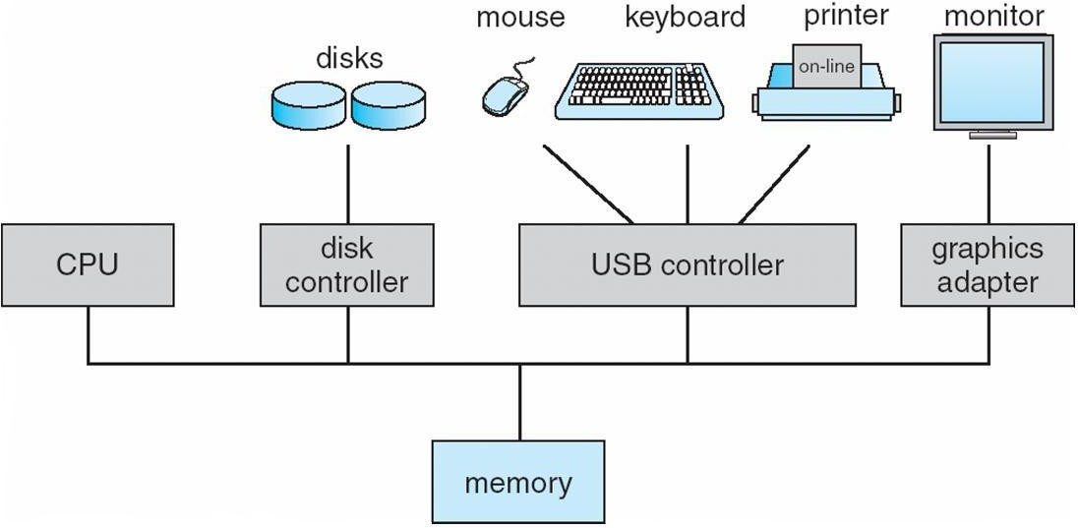

Computer-System Operation
- I/O devices and the CPU can execute concurrently
- Each device controller is in charge of a particular device type
- Each device controller has a local buffer
- CPU moves data from/to main memory to/from local buffers
- I/O is from the device to local buffer of controller
- Device controller informs CPU that it has finished its operation by causing An interrupt

Common Functions of Interrupts
- Interrupt transfers control to the interrupt service routine generally, through the interrupt vector, which contains the addresses of all the service routines
- Interrupt architecture must save the address of the interrupted instruction
- Incoming interrupts are disabled while another interrupt is being processed to prevent a lost interruptnA trap is a software-generated interrupt caused either by an error or a user request
- An operating system is interrupt driven

Interrupt Handling
- The operating system preserves the state of the CPU by storing registers and the program counter
- Determines which type of interrupt has occurred:
- vectored interrupt system
- Separate segments of code determine what action should be taken for each type of interrupt

Interrupt Timeline
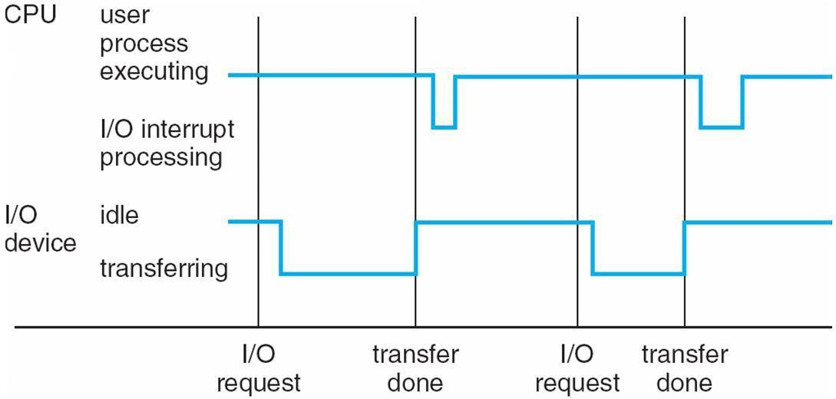

I/O Structure
- After I/O starts, control returns to user program only upon I/O completion
- Wait instruction idles the CPU until the next interrupt
- Wait loop (contention for memory access)
- At most one I/O request is outstanding at a time, no simultaneous I/O processing
- After I/O starts, control returns to user program without waiting for I/O completion
- System call – request to the operating system to allow user to wait for I/O completion
- Device-status table contains entry for each I/O device indicating its type, address, and state
- Operating system indexes into I/O device table to determine device status and to modify table entry to include interrupt.

Direct Memory Access Structure
- Used for high-speed I/O devices able to transmit information at close to memory speeds
- Device controller transfers blocks of data from buffer storage directly to main memory without CPU intervention
- Only one interrupt is generated per block, rather than the one interrupt per byte.

Storage Structure
- Main memory – only large storage media that the CPU can access directly
- Secondary storage – extension of main memory that provides large nonvolatile storage capacity
- Magnetic disks – rigid metal or glass platters covered with magnetic recording material
- Disk surface is logically divided into tracks, which are subdivided into sectors
- The disk controller determines the logical interaction between the device and the computer

Storage Hierarchy
- Storage systems organized in hierarchy
- Speed
- Cost
- Volatility

Caching – copying information into faster storage system; main memory can be viewed as a last
cache for secondary storage
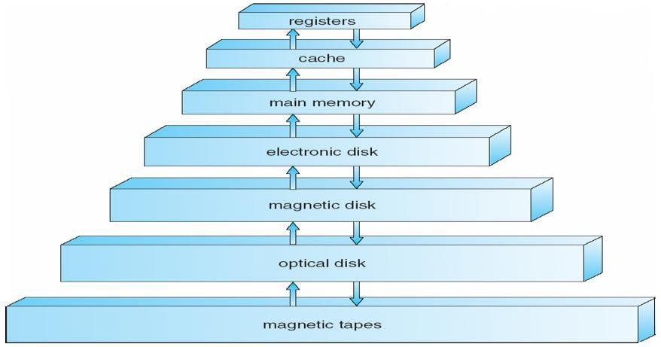

Caching
- Important principle, performed at many levels in a computer (in hardware, operating system, software)
- Information in use copied from slower to faster storage temporarily
- Faster storage (cache) checked first to determine if information is there
- If it is, information used directly from the cache (fast)
- If not, data copied to cache and used there
- Cache smaller than storage being cached
- Cache management important design problem
- Cache size and replacement policy

Computer-System Architecture
- Most systems use a single general-purpose processor (PDAs through mainframes)
- Most systems have special-purpose processors as well
- Multiprocessors systems growing in use and importance
- Also known as parallel systems, tightly-coupled systems Advantages include
  - Increased throughput
  - Economy of scale
  - Increased reliability – graceful degradation or fault tolerance Two types
1.Asymmetric Multiprocessing 2.Symmetric Multiprocessing
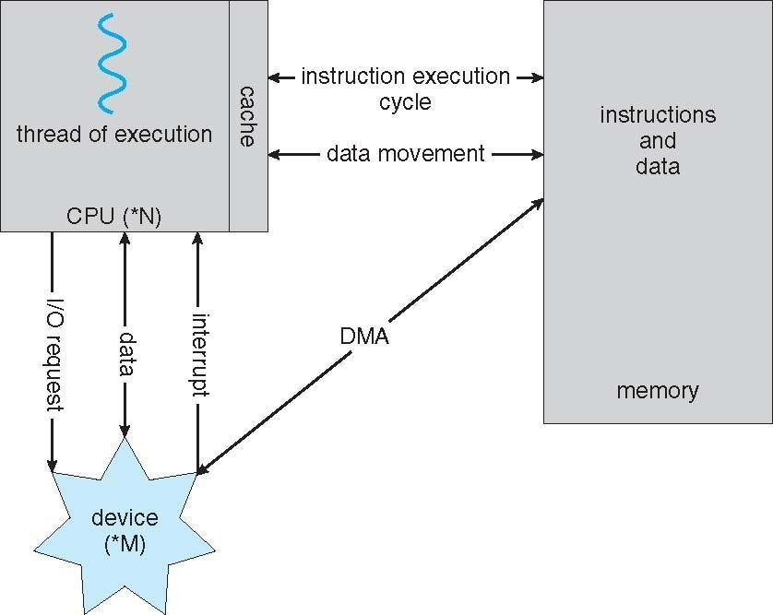

How a Modern Computer Works Symmetric Multiprocessing Architecture
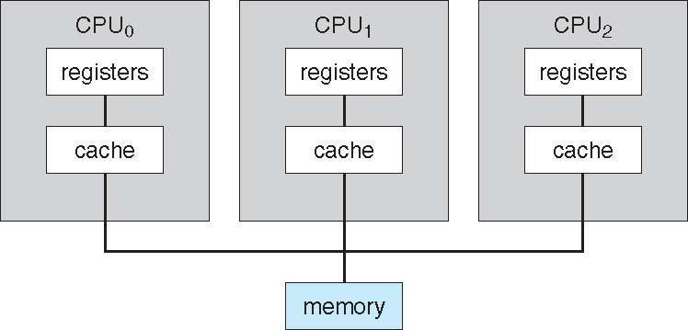
A Dual-Core Design
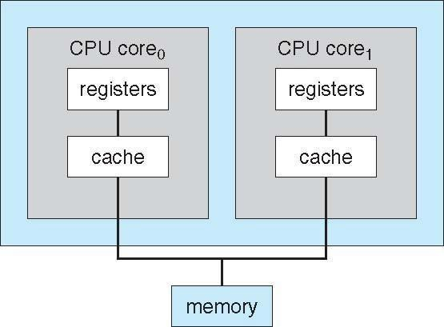
Clustered Systems

- Like multiprocessor systems, but multiple systems working together
- Usually sharing storage via a storage-area network (SAN)
- Provides a high-availability service which survives failures Asymmetric clustering has one machine in hot-standby mode
Symmetric clustering has multiple nodes running applications, monitoring each other
- Some clusters are for high-performance computing (HPC) Applications must be written to use parallelization

Operating System Structure
- Multiprogramming needed for efficiency
- Single user cannot keep CPU and I/O devices busy at all times
- Multiprogramming organizes jobs (code and data) so CPU always has one to Execute
- A subset of total jobs in system is kept in memory
- One job selected and run via job scheduling
- When it has to wait (for I/O for example), OS switches to another job
- Timesharing (multitasking) is logical extension in which CPU switches jobs so frequently that users can interact with each job while it is running, creating interactive computing
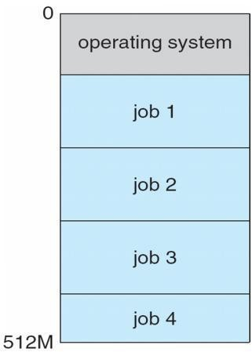
- Response time should be < 1 second
- Each user has at least one program executing in memory [process
- If several jobs ready to run at the same time [ CPU scheduling
- If processes don’t fit in memory, swapping moves them in and out to run Virtual memory allows execution of processes not completely in memory. Memory Layout for Multiprogrammed System

Operating-System Operations
- Interrupt driven by hardware
- Software error or request creates exception or trap
- Division by zero, request for operating system service
- Other process problems include infinite loop, processes modifying each Other or the operating system
- Dual-mode operation allows OS to protect itself and other system components

User mode and kernel mode
- Mode bit provided by hardware

- Provides ability to distinguish when system is running user code or kernel code
- Some instructions designated as privileged, only executable in kernel mode
- System call changes mode to kernel, return from call resets it to user

Transition from User to Kernel Mode
- Timer to prevent infinite loop / process hogging resources
- Set interrupt after specific period
- Operating system decrements counter
- When counter zero generate an interrupt
- Set up before scheduling process to regain control or terminate program that exceeds allotted time
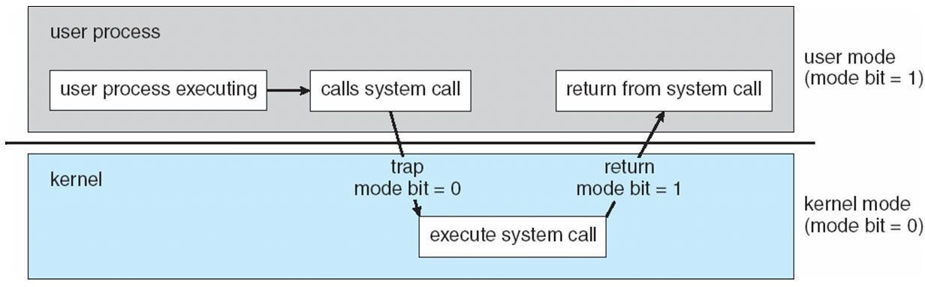

OPERATING SYSTEM FUNCTIONS
Process Management
- A process is a program in execution. It is a unit of work within the system. Program is a passive entity, process is an active entity.
- Process needs resources to accomplish its task
- CPU, memory, I/O, files
- Initialization data
- Process termination requires reclaim of any reusable resources
- Single-threaded process has one program counter specifying location of next instruction to execute
- Process executes instructions sequentially, one at a time, until completion
- Multi-threaded process has one program counter per thread
- Typically system has many processes, some user, some operating system running concurrently on one or more CPUs
- Concurrency by multiplexing the CPUs among the processes / threads

Process Management Activities
- The operating system is responsible for the following activities in connection with process management:
- Creating and deleting both user and system processes
- Suspending and resuming processes
- Providing mechanisms for process synchronization
- Providing mechanisms for process communication
- Providing mechanisms for deadlock handling

Memory Management
- All data in memory before and after processing
- All instructions in memory in order to execute
- Memory management determines what is in memory when
- Optimizing CPU utilization and computer response to users

Memory management activities
- Keeping track of which parts of memory are currently being used and by whom
- Deciding which processes (or parts thereof) and data to move into and out of memory
- Allocating and deallocating memory space as needed

Storage Management
- OS provides uniform, logical view of information storage
- Abstracts physical properties to logical storage unit - file
- Each medium is controlled by device (i.e., disk drive, tape drive)
- Varying properties include access speed, capacity, data-transfer rate, access method (sequential or random)
- File-System management
- Files usually organized into directories
- Access control on most systems to determine who can access what

OS activities include
- Creating and deleting files and directories
- Primitives to manipulate files and dirs
- Mapping files onto secondary storage
- Backup files onto stable (non-volatile) storage media

Mass-Storage Management
- Usually disks used to store data that does not fit in main memory or data that must be kept for a
―long‖ period of time
- Proper management is of central importance
- Entire speed of computer operation hinges on disk subsystem and its algorithms

Mass-Storage Activities
- Free-space management
- Storage allocation
- Disk scheduling
- Some storage need not be fast
- Tertiary storage includes optical storage, magnetic tape
- Still must be managed
- Varies between WORM (write-once, read-many-times) and RW (read-write)

DISTRIBUTED SYSTEMS
Computing Environments Traditional computer
- Blurring over time
- Office environment
PCs connected to a network, terminals attached to mainframe or minicomputers providing batch and timesharing
Now portals allowing networked and remote systems access to same resources
- Home networks
Used to be single system, then modems Now firewalled, networked
- Client-Server Computing
- Dumb terminals supplanted by smart PCs
- Many systems now servers, responding to requests generated by clients Compute-server provides an interface to client to request services (i.e. database) File-server provides interface for clients to store and retrieve files

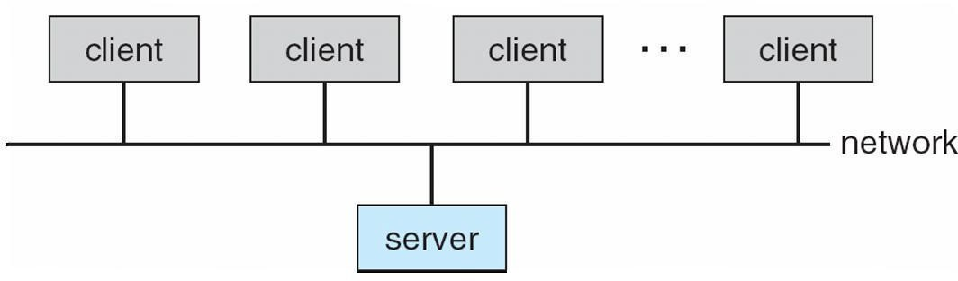

Peer-to-Peer Computing

- Another model of distributed system
- P2P does not distinguish clients and servers
- Instead all nodes are considered peers
- May each act as client, server or both
- Node must join P2P network
Registers its service with central lookup service on network, or
Broadcast request for service and respond to requests for service via discovery protocol
- Examples include Napster and Gnutella

Web-Based Computing
- Web has become ubiquitous
- PCs most prevalent devices
- More devices becoming networked to allow web access
- New category of devices to manage web traffic among similar servers: load balancers

- Use of operating systems like Windows 95, client-side, have evolved into Linux and Windows XP, which can be clients and servers

Open-Source Operating Systems
- Operating systems made available in source-code format rather than just binary closed-source
- Counter to the copy protection and Digital Rights Management (DRM) movement
- Started by Free Software Foundation (FSF), which has ―copyleft‖ GNU Public License (GPL)
- Examples include GNU/Linux, BSD UNIX (including core of Mac OS X), and Sun Solaris

Operating System Services
- One set of operating-system services provides functions that are helpful to the user:
- User interface - Almost all operating systems have a user interface (UI)
- Varies between Command-Line (CLI), Graphics User Interface (GUI), Batch
- Program execution - The system must be able to load a program into memory and to run that program, end execution, either normally or abnormally (indicating error)
- I/O operations - A running program may require I/O, which may involve a file or an I/O device
- File-system manipulation - The file system is of particular interest. Obviously, programs need to read and write files and directories, create and delete them, search them, list file Information, permission management.

A View of Operating System Services
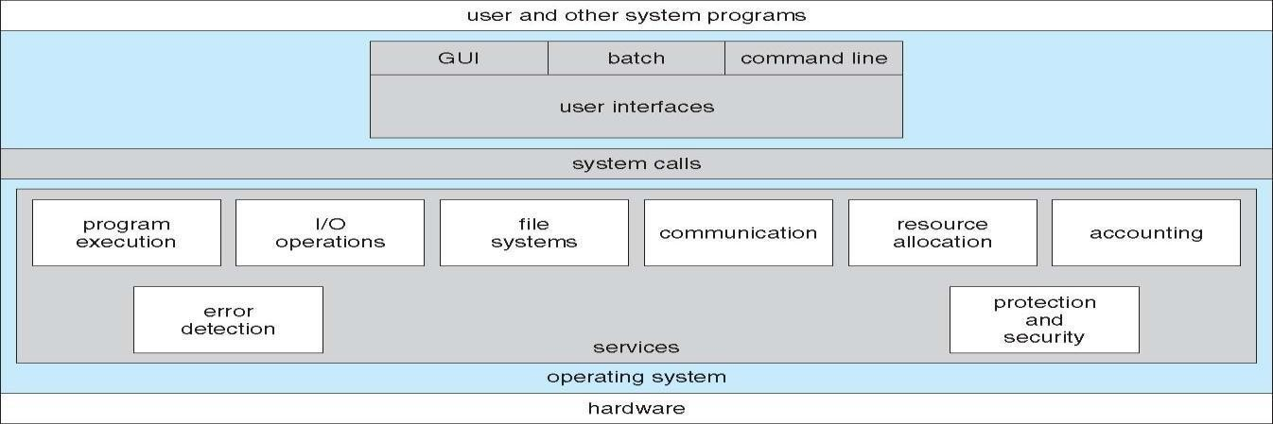

Operating System Services
- One set of operating-system services provides functions that are helpful to the user (Cont):l Communications – Processes may exchange information, on the same computer or between computers over a network
Communications may be via shared memory or through message passing (packets moved by the OS)
- Error detection – OS needs to be constantly aware of possible errors
May occur in the CPU and memory hardware, in I/O devices, in user program
For each type of error, OS should take the appropriate action to ensure correct and consistent computing Debugging facilities can greatly enhance the user’s and programmer’s abilities to efficiently use
the system
- Another set of OS functions exists for ensuring the efficient operation of the system itself via resource sharing
- Resource allocation - When multiple users or multiple jobs running concurrently, resources must be allocated to each of them
- Many types of resources - Some (such as CPU cycles, main memory, and file storage) may have special allocation code, others (such as I/O devices) may have general request and release code

- Accounting - To keep track of which users use how much and what kinds of computer resources
- Protection and security - The owners of information stored in a multiuser or networked computer system may want to control use of that information, concurrent processes should not interfere with each other
- Protection involves ensuring that all access to system resources is controlled
- Security of the system from outsiders requires user authentication, extends to defending external I/O devices from invalid access attempts
- If a system is to be protected and secure, precautions must be instituted throughout it. A chain is only as strong as its weakest link.

User Operating System Interface - CLI
- Command Line Interface (CLI) or command interpreter allows direct command entry Sometimes implemented in kernel, sometimes by systems program
Sometimes multiple flavors implemented – shells Primarily fetches a command from user and executes it
- Sometimes commands built-in, sometimes just names of programs
- If the latter, adding new features doesn’t require shell modification

User Operating System Interface - GUI
- User-friendly desktop metaphor interface
- Usually mouse, keyboard, and monitor
- Icons represent files, programs, actions, etc
- Various mouse buttons over objects in the interface cause various actions (provide information, options, execute function, open directory (known as a folder)
- Invented at Xerox PARC
- Many systems now include both CLI and GUI interfaces
- Microsoft Windows is GUI with CLI ―command‖ shell
- Apple Mac OS X as ―Aqua‖ GUI interface with UNIX kernel underneath and shells available
- Solaris is CLI with optional GUI interfaces (Java Desktop, KDE)

Bourne Shell Command Interpreter

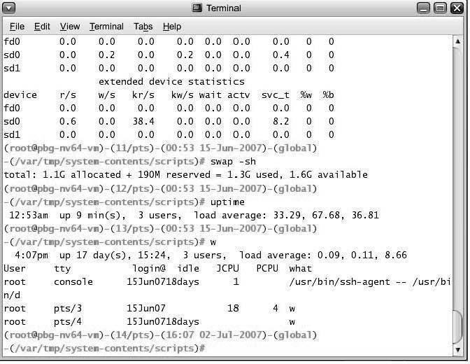
The Mac OS X GUI

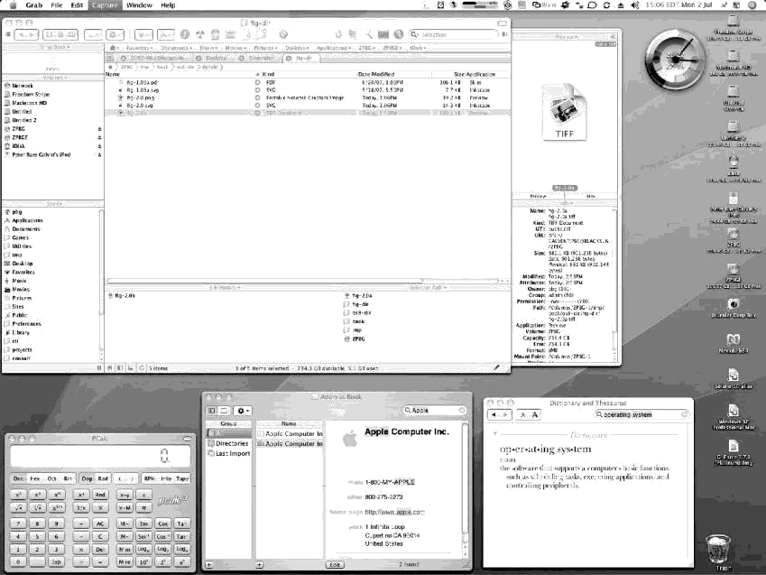

System Calls
- Programming interface to the services provided by the OS
- Typically written in a high-level language (C or C++)
- Mostly accessed by programs via a high-level Application Program Interface (API) rather than direct system call usen Three most common APIs are Win32 API for Windows, POSIX API for POSIX-based systems (including virtually all versions of UNIX, Linux, and Mac OS X), and Java API for the Java virtual machine (JVM)
- Why use APIs rather than system calls?(Note that the system-call names used throughout this text are generic)

Example of System Calls
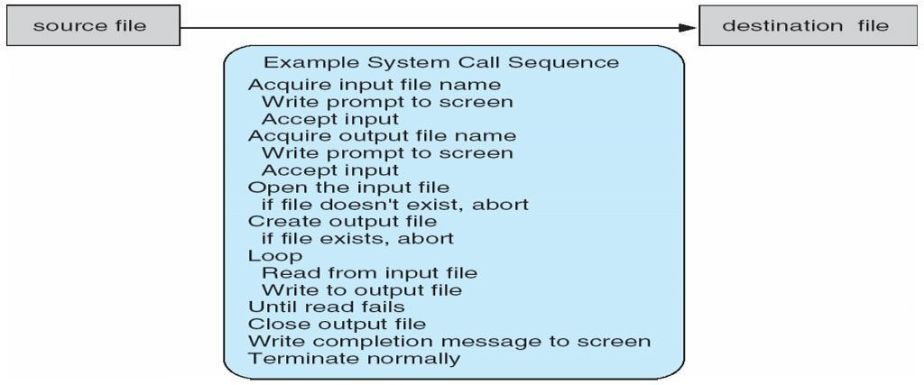

System Call Implementation
- Typically, a number associated with each system call
- System-call interface maintains a table indexed according to these
- Numbers
- The system call interface invokes intended system call in OS kernel and returns status of the system call and any return values
- The caller need know nothing about how the system call is implemented
- Just needs to obey API and understand what OS will do as a result call
- Most details of OS interface hidden from programmer by API
Managed by run-time support library (set of functions built into libraries included with compiler)

API – System Call – OS Relationship
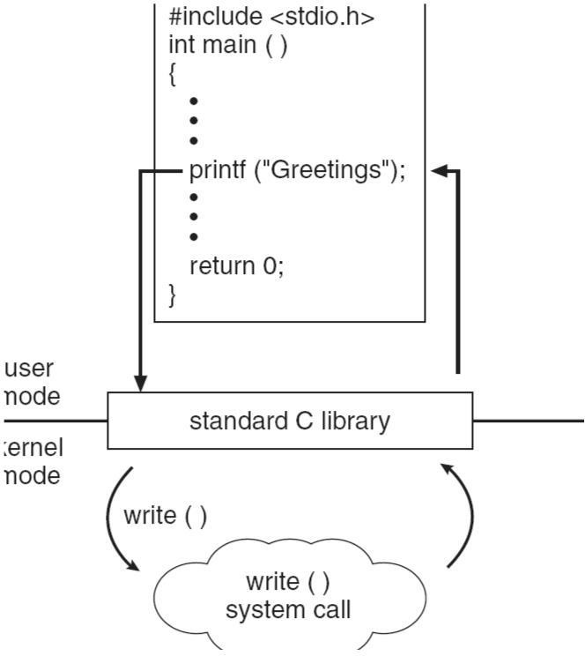
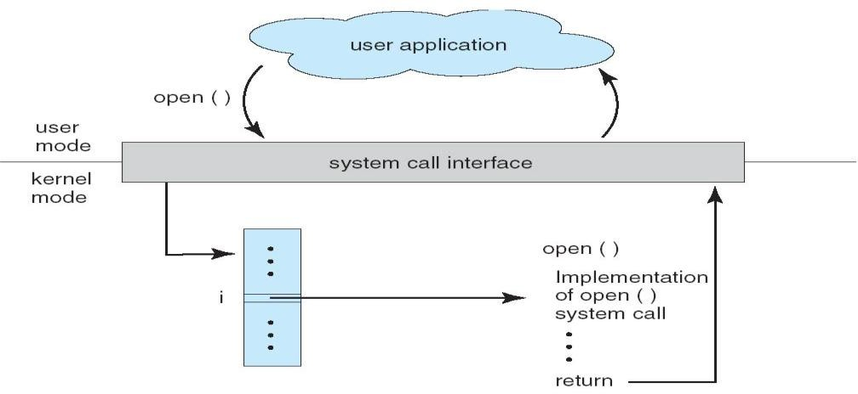

Standard C Library Example

System Call Parameter Passing
- Often, more information is required than simply identity of desired system call
- Exact type and amount of information vary according to OS and call
- Three general methods used to pass parameters to the OS
- Simplest: pass the parameters in registers
In some cases, may be more parameters than registers
- Parameters stored in a block, or table, in memory, and address of block passed as a parameter in a register . This approach taken by Linux and Solaris
- Parameters placed, or pushed, onto the stack by the program and popped off the stack by the operating system
- Block and stack methods do not limit the number or length of parameters being passed

Parameter Passing via Table

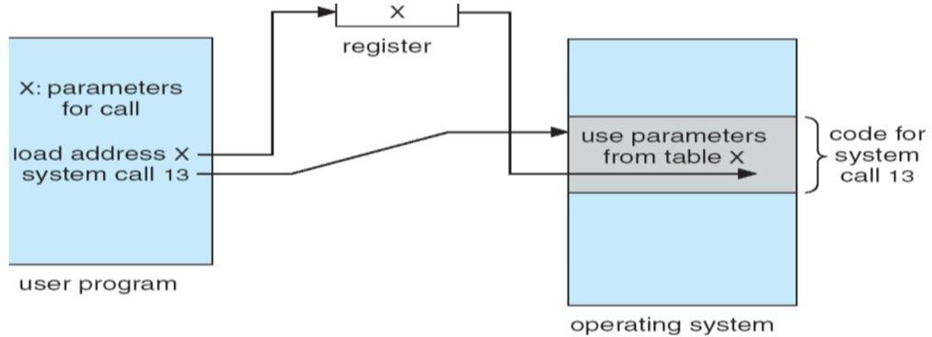
Types of System Calls
- Process control
- File management
- Device management
- Information maintenance
- Communications
- Protection

Examples of Windows and Unix System Calls
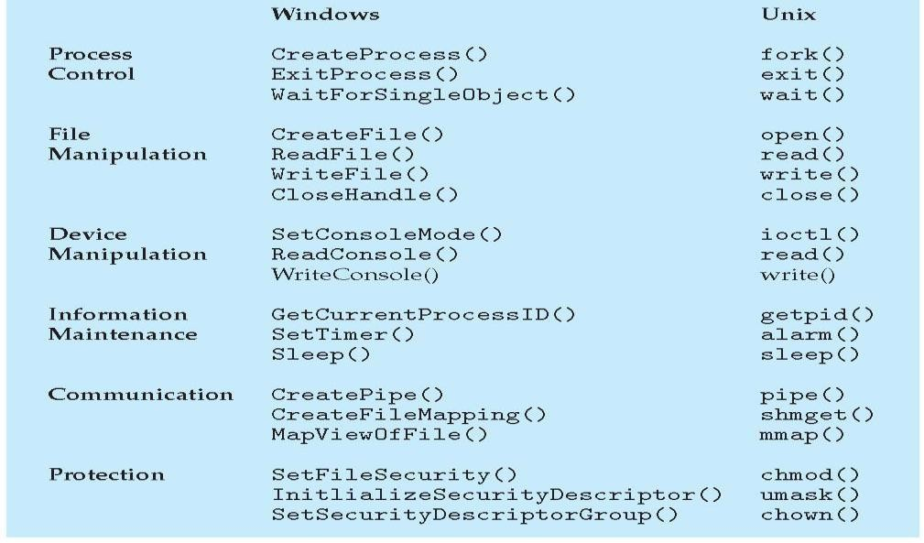
MS-DOS execution

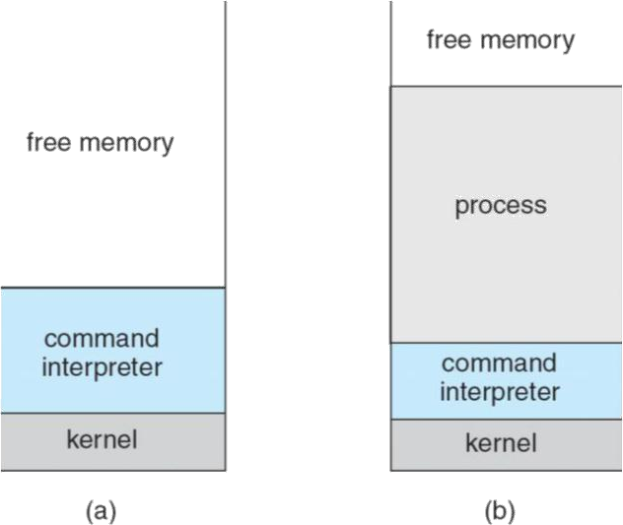

(a) At system startup (b) running a program

FreeBSD Running Multiple Programs
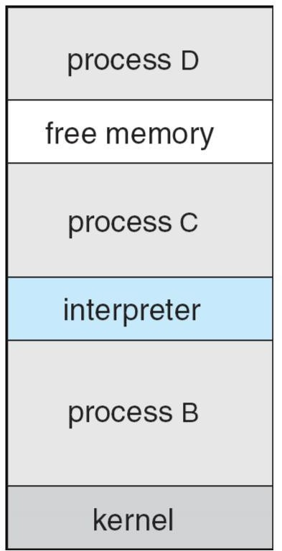

System Programs
System programs provide a convenient environment for program development and execution. The can be divided into:
- File manipulation
- Status information
- File modification
- Programming language support
- Program loading and execution
- Communications
- Application programs

Most users’ view of the operation system is defined by system programs, not the actual system calls
- Provide a convenient environment for program development and execution
- Some of them are simply user interfaces to system calls; others are considerably more complex
- File management - Create, delete, copy, rename, print, dump, list, and generally manipulate files and directories
- Status information
- Some ask the system for info - date, time, amount of available memory, disk space, number of users
- Others provide detailed performance, logging, and debugging information
- Typically, these programs format and print the output to the terminal or other output devices
- Some systems implement a registry - used to store and retrieve configuration information

File modification
- Text editors to create and modify files
- Special commands to search contents of files or perform transformations of the text
- Programming-language support - Compilers, assemblers, debuggers and interpreters sometimes provided
- Program loading and execution- Absolute loaders, relocatable loaders, linkage editors, and overlay-loaders, debugging systems for higher-level and machine language
- Communications - Provide the mechanism for creating virtual connections among processes, users, and computer systems
- Allow users to send messages to one another’s screens, browse web pages, send electronic-mail messages, log in remotely, transfer files from one machine to another

Operating System Design and Implementation
- Design and Implementation of OS not ―solvable‖, but some approaches have proven successful
- Internal structure of different Operating Systems can vary widely
- Start by defining goals and specifications
- Affected by choice of hardware, type of system
- User goals and System goals
- User goals – operating system should be convenient to use, easy to learn, reliable, safe, and fast
- System goals – operating system should be easy to design, implement, and maintain, as well as flexible, reliable, error-free, and efficient
- Important principle to separate
- Policy: What will be done?
Mechanism: How to do it?
- Mechanisms determine how to do something, policies decide what will be done
- The separation of policy from mechanism is a very important principle, it allows maximum flexibility if
policy decisions are to be changed later

Simple Structure
- MS-DOS – written to provide the most functionality in the least space
- Not divided into modules
- Although MS-DOS has some structure, its interfaces and levels of Functionality are not well separated

MS-DOS Layer Structure
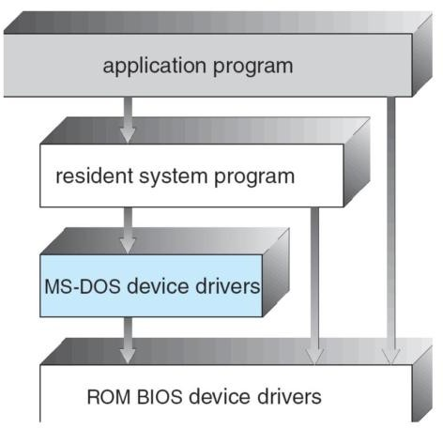

Layered Approach

- The operating system is divided into a number of layers (levels), each built on top of lower layers. The bottom layer (layer 0), is the hardware; the highest (layer N) is the user interface.
- With modularity, layers are selected such that each uses functions (operations) and services of only lower-level layer

Traditional UNIX System Structure
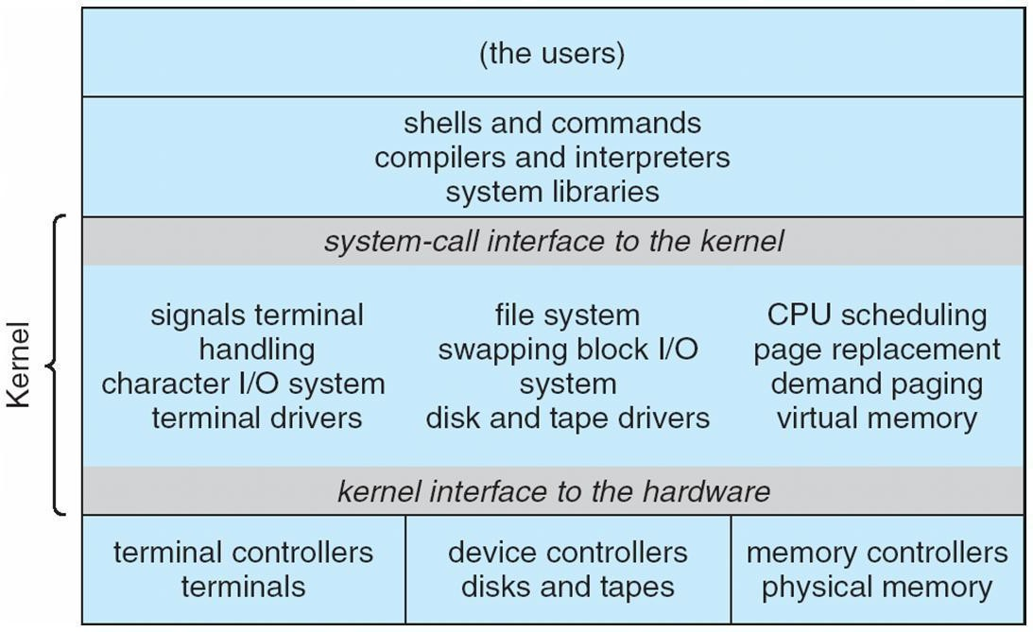

UNIX

- UNIX – limited by hardware functionality, the original UNIX operating system had limited structuring. The UNIX OS consists of two separable parts
- Systems programs
- The kernel
Consists of everything below the system-call interface and above the physical hardware
Provides the file system, CPU scheduling, memory management, and other operating-system functions; a large number of functions for one level.

Layered Operating System
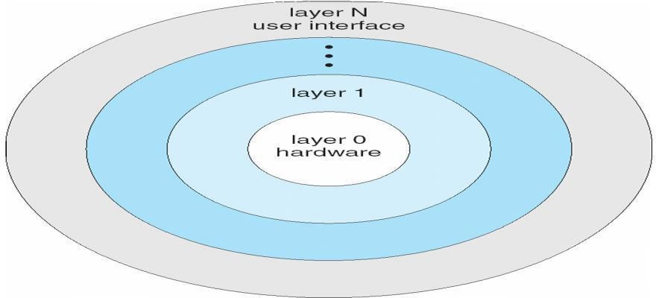
Micro kernel System Structure
- Moves as much from the kernel into ―user‖ space
- Communication takes place between user modules using message passing
- Benefits:
- Easier to extend a microkernel
- Easier to port the operating system to new architectures
- More reliable (less code is running in kernel mode)
- More secure
- Detriments:
- Performance overhead of user space to kernel space communication

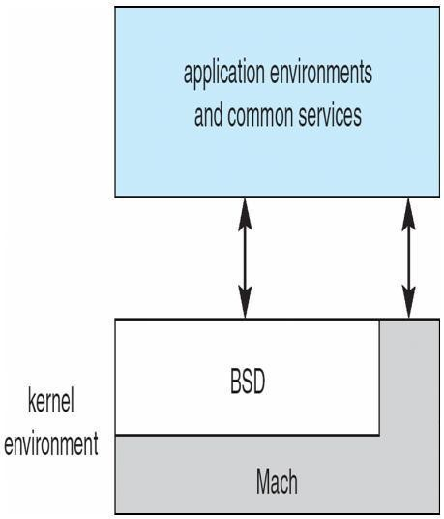
Mac OS X Structure

Modules
- Most modern operating systems implement kernel modules
- Uses object-oriented approach
- Each core component is separate
- Each talks to the others over known interfaces
- Each is loadable as needed within the kernel
- Overall, similar to layers but with more flexible.

Solaris Modular Approach

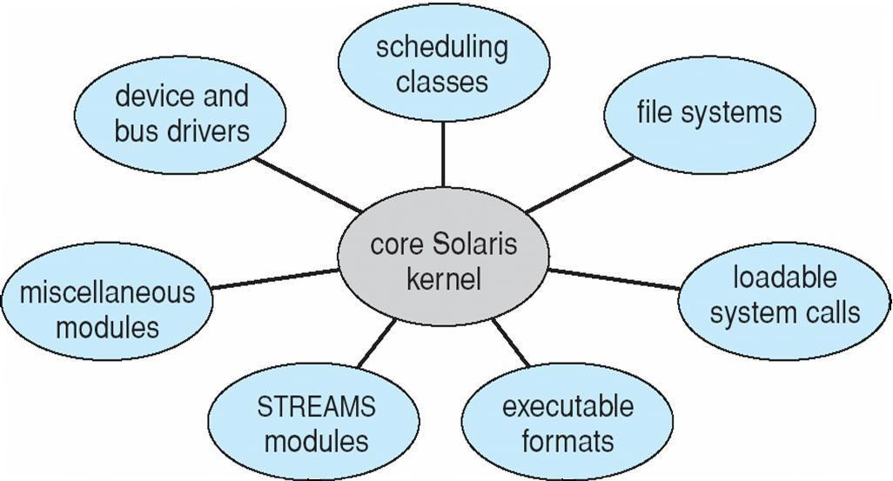

Virtual Machines
- A virtual machine takes the layered approach to its logical conclusion. It treats hardware and the operating system kernel as though they were all hardware
- A virtual machine provides an interface identical to the underlying bare hardware
- The operating system host creates the illusion that a process has its own processor and (virtual memory)
- Each guest provided with a (virtual) copy of underlying computer

Virtual Machines History and Benefits
- First appeared commercially in IBM mainframes in 1972
- Fundamentally, multiple execution environments (different operating systems) can share the same hardware
- Protect from each other
- Some sharing of file can be permitted, controlled
- Commutate with each other, other physical systems via networking
- Useful for development, testing
- Consolidation of many low-resource use systems onto fewer busier systems
- ―Open Virtual Machine Format‖, standard format of virtual machines, allows a VM to run within many different virtual machine (host) platforms
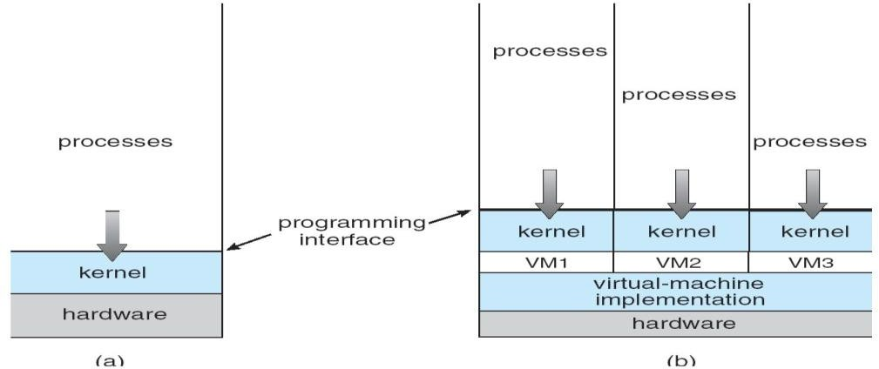

Para-virtualization
- Presents guest with system similar but not identical to hardware
- Guest must be modified to run on paravirtualized hardwareF
- Guest can be an OS, or in the case of Solaris 10 applications running in containers
Solaris 10 with Two Container
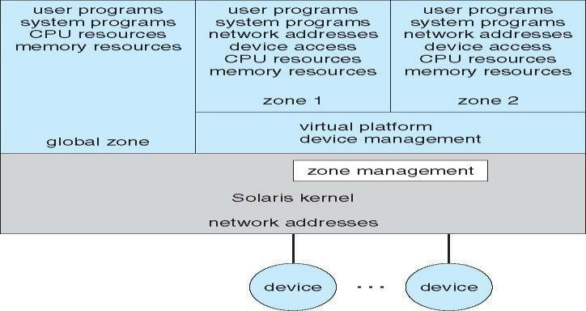

VMware Architecture

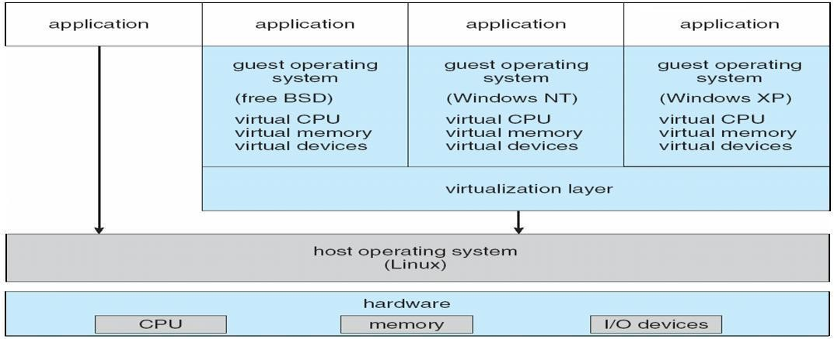

The Java Virtual Machine

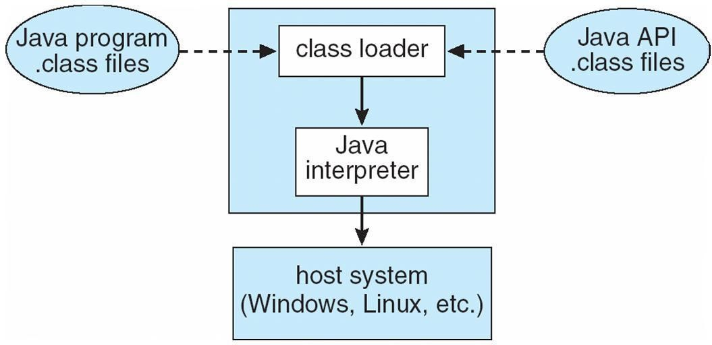

Operating-System Debugging

- Debugging is finding and fixing errors, or bugs
- OSes generate log files containing error information
- Failure of an application can generate core dump file capturing memory of the process
- Operating system failure can generate crash dump file containing kernel memory
- Beyond crashes, performance tuning can optimize system performance
- Kernighan’s Law: ―Debugging is twice as hard as writing the code in the rst place. Therefore, if you write the code as cleverly as possible, you are, by definition, not smart enough to debug it.‖
- DTrace tool in Solaris, FreeBSD, Mac OS X allows live instrumentation on production systems
- Probes fire when code is executed, capturing state data and sending it to consumers of those probes

Solaris 10 dtrace Following System Call

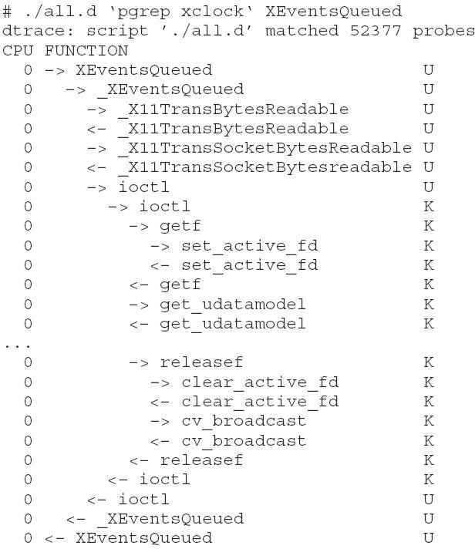

Operating System Generation
- Operating systems are designed to run on any of a class of machines; the system must be configured for each specific computer site
- SYSGEN program obtains information concerning the specific configuration of the hardware system
- Booting – starting a computer by loading the kernel
- Bootstrap program – code stored in ROM that is able to locate the kernel, load it into memory, and start its execution

System Boot
- Operating system must be made available to hardware so hardware can start it
- Small piece of code – bootstrap loader, locates the kernel, loads it into memory, and starts it
- Sometimes two-step process where boot block at fixed location loads bootstrap loader

- When power initialized on system, execution starts at a fixed memory location Firmware used to hold initial boot code
UNIT – II

Process Management

Process Concept
- An operating system executes a variety of programs:
- Batch system – jobs
- Time-shared systems – user programs or tasks
- Textbook uses the terms job and process almost interchangeably
Process – a program in execution; process execution must progress in sequential fashion A process includes:
- program counter
- stack
- data section

Process in Memory
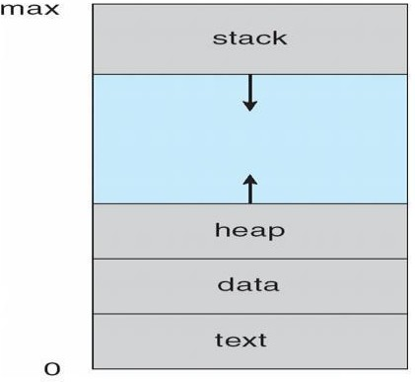

Process State
As a process executes, it changes state
- new: The process is being created
- running: Instructions are being executed
- waiting: The process is waiting for some event to occur
- ready: The process is waiting to be assigned to a processor
- terminated: The process has finished execution

Diagram of Process State

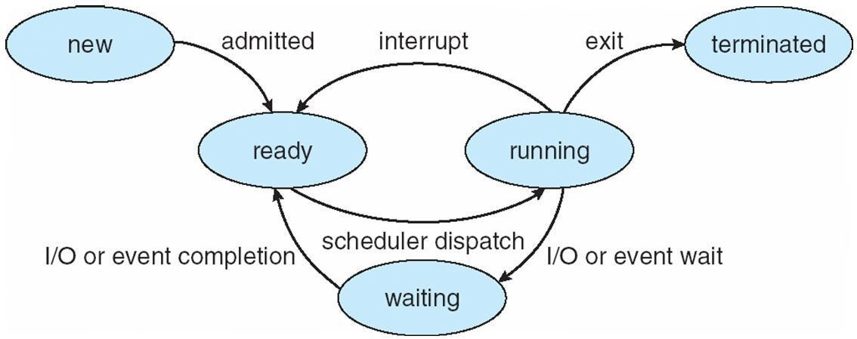

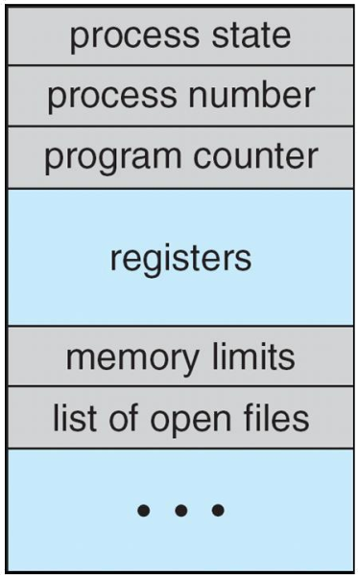
Process Control Block (PCB)

Information associated with each process
- Process state
- Program counter
- CPU registers
- CPU scheduling information
- Memory-management information
- Accounting information
- I/O status information

CPU Switch From Process to Process

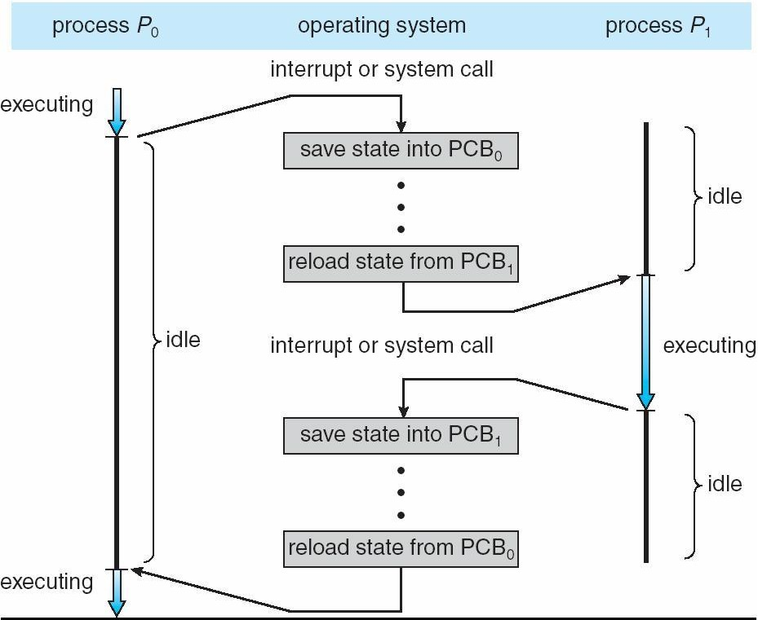

Process Scheduling Queues

- Job queue – set of all processes in the system
- Ready queue – set of all processes residing in main memory, ready and waiting to execute
- Device queues – set of processes waiting for an I/O device
- Processes migrate among the various queues

Ready Queue And Various I/O Device Queues

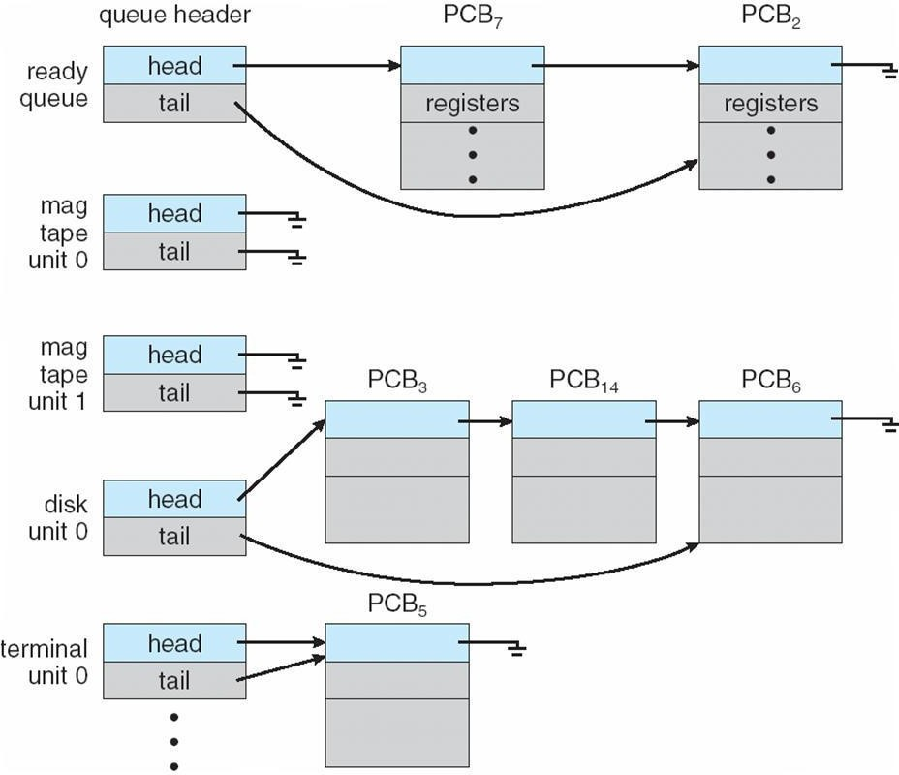

Representation of Process Scheduling
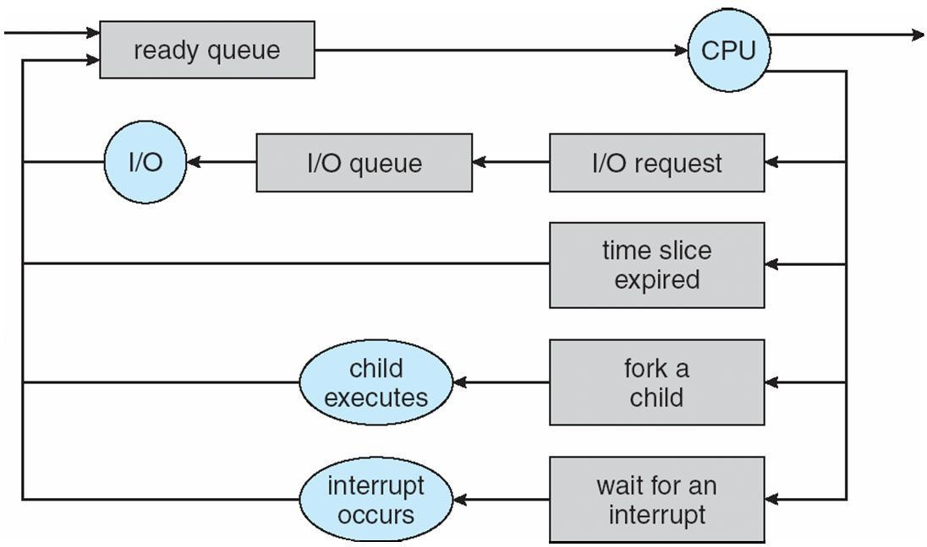
Schedulers
- Long-term scheduler (or job scheduler) – selects which processes should be brought into the ready queue
- Short-term scheduler (or CPU scheduler) – selects which process should be executed next and allocates CPU

Addition of Medium Term Scheduling
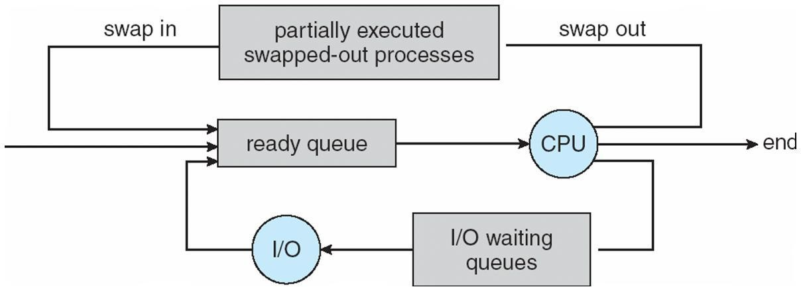

- Short-term scheduler is invoked very frequently (milliseconds) Þ (must be fast)
- Long-term scheduler is invoked very infrequently (seconds, minutes) Þ (may be slow)
- The long-term scheduler controls the degree of multiprogramming
- Processes can be described as either:
- I/O-bound process – spends more time doing I/O than computations, many short CPU bursts
- CPU-bound process – spends more time doing computations; few very long CPU bursts

Context Switch
- When CPU switches to another process, the system must save the state of the old process and load the saved state for the new process via a context switch
- Context of a process represented in the PCB
- Context-switch time is overhead; the system does no useful work while switching
- Time dependent on hardware support

Process Creation
- Parent process create children processes, which, in turn create other processes, forming a tree of processes
- Generally, process identified and managed via a process identifier (pid)
- Resource sharing
- Parent and children share all resources
- Children share subset of parent’s resources
- Parent and child share no resources
- Execution
- Parent and children execute concurrently
- Parent waits until children terminate
- Address space
- Child duplicate of parent
- Child has a program loaded into it
- UNIX examples
- fork system call creates new process
- exec system call used after a fork to replace the process’ memory space with a new program

Process Creation

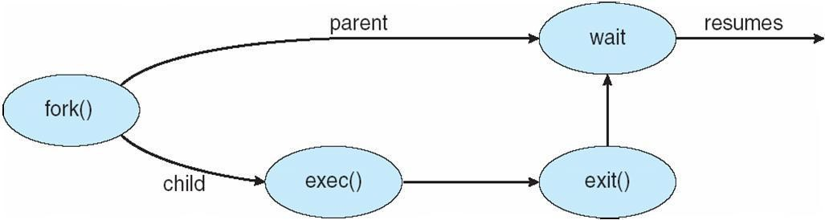

Process Termination
- Process executes last statement and asks the operating system to delete it (exit)
- Output data from child to parent (via wait)
- Process’ resources are deallocated by operating system
- Parent may terminate execution of children processes (abort)
- Child has exceeded allocated resources
- Task assigned to child is no longer required
- If parent is exiting
Some operating system do not allow child to continue if its parent terminates All children terminated - cascading termination Interprocess Communication
- Processes within a system may be independent or cooperating
- Cooperating process can affect or be affected by other processes, including sharing data
- Reasons for cooperating processes:
- Information sharing
- Computation speedup
- Modularity
- Convenience
- Cooperating processes need interprocess communication (IPC)
- Two models of IPC
- Shared memory
- Message passing

Communications Models
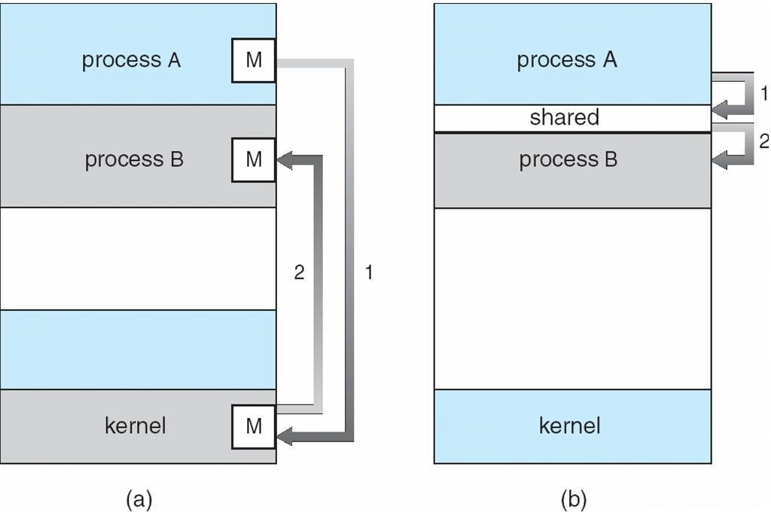

Cooperating Processes
- Independent process cannot affect or be affected by the execution of another process
- Cooperating process can affect or be affected by the execution of another process Advantages of process cooperation
- Information sharing
- Computation speed-up
- Modularity
- Convenience

Producer-Consumer Problem
- Paradigm for cooperating processes, producer process produces information that is consumed by a consumer process
- unbounded-buffer places no practical limit on the size of the buffer
- bounded-buffer assumes that there is a fixed buffer size

Bounded-Buffer – Shared-Memory Solution
Shared data
#define BUFFER_SIZE 10 typedef struct {
. . .
} item;
item buffer[BUFFER_SIZE]; int in = 0;
int out = 0;
Solution is correct, but can only use BUFFER_SIZE-1 elements

Bounded-Buffer – Producer
while (true) {
/* Produce an item */
while (((in = (in + 1) % BUFFER SIZE count) == out)
; /* do nothing -- no free buffers */ buffer[in] = item;
in = (in + 1) % BUFFER SIZE;
}

Bounded Buffer – Consumer
while (true) {
while (in == out)
; // do nothing -- nothing to consume
// remove an item from the buffer item = buffer[out];
out = (out + 1) % BUFFER SIZE;
return item;
}

Interprocess Communication – Message Passing
- Mechanism for processes to communicate and to synchronize their actions
- Message system – processes communicate with each other without resorting to shared variables
- IPC facility provides two operations:
- send(message) – message size fixed or variable
- receive(message)

- If P and Q wish to communicate, they need to:
- establish a communication link between them
- exchange messages via send/receive
- Implementation of communication link
- physical (e.g., shared memory, hardware bus)
- logical (e.g., logical properties)

Direct Communication
- Processes must name each other explicitly:
- send (P, message) – send a message to process P
- receive(Q, message) – receive a message from process Q
- Properties of communication link
- Links are established automatically
- A link is associated with exactly one pair of communicating processes
- Between each pair there exists exactly one link
- The link may be unidirectional, but is usually bi-directional

Indirect Communication
- Messages are directed and received from mailboxes (also referred to as ports)
- Each mailbox has a unique id
- Processes can communicate only if they share a mailbox
- Properties of communication link
- Link established only if processes share a common mailbox
- A link may be associated with many processes
- Each pair of processes may share several communication links
- Link may be unidirectional or bi-directional
- Operations
- create a new mailbox
- send and receive messages through mailbox
- destroy a mailbox
- Primitives are defined as:
- send(A, message) – send a message to mailbox A
- receive(A, message) – receive a message from mailbox A
- Mailbox sharing
- P1, P2, and P3 share mailbox A
- P1, sends; P2 and P3 receive
- Who gets the message?
- Solutions
- Allow a link to be associated with at most two processes
- Allow only one process at a time to execute a receive operation
- Allow the system to select arbitrarily the receiver. Sender is notified who the receiver was.

Synchronization
- Message passing may be either blocking or non-blocking
- Blocking is considered synchronous
- Blocking send has the sender block until the message is received
- Blocking receive has the receiver block until a message is available

- Non-blocking is considered asynchronous
- Non-blocking send has the sender send the message and continue
- Non-blocking receive has the receiver receive a valid message or null

Buffering
Queue of messages attached to the link; implemented in one of three ways
- Zero capacity – 0 messages
Sender must wait for receiver (rendezvous)
- Bounded capacity – finite length of n messages Sender must wait if link full
- Unbounded capacity – infinite length Sender never waits

Examples of IPC Systems - POSIX
  - POSIX Shared Memory
  - Process first creates shared memory segment
  - segment id = shmget(IPC PRIVATE, size, S IRUSR | S IWUSR);
  - Process wanting access to that shared memory must attach to it
  - shared memory = (char *) shmat(id, NULL, 0);
  - Now the process could write to the shared memory
  - printf(shared memory, "Writing to shared memory");
  - When done a process can detach the shared memory from its address space
  - shmdt(shared memory);

Examples of IPC Systems - Mach
  - Mach communication is message based
  - Even system calls are messages
  - Each task gets two mailboxes at creation- Kernel and Notify
  - Only three system calls needed for message transfer
  - msg_send(), msg_receive(), msg_rpc()
  - Mailboxes needed for commuication, created via
  - port_allocate()

Examples of IPC Systems – Windows XP
  - Message-passing centric via local procedure call (LPC) facility
  - Only works between processes on the same system
  - Uses ports (like mailboxes) to establish and maintain communication channels
  - Communication works as follows:
The client opens a handle to the subsystem’s connection port object The client sends a connection request
The server creates two private communication ports and returns the handle to one of them to the client The client and server use the corresponding port handle to send messages or callbacks and to listen for replies

Communications in Client-Server Systems
  - Sockets
  - Remote Procedure Calls
  - Remote Method Invocation (Java)

Remote Procedure Calls
  - Remote procedure call (RPC) abstracts procedure calls between processes on networked systems
  - Stubs – client-side proxy for the actual procedure on the server

  - The client-side stub locates the server and marshalls the parameters
  - The server-side stub receives this message, unpacks the marshalled parameters, and peforms the procedure on the server

Execution of RPC
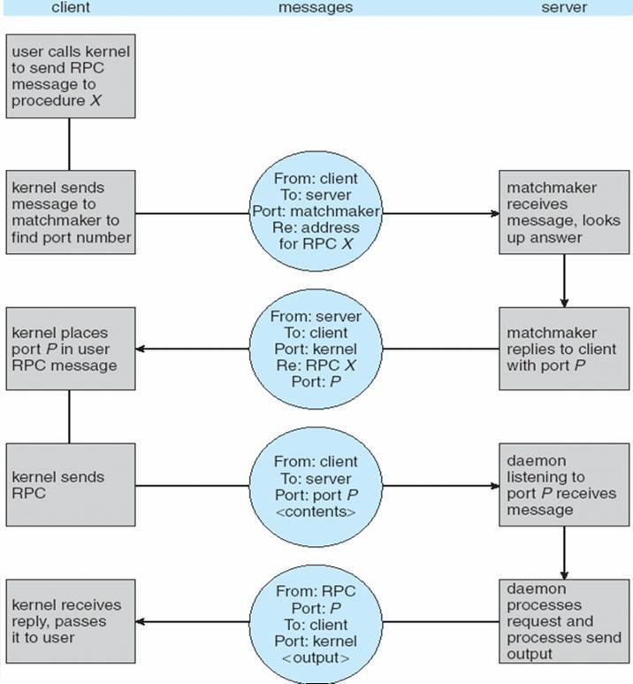

Remote Method Invocation
  - Remote Method Invocation (RMI) is a Java mechanism similar to RPCs
  - RMI allows a Java program on one machine to invoke a method on a remote object

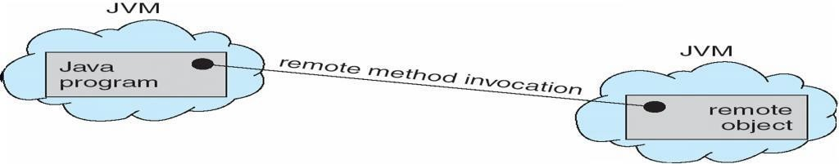

Marshalling Parameters
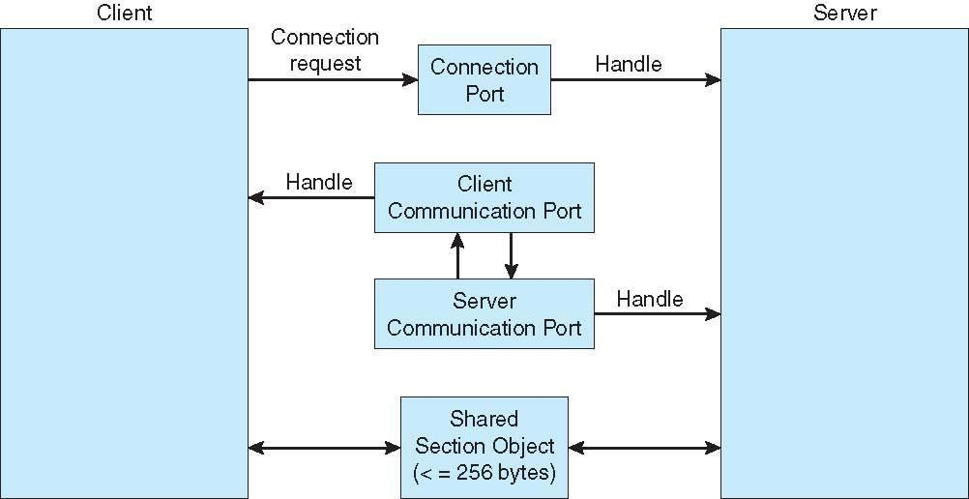

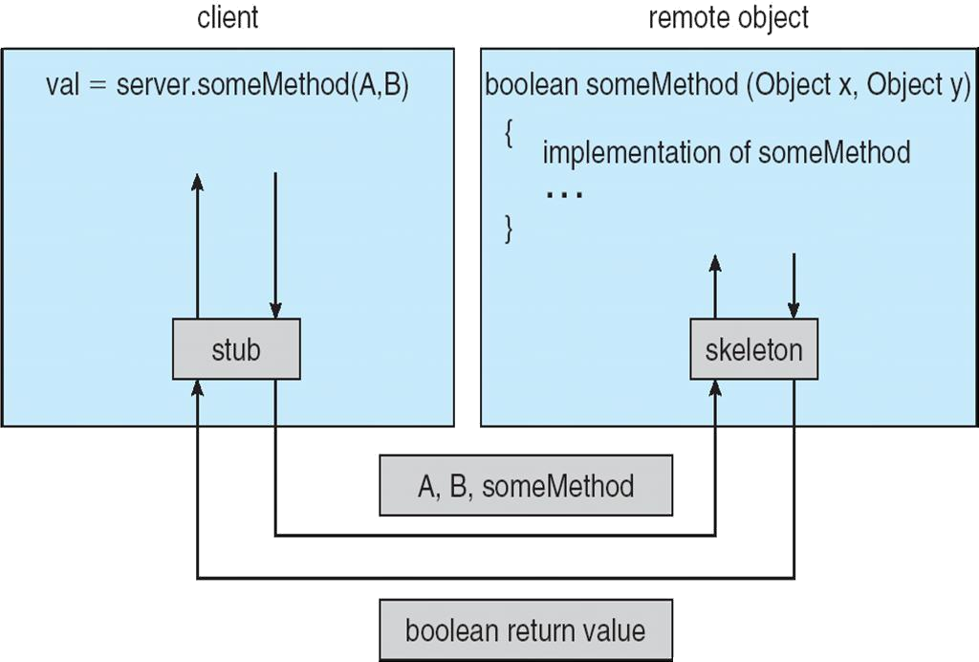

Threads
  - To introduce the notion of a thread — a fundamental unit of CPU utilization that forms the basis of multithreaded computer systems
  - To discuss the APIs for the Pthreads, Win32, and Java thread libraries
  - To examine issues related to multithreaded programming

Single and Multithreaded Processes Benefits
  - Responsiveness
  - Resource Sharing
  - Economy
  - Scalability

Multicore Programming
Multicore systems putting pressure on programmers, challenges include
  - Dividing activities
  - Balance
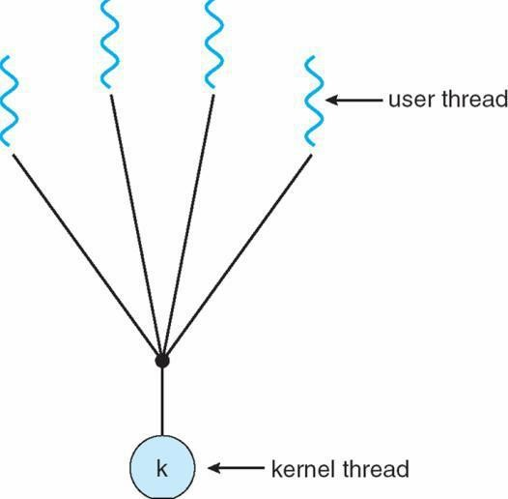
  - Data splitting
  - Data dependency
  - Testing and debugging

User Threads
  - Thread management done by user-level threads librarynThree primary thread libraries:
  - POSIX Pthreadsl Win32 threads
  - Java threads
Kernel Threads Supported by the Kernel Examples
  - Windows XP/2000
  - Solaris

  - Linux
  - Tru64 UNIX
  - Mac OS X

Multithreading Models
  - Many-to-One
  - One-to-One
  - Many-to-Many

Many-to-One
Many user-level threads mapped to single kernel thread Examples:
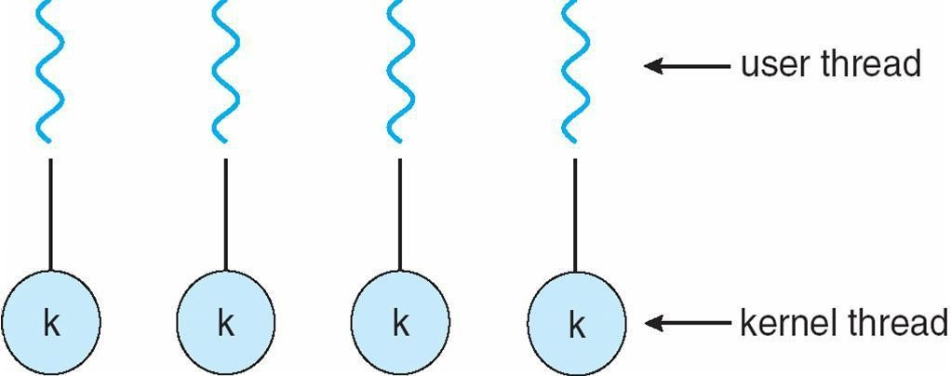
  - Solaris Green Threads
  - GNU Portable Threads

One-to-One
Each user-level thread maps to kernel thread Examples
Windows NT/XP/2000 Linux
Solaris 9 and later

Many-to-Many Model
  - Allows many user level threads to be mapped to many kernel threads
  - Allows the operating system to create a sufficient number of kernel threads
  - Solaris prior to version 9
Windows NT/2000 with the ThreadFiber package
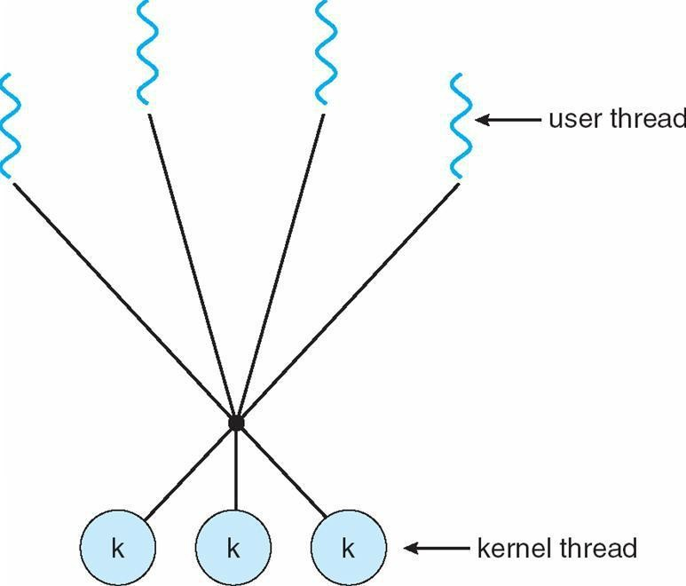

Two-level Model
Similar to M:M, except that it allows a user thread to be bound to kernel thread Examples
  - IRIX
  - HP-UX
  - Tru64 UNIX
  - Solaris 8 and earlier

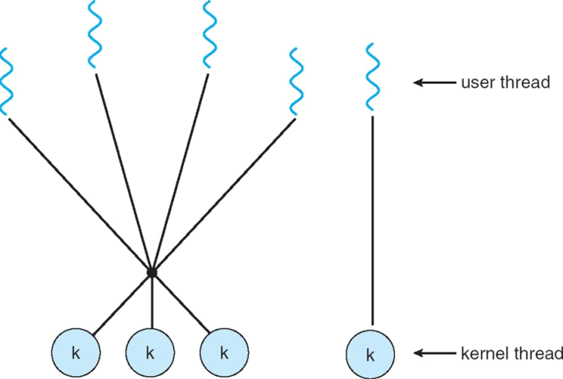

Thread Libraries
  - Thread library provides programmer with API for creating and managing threads
  - Two primary ways of implementing
  - Library entirely in user space

Threading Issues
  - Semantics of fork() and exec() system calls
  - Thread cancellation of target thread
  - Asynchronous or deferred
  - Signal handling
  - Thread pools
  - Thread-specific data
  - Scheduler activations

Thread Cancellation
  - Terminating a thread before it has finished
  - Two general approaches:
  - Asynchronous cancellation terminates the target thread immediately
  - Deferred cancellation allows the target thread to periodically check if it should be cancelled

CPU Scheduling
  - To introduce CPU scheduling, which is the basis for multiprogrammed operating systems
  - To describe various CPU-scheduling algorithms
  - To discuss evaluation criteria for selecting a CPU-scheduling algorithm for a particular system
  - Maximum CPU utilization obtained with multiprogramming
  - CPU–I/O Burst Cycle – Process execution consists of a cycle of CPU execution and I/O wait
  - CPU burst distribution

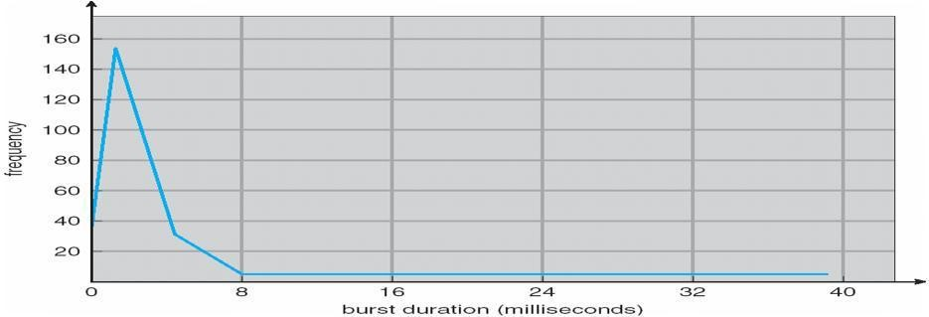
Histogram of CPU-burst Times

Alternating Sequence of CPU And I/O Bursts
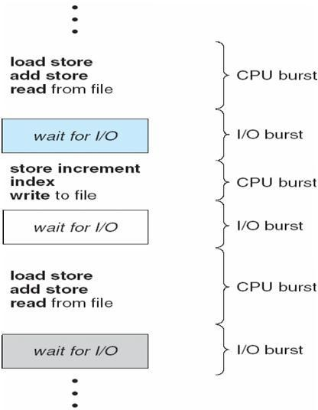

CPU Scheduler
Selects from among the processes in memory that are ready to execute, and allocates the CPU to one of them
CPU scheduling decisions may take place when a process:
- Switches from running to waiting state
- Switches from running to ready state
- Switches from waiting to ready
- Terminates

Scheduling under 1 and 4 is non preemptive All other scheduling is preemptive Dispatcher
  - Dispatcher module gives control of the CPU to the process selected by the short-term scheduler; this involves:
  - switching context
  - switching to user mode
  - jumping to the proper location in the user program to restart that program
  - Dispatch latency – time it takes for the dispatcher to stop one process and start another running

Scheduling Criteria
  - CPU utilization – keep the CPU as busy as possible
  - Throughput – # of processes that complete their execution per time unit
  - Turnaround time – amount of time to execute a particular process
  - Waiting time – amount of time a process has been waiting in the ready queue
  - Response time – amount of time it takes from when a request was submitted until the first response is produced, not output (for time-sharing environment)
  - Max CPU utilization
  - Max throughput
  - Min turnaround time

  - Min waiting time
  - Min response time

First-Come, First-Served (FCFS) Scheduling

Process | Burst Time
P1 | 24
P2 | 3
P3 | 3

Suppose that the processes arrive in the order: P1 , P2 , P3
The Gantt Chart for the schedule is:

P1 | P2 | P3

0 24 27 30
Waiting time for P1 = 0; P2 = 24; P3 = 27 Average waiting time: (0 + 24 + 27)/3 = 17 Suppose that the processes arrive in the order
P2 , P3 , P1
The Gantt chart for the schedule is:nnnn Waiting time for P1 = 6; P2 = 0; P3 = 3nAverage waiting time: (6
+ 0 + 3)/3 = 3
Much better than previous case
Convoy effect short process behind long process

P2 | P3 | P1

0 3 6 30

Shortest-Job-First (SJF) Scheduling

  - Associate with each process the length of its next CPU burst. Use these lengths to schedule the process with the shortest time
  - SJF is optimal – gives minimum average waiting time for a given set of processes The difficulty is knowing

Process | Arrival Time | Burst Time
P1 | 0.0 | 0.0
P2 | 2.0 | 2.0
P3 | 4.0 | 4.0
P4 | 5.0 | 5.0

Process | Arrival Time | Burst Time
P1 | 0.0 | 6
P2 | 2.0 | 8
P3 | 4.0 | 7
P4 | 5.0 | 3

SJF scheduling chart
average waiting time = (3 + 16 + 9 + 0) / 4 = 7the length of the next CPU request

0 3 9 16 24
P | P1 | P3 | P2
4

tn = actual length of nth CPU burst
- τn+1 = predicted value for the next CPU burst
- α, 0 ≤ α ≤ 1

Define :

Determining Length of Next CPU Burst
  - Can only estimate the length
  - Can be done by using the length of previous CPU bursts, using exponential averaging

Prediction of the Length of the Next CPU Burst
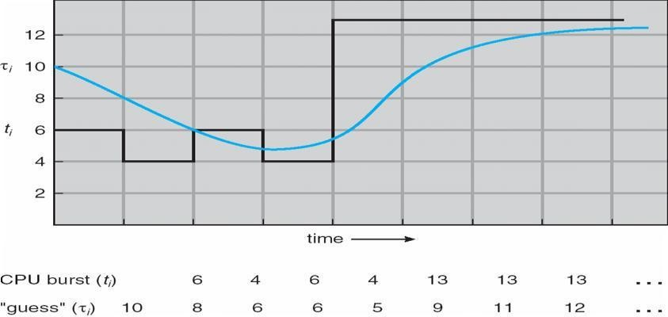

Examples of Exponential Averaging a =0
tn+1 = tn
Recent history does not count a =1

tn+1 = a tn
Only the actual last CPU burst counts If we expand the formula, we get:
tn+1 = a tn+(1 - a)a tn -1 + …
+(1 - a )j a tn -j + …
+(1 - a )n +1 t0
Since both a and (1 - a) are less than or equal to 1, each successive term has less weight than its predecessor

Priority Scheduling
  - A priority number (integer) is associated with each process
  - The CPU is allocated to the process with the highest priority (smallest integer º highest priority)
  - Preemptive
  - nonpreemptive
  - SJF is a priority scheduling where priority is the predicted next CPU burst time
  - Problem º Starvation – low priority processes may never execute
  - Solution º Aging – as time progresses increase the priority of the process

Round Robin (RR)
  - Each process gets a small unit of CPU time (time quantum), usually 10-100 milliseconds. After this time has elapsed, the process is preempted and added to the end of the ready queue.
  - If there are n processes in the ready queue and the time quantum is q, then each process gets 1/n of the CPU time in chunks of at most q time units at once. No process waits more than (n-1)q time units.
  - Performance
  - q large Þ FIFO
  - q small Þ q must be large with respect to context switch, otherwise overhead is too high

Example of RR with Time Quantum = 4
Process | Burst Time
P1 | 24
P2 | 3
P3 | 3

The Gantt chart is:

P1 | P2 | P3 | P1 | P1 | P1 | P1 | P1

0 4 7 10 14 18 22 26 30

Typically, higher average turnaround than SJF, but better response

Time Quantum and Context Switch Time

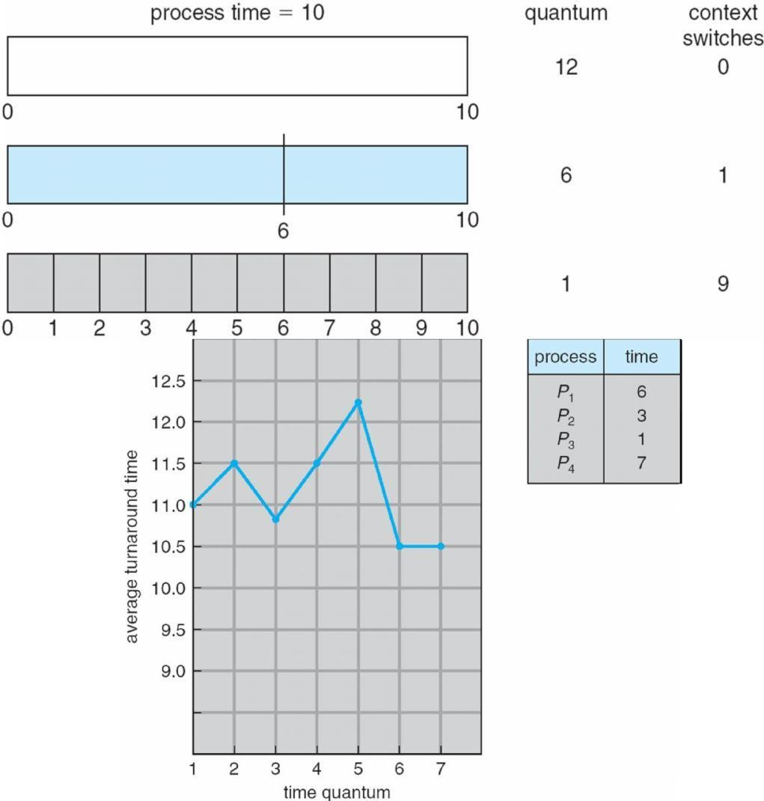

Turnaround Time Varies With The Time Quantum

Multilevel Queue
  - Ready queue is partitioned into separate queues: foreground (interactive)
background (batch)
  - Each queue has its own scheduling algorithm
  - foreground – RR
  - background – FCFS
  - Scheduling must be done between the queues
  - Fixed priority scheduling; (i.e., serve all from foreground then from background). Possibility of starvation.
  - Time slice – each queue gets a certain amount of CPU time which it can schedule amongst its processes; i.e., 80% to foreground in RR
20% to background in FCFS

Multilevel Queue Scheduling
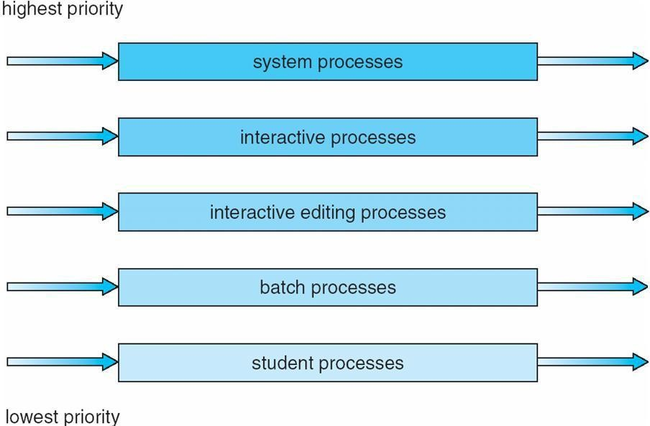

Multilevel Feedback Queue
  - A process can move between the various queues; aging can be implemented this way
  - Multilevel-feedback-queue scheduler defined by the following parameters:
  - number of queues
  - scheduling algorithms for each queue
  - method used to determine when to upgrade a process
  - method used to determine when to demote a process
method used to determine which queue a process will enter when that process needs service

Example of Multilevel Feedback Queue
Three queues:
  - Q0 – RR with time quantum 8 milliseconds
  - Q1 – RR time quantum 16 milliseconds
  - Q2 – FCFS
  - Scheduling
  - A new job enters queue Q0 which is served FCFS. When it gains CPU, job receives 8 milliseconds. If it does not finish in 8 milliseconds, job is moved to queue Q1.
  - At Q1 job is again served FCFS and receives 16 additional milliseconds. If it still does not complete, it is preempted and moved to queue Q2.

Multilevel Feedback Queues

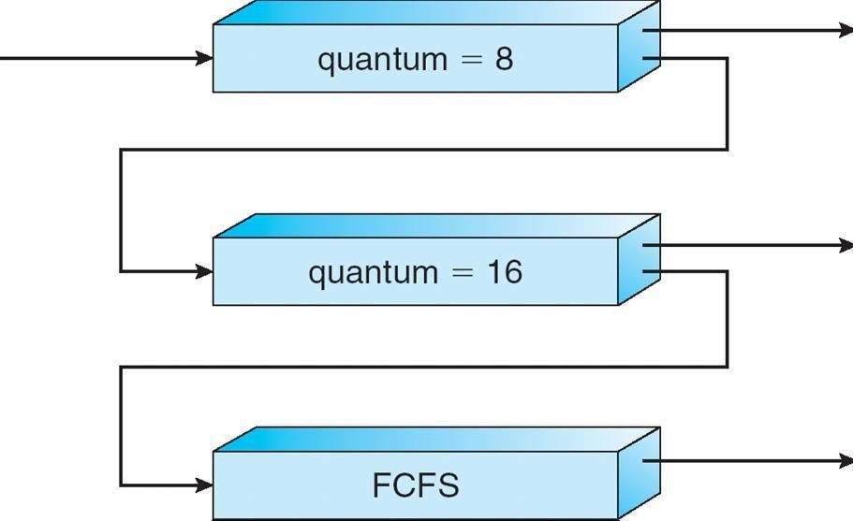
Thread Scheduling
  - Distinction between user-level and kernel-level threads
  - Many-to-one and many-to-many models, thread library schedules user-level threads to run on LWP
  - Known as process-contention scope (PCS) since scheduling competition is within the process
  - Kernel thread scheduled onto available CPU is system-contention scope (SCS) – competition among all threads in system

Multiple-Processor Scheduling
  - CPU scheduling more complex when multiple CPUs are available
  - Homogeneous processors within a multiprocessor
  - Asymmetric multiprocessing – only one processor accesses the system data structures, alleviating the need for data sharing
  - Symmetric multiprocessing (SMP) – each processor is self-scheduling, all processes in common ready queue, or each has its own private queue of ready processes
  - Processor affinity – process has affinity for processor on which it is currently running
  - soft affinity
  - hard affinity

NUMA and CPU Scheduling
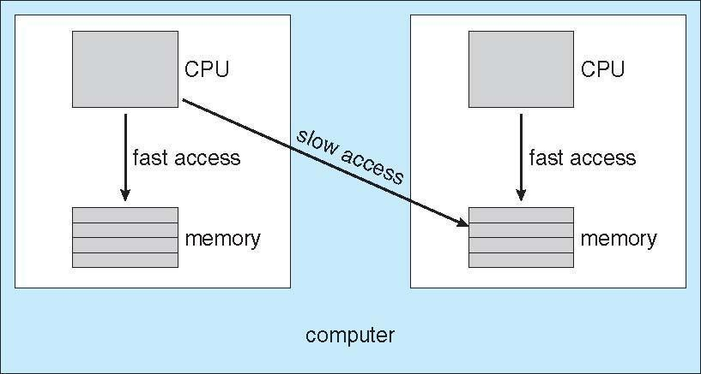

Multicore Processors
  - Recent trend to place multiple processor cores on same physical chip
  - Faster and consume less power
  - Multiple threads per core also growing
  - Takes advantage of memory stall to make progress on another thread while memory retrieve happens

Operating System Examples
  - Solaris scheduling
  - Windows XP scheduling
  - Linux scheduling

Linux Scheduling
  - Constant order O(1) scheduling time
  - Two priority ranges: time-sharing and real-time
  - Real-time range from 0 to 99 and nice value from 100 to 140

Priorities and Time-slice length
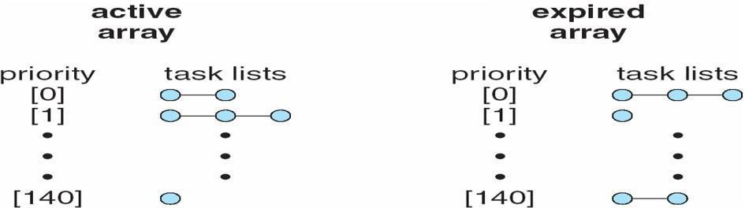

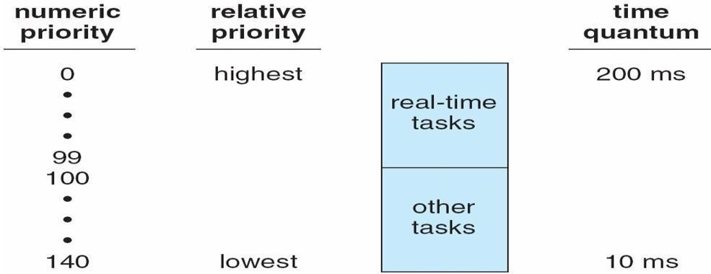
List of Tasks Indexed According to Priorities

Algorithm Evaluation
  - Deterministic modeling – takes a particular predetermined workload and defines the performance of each algorithm for that workload
  - Queueing models
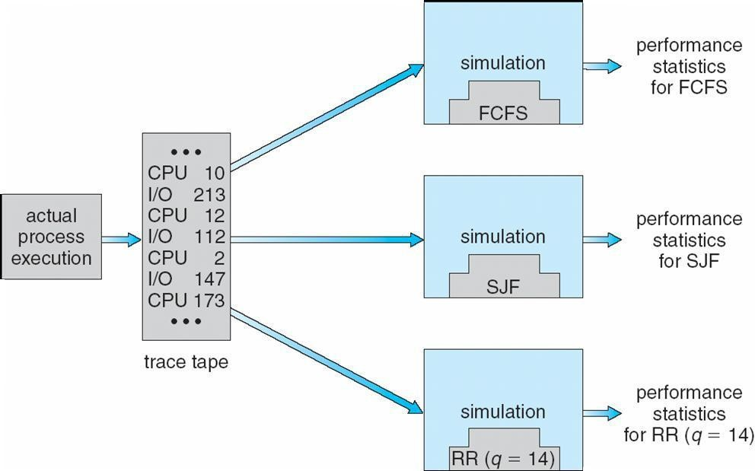
  - Implementation

Evaluation of CPU schedulers by Simulation

Process Synchronization
  - To introduce the critical-section problem, whose solutions can be used to ensure the consistency of shared data
  - To present both software and hardware solutions of the critical-section problem
  - To introduce the concept of an atomic transaction and describe mechanisms to ensure atomicity
  - Concurrent access to shared data may result in data inconsistency
  - Maintaining data consistency requires mechanisms to ensure the orderly execution of cooperating processes
  - Suppose that we wanted to provide a solution to the consumer-producer problem that fills all the buffers. We can do so by having an integer count that keeps track of the number of full buffers. Initially, count is set to 0. It is incremented by the producer after it produces a new buffer and is decremented by the consumer after it consumes a buffer
Producer
while (true) {

/* produce an item and put in nextProduced */ while (count == BUFFER_SIZE)
; // do nothing
buffer [in] = nextProduced;
in = (in + 1) % BUFFER_SIZE; count++;
}

Consumer
while (true) {
while (count == 0)
; // do nothing
nextConsumed = buffer[out]; out = (out + 1) %
BUFFER_SIZE; count--;
/* consume the item in nextConsumed
}

Race Condition
count++ could be implemented as

register1 = count register1 = register1 + 1 count = register1
count-- could be implemented as

register2 = count register2 = register2 - 1 count = register2
Consider this execution interleaving with ―count = 5‖ initially:
S0: producer execute register1 = count | {register1 = 5}
S1: producer execute register1 = register1 + 1 |  | {register1 = 6}
S2: consumer execute register2 = count | {register2 = 5}
S3: consumer execute register2 = register2 - 1 |  | {register2 = 4}
S4: producer execute count = register1 | {count = 6 }
S5: consumer execute count = register2 | {count = 4}

Solution to Critical-Section Problem
- Mutual Exclusion - If process Pi is executing in its critical section, then no other processes can be executing in their critical sections
- Progress - If no process is executing in its critical section and there exist some processes that wish to enter their critical section, then the selection of the processes that will enter the critical section next cannot be postponed indefinitely

- Bounded Waiting - A bound must exist on the number of times that other processes are allowed to enter their critical sections after a process has made a request to enter its critical section and before that request is granted

  - Assume that each process executes at a nonzero speed
  - No assumption concerning relative speed of the N processes

Peterson’s Solution
  - Two process solution
  - Assume that the LOAD and STORE instructions are atomic; that is, cannot be interrupted.
  - The two processes share two variables:
  - int turn;
  - Boolean flag[2]
  - The variable turn indicates whose turn it is to enter the critical section.
  - The flag array is used to indicate if a process is ready to enter the critical section. flag[i] = true implies that process Pi is ready!

Algorithm for Process Pi
do {
flag[i] = TRUE; turn = j;
while (flag[j] && turn == j); critical section
flag[i] = FALSE; remainder section
} while (TRUE);

Synchronization Hardware

  - Many systems provide hardware support for critical section code
  - Uniprocessors – could disable interrupts
  - Currently running code would execute without preemption
  - Generally too inefficient on multiprocessor systems Operating systems using this not broadly scalable
  - Modern machines provide special atomic hardware instructions Atomic = non-interruptable
  - Either test memory word and set value Or swap contents of two memory words

Solution to Critical-section Problem Using Locks
do {
acquire lock critical section
release lock remainder section
} while (TRUE);

TestAndSet Instruction
Definition:
boolean TestAndSet (boolean *target)
{
boolean rv = *target;
*target = TRUE; return rv:
}

Solution using TestAndSet
Shared boolean variable lock., initialized to false. Solution:
do {
while ( TestAndSet (&lock ))
; // do nothing
// critical section lock = FALSE;
// remainder section
} while (TRUE);

Swap Instruction
Definition:
void Swap (boolean *a, boolean *b)
{
boolean temp =
*a; *a = *b;
*b = temp:
}

Solution using Swap
Shared Boolean variable lock initialized to FALSE; Each process has a local Boolean variable key
Solution:
do {
key = TRUE;
while ( key == TRUE) Swap (&lock, &key );

// critical section lock = FALSE;
// remainder section
} while (TRUE);

Bounded-waiting Mutual Exclusion with TestandSet() do {
waiting[i] = TRUE; key = TRUE;
while (waiting[i] && key) key = TestAndSet(&lock); waiting[i] = FALSE;
// critical section j = (i + 1) % n;
while ((j != i) && !waiting[j]) j = (j + 1) % n;
if (j == i)
lock = FALSE; else
waiting[j] = FALSE;
// remainder section } while (TRUE);

Semaphore
  - Synchronization tool that does not require busy waiting nSemaphore S – integer variable
  - Two standard operations modify S: wait() and signal()
  - Originally called P() and V()
  - Less complicated
  - Can only be accessed via two indivisible (atomic) operations wait (S) {
while S <= 0
; // no-op S--;
}
signal (S)
{ S++;
}

Semaphore as General Synchronization Tool
  - Counting semaphore – integer value can range over an unrestricted domain
  - Binary semaphore – integer value can range only between 0 and 1; can be simpler to implement
  - Also known as mutex locksnCan implement a counting semaphore S as a binary semaphore
  - Provides mutual exclusionSemaphore mutex; // initialized to do {
wait (mutex);

// Critical Section signal (mutex);

} while (TRUE);

// remainder section

Semaphore Implementation
  - Must guarantee that no two processes can execute wait () and signal () on the same semaphore at the same time
  - Thus, implementation becomes the critical section problem where the wait and signal code are placed in the crtical section.

  - Could now have busy waiting in critical section implementation But implementation code is short
Little busy waiting if critical section rarely occupied
  - Note that applications may spend lots of time in critical sections and therefore this is not a good solution.

Semaphore Implementation with no Busy waiting
  - With each semaphore there is an associated waiting queue. Each entry in a waiting queue has two data items:
  - value (of type integer)
  - pointer to next record in the list
  - Two operations:
  - block – place the process invoking the operation on the appropriate waiting queue.
  - wakeup – remove one of processes in the waiting queue and place it in the ready queue.

Implementation of wait: wait(semaphore *S) {
S->value--;
if (S->value < 0) {
add this process to S-
>list; block();
}
}
Implementation of signal: signal(semaphore *S) {
S->value++;
if (S->value <= 0) {
remove a process P from S-
>list; wakeup(P);
}
}

Deadlock and Starvation
  - Deadlock – two or more processes are waiting indefinitely for an event that can be caused by only one of the waiting processes
  - Let S and Q be two semaphores initialized to 1

P1 | P0
wait (Q); | wait (S);
wait (S); | wait (Q);
 | .
 | .
 | .
signal (Q); | signal (S);
signal (S); | signal (Q);

Starvation – indefinite blocking. A process may never be removed from the semaphore queue in which it is suspended
  - Priority Inversion - Scheduling problem when lower-priority process holds a lock needed by higher-priority process

Classical Problems of Synchronization
  - Bounded-Buffer Problem
  - Readers and Writers Problem
  - Dining-Philosophers Problem

Bounded-Buffer Problem
  - N buffers, each can hold one item
  - Semaphore mutex initialized to the value 1
  - Semaphore full initialized to the value 0
  - Semaphore empty initialized to the value N.
  - The structure of the producer process
do { // produce an item in nextp wait (empty);

wait (mutex);
// add the item to the buffer signal (mutex);
signal (full);
} while (TRUE);
The structure of the consumer process do { wait (full);
wait (mutex);
// remove an item from buffer to nextc
signal (mutex); signal (empty);

// consume the item in nextc } while (TRUE);

Readers-Writers Problem
A data set is shared among a number of concurrent processes
  - Readers – only read the data set; they do not perform any updates
  - Writers – can both read and writenProblem – allow multiple readers to read at the same time. Only one single writer can access the shared data at the same time
  - Shared Data
  - Data set
  - Semaphore mutex initialized to 1
  - Semaphore wrt initialized to 1
  - Integer readcount initialized to 0 The structure of a writer process

do { wait (wrt) ;

// writing is performed signal (wrt) ;
} while (TRUE);

The structure of a reader process do {
wait (mutex) ; readcount ++ ;
if (readcount == 1) wait (wrt) ; signal (mutex)

// reading is performed wait (mutex) ; readcount - - ;
if (readcount == 0) signal (wrt) ; signal (mutex)
; } while (TRUE);

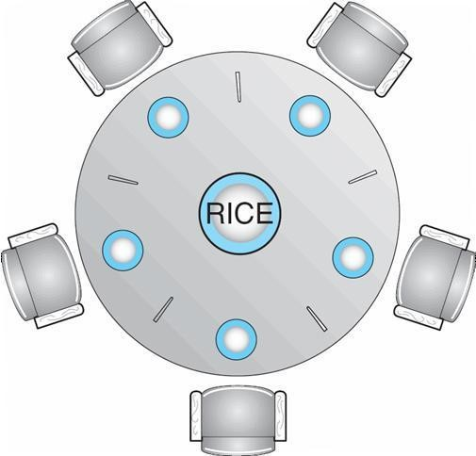
Dining-Philosophers Problem

  - Shared data
  - Bowl of rice (data set)
  - Semaphore chopstick [5] initialized to 1
  - The structure of Philosopher i: do {

wait ( chopstick[i] );

wait ( chopStick[ (i + 1) % 5] );

// eat
signal ( chopstick[i] );
signal (chopstick[ (i + 1) % 5] );

// think
} while (TRUE);

Problems with Semaphores Incorrect use of semaphore operations: l signal (mutex)
….
wait (mutex)

wait (mutex) … wait (mutex)

Omitting of wait (mutex) or signal (mutex) (or both)

Monitors
A high-level abstraction that provides a convenient and effective mechanism for process synchronization Only one process may be active within the monitor at a time
monitor monitor-name
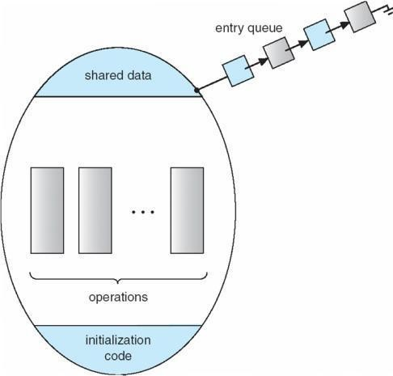
{
// shared variable declarations procedure P1 (…) { …. }
…
procedure Pn (…) {……} Initialization code ( ….) { … }
…
}
}

Schematic view of a Monitor Condition Variables
condition x, y;
Two operations on a condition variable:
x.wait () – a process that invokes the operation is suspended.
x.signal () – resumes one of processes (if any) that invoked x.wait ()

Monitor with Condition Variables

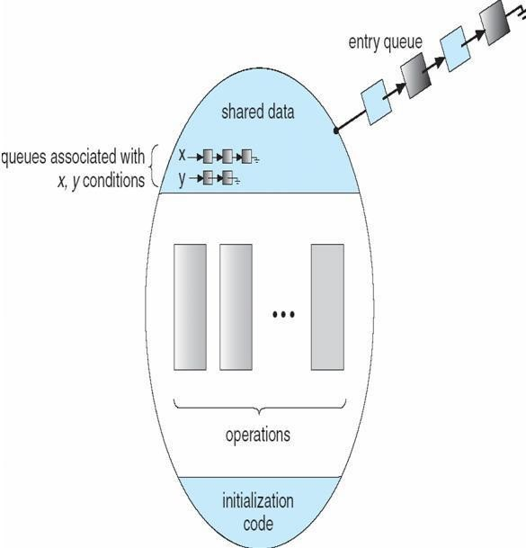

Solution to Dining Philosophers

monitor DP
{
enum { THINKING; HUNGRY, EATING) state [5] ;
condition self [5]; void pickup (int i) {

state[i] = HUNGRY; test(i);
if (state[i] != EATING) self [i].wait;
}

void putdown (int i) { state[i] = THINKING;
// test left and right neighbors test((i + 4) % 5);
test((i + 1) % 5);
}

void test (int i) {
if ( (state[(i + 4) % 5] != EATING)
&& (state[i] == HUNGRY) && (state[(i + 1) % 5] != EATING) )
{ state[i] = EATING ;
self[i].signal () ;
}
}
initialization_code() {
for (int i = 0; i < 5; i++) state[i] = THINKING;
}
}

Each philosopher I invokes the operations pickup() and putdown() in the following sequence:
DiningPhilosophters.pickup (i);
EAT
DiningPhilosophers.putdown (i);

Monitor Implementation Using Semaphores

Variables

semaphore mutex; // (initially = 1) semaphore next; // (initially = 0)
int next-count = 0;nEach procedure F will be replaced by wait(mutex);
… body of F;
…
if (next_count > 0) signal(next) else
signal(mutex);nMutual exclusion within a monitor is ensured.

Monitor Implementation
For each condition variable x, we have:
semaphore x_sem; // (initially = 0)
int x-count = 0;nThe operation x.wait can be implemented as:

x-count++;
if (next_count > 0) signal(next);
else
signal(mutex);
wait(x_sem); x-count--;

The operation x.signal can be implemented
as: if (x-count > 0) {
next_count++; signal(x_sem); wait(next); next_count--;
}

A Monitor to Allocate Single Resource
monitor ResourceAllocator
{
boolean busy; condition x;
void acquire(int time)
{ if (busy)
x.wait(time); busy = TRUE;
}
void release() {
busy = FALSE; x.signal();

initialization code() {

}
}

busy = FALSE;
}

Synchronization Examples
- Solaris
- Windows XP
- Linux
- Pthreads

Solaris Synchronization
- Implements a variety of locks to support multitasking, multithreading (including real-time threads), and multiprocessing
- Uses adaptive mutexes for efficiency when protecting data from short code segments
- Uses condition variables and readers-writers locks when longer sections of code need access to data

- Uses turnstiles to order the list of threads waiting to acquire either an adaptive mutex or reader-writer lock

Windows XP Synchronization
- Uses interrupt masks to protect access to global resources on uniprocessor systems
- Uses spinlocks on multiprocessor systems
- Also provides dispatcher objects which may act as either mutexes and semaphores
- Dispatcher objects may also provide events
- An event acts much like a condition variable

Linux Synchronization
- Linux:lPrior to kernel Version 2.6, disables interrupts to implement short critical sections
- Version 2.6 and later, fully preemptive
- Linux provides:
- semaphores
- spin locks

Pthreads Synchronization
- Pthreads API is OS-independent
- It provides:
- mutex locks
- condition variablesnNon-portable extensions include:
- read-write locks
- spin locks

Atomic Transactions
- System Model
- Log-based Recovery
- Checkpoints
- Concurrent Atomic Transactions

System Model
- Assures that operations happen as a single logical unit of work, in its entirety, or not at all
- Related to field of database systems
- Challenge is assuring atomicity despite computer system failures
- Transaction - collection of instructions or operations that performs single logical function
- Here we are concerned with changes to stable storage – disk
- Transaction is series of read and write operations
- Terminated by commit (transaction successful) or abort (transaction failed) operation Aborted transaction must be rolled back to undo any changes it performed

Types of Storage Media
- Volatile storage – information stored here does not survive system crashes
- Example: main memory, cache
- Nonvolatile storage – Information usually survives crashes
- Example: disk and tape
- Stable storage – Information never lost
- Not actually possible, so approximated via replication or RAID to devices with independent failure modes

- Goal is to assure transaction atomicity where failures cause loss of information on volatile storage

Log-Based Recovery
- Record to stable storage information about all modifications by a transaction
- Most common is write-ahead logging
- Log on stable storage, each log record describes single transaction write operation, including Transaction name
Data item name Old value
New value
- <Ti starts> written to log when transaction Ti starts
- <Ti commits> written when Ti commits
- Log entry must reach stable storage before operation on data occurs

Log-Based Recovery Algorithm
Using the log, system can handle any volatile memory errors
- Undo(Ti) restores value of all data updated by Ti
- Redo(Ti) sets values of all data in transaction Ti to new values
- Undo(Ti) and redo(Ti) must be idempotent
- Multiple executions must have the same result as one execution
- If system fails, restore state of all updated data via log
- If log contains <Ti starts> without <Ti commits>, undo(Ti)
- If log contains <Ti starts> and <Ti commits>, redo(Ti)

Checkpoints
Log could become long, and recovery could take long Checkpoints shorten log and recovery time.
Checkpoint scheme:
1.Output all log records currently in volatile storage to stable storage 2.Output all modified data from volatile to stable storage
3.Output a log record <checkpoint> to the log on stable storage
Now recovery only includes Ti, such that Ti started executing before the most recent checkpoint, and all transactions after Ti All other transactions already on stable storage

Concurrent Transactions
- Must be equivalent to serial execution – serializability
- Could perform all transactions in critical section
- Inefficient, too restrictive
- Concurrency-control algorithms provide serializability

Serializability

- Consider two data items A and B
- Consider Transactions T0 and T1
- Execute T0, T1 atomically

- Execution sequence called schedule
- Atomically executed transaction order called serial schedule
- For N transactions, there are N! valid serial schedules

Schedule 1: T0 then T1
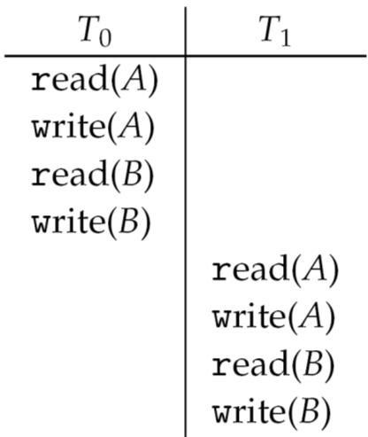

Nonserial Schedule
- Nonserial schedule allows
•
•
•
•
•

- overlapped execute
- Resulting execution not necessarily incorrect
- Consider schedule S, operations Oi, Oj
- Conflict if access same data item, with at least one write
- If Oi, Oj consecutive and operations of different transactions & Oi and Oj don’t conflict
- Then S’ with swapped order Oj Oi equivalent to S
- If S can become S’ via swapping nonconflicting operations
- S is conflict serializable

Schedule 2: Concurrent Serializable Schedule
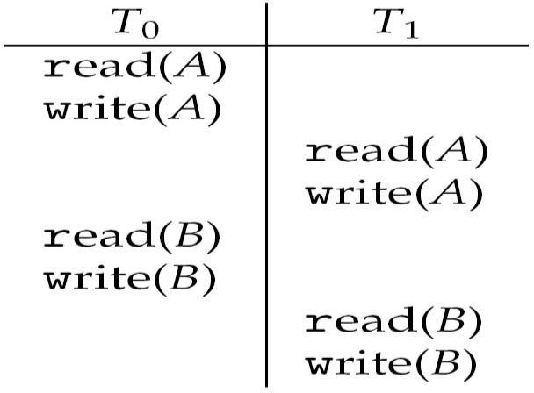

Locking Protocol
- Ensure serializability by associating lock with each data item
- Follow locking protocol for access control

- Locks
- Shared – Ti has shared-mode lock (S) on item Q, Ti can read Q but not write Q
- Exclusive – Ti has exclusive-mode lock (X) on Q, Ti can read and write Q
- Require every transaction on item Q acquire appropriate lock
- If lock already held, new request may have to wait
- Similar to readers-writers algorithm

Two-phase Locking Protocol
- Generally ensures conflict serializability
- Each transaction issues lock and unlock requests in two phases
- Growing – obtaining locks
- Shrinking – releasing locks
- Does not prevent deadlock

Timestamp-based Protocols
- Select order among transactions in advance – timestamp-ordering
- Transaction Ti associated with timestamp TS(Ti) before Ti starts
- TS(Ti) < TS(Tj) if Ti entered system before Tj
- TS can be generated from system clock or as logical counter incremented at each entry of transaction
- Timestamps determine serializability order
- If TS(Ti) < TS(Tj), system must ensure produced schedule equivalent to serial schedule where Ti appears before Tj

Timestamp-based Protocol Implementation
- Data item Q gets two timestamps
- W-timestamp(Q) – largest timestamp of any transaction that executed write(Q) successfully
- R-timestamp(Q) – largest timestamp of successful read(Q)
- Updated whenever read(Q) or write(Q) executed
- Timestamp-ordering protocol assures any conflicting read and write executed in timestamp order Suppose Ti executes read(Q)

- If TS(Ti) < W-timestamp(Q), Ti needs to read value of Q that was already overwritten read operation rejected and Ti rolled back
- If TS(Ti) ≥ W-timestamp(Q)
read executed, R-timestamp(Q) set to max(R-timestamp(Q), TS(Ti))

Timestamp-ordering Protocol
Supose Ti executes write(Q)
If TS(Ti) < R-timestamp(Q), value Q produced by Ti was needed previously and Ti assumed it
would never be produced
Write operation rejected, Ti rolled back
If TS(Ti) < W-tiimestamp(Q), Ti attempting to write obsolete value of Q Write operation rejected and Ti rolled back
Otherwise, write executed
Any rolled back transaction Ti is assigned new timestamp and restarted

Algorithm ensures conflict serializability and freedom from deadlock

Schedule Possible Under Timestamp Protocol

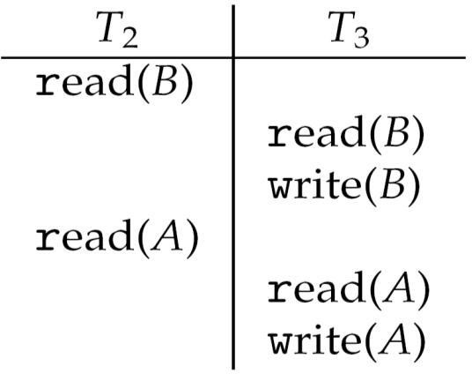

UNIT – III
Memory Management

- To provide a detailed description of various ways of organizing memory hardware
- To discuss various memory-management techniques, including paging and segmentation
- To provide a detailed description of the Intel Pentium, which supports both pure segmentation and segmentation with paging
- Program must be brought (from disk) into memory and placed within a process for it to be run
- Main memory and registers are only storage CPU can access directly
- Register access in one CPU clock (or less)
- Main memory can take many cycles
- Cache sits between main memory and CPU registers
- Protection of memory required to ensure correct operation

Base and Limit Registers
A pair of base and limit registers define the logical address space
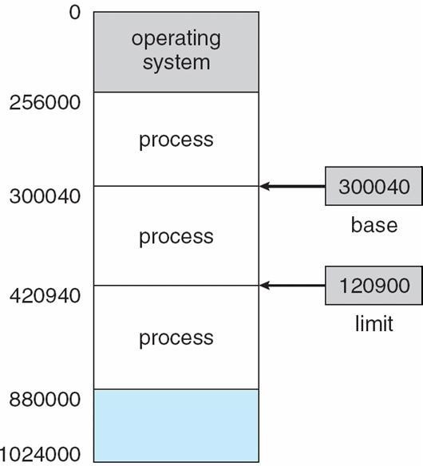

Binding of Instructions and Data to Memory

- Address binding of instructions and data to memory addresses can happen at three different stages
- Compile time: If memory location known a priori, absolute code can be generated; must recompile code if starting location changes
- Load time: Must generate relocatable code if memory location is not known at compile time
- Execution time: Binding delayed until run time if the process can be moved during its execution from one memory segment to another. Need hardware support for address maps (e.g., base and limit registers)

Multistep Processing of a User Program
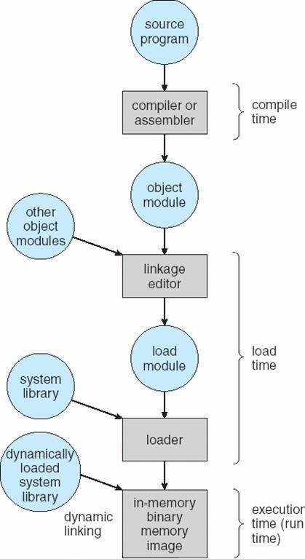

Logical vs. Physical Address Space
- The concept of a logical address space that is bound to a separate physical address space is central to proper memory management
- Logical address – generated by the CPU; also referred to as virtual address
- Physical address – address seen by the memory unit
- Logical and physical addresses are the same in compile-time and load-time address-binding schemes; logical (virtual) and physical addresses differ in execution-time address-binding scheme

Memory-Management Unit (MMU)
- Hardware device that maps virtual to physical address
- In MMU scheme, the value in the relocation register is added to every address generated by a user process at the time it is sent to memory
- The user program deals with logical addresses; it never sees the real physical addresses

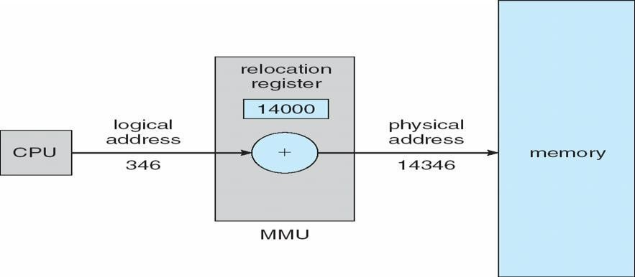
Dynamic relocation using a relocation register

Dynamic Loading
- Routine is not loaded until it is called
- Better memory-space utilization; unused routine is never loaded

- Useful when large amounts of code are needed to handle infrequently occurring cases
- No special support from the operating system is required implemented through program design

Dynamic Linking
- Linking postponed until execution time
- Small piece of code, stub, used to locate the appropriate memory-resident library routine
- Stub replaces itself with the address of the routine, and executes the routine
- Operating system needed to check if routine is in processes’ memory address
- Dynamic linking is particularly useful for libraries
- System also known as shared libraries

Swapping
A process can be swapped temporarily out of memory to a backing store, and then brought back into memory for continued execution Backing store – fast disk large enough to accommodate copies of all memory images for all users; must provide direct access to these memory images Roll out, roll in –swapping variant used for priority-based scheduling algorithms; lower-priority process is swapped out so higher-priority process can be loaded and executed Major part of swap time is transfer time; total transfer time is directly proportional to the amount of memory swapped Modified versions of swapping are found on many systems (i.e., UNIX, Linux, and Windows)
System maintains a ready queue of ready-to-run processes which have memory images on disk

Schematic View of Swapping
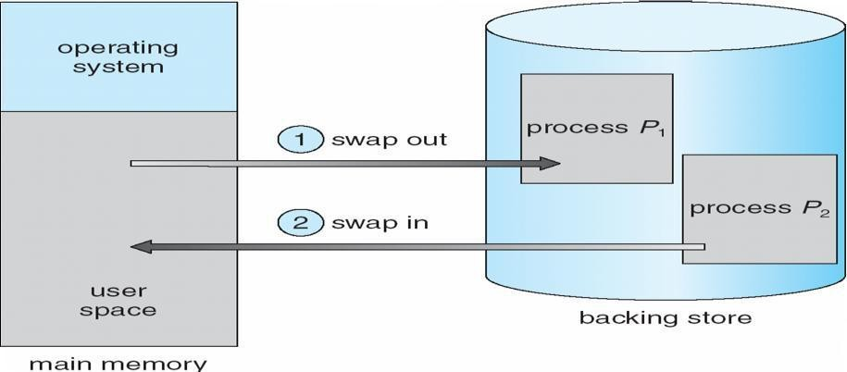

Contiguous Allocation

- Main memory usually into two partitions:
- Resident operating system, usually held in low memory with interrupt vector
- User processes then held in high memory Relocation registers used to protect user processes from each other, and from changing operating-system code and data
- Base register contains value of smallest physical address
- Limit register contains range of logical addresses – each logical address must be less than the limit register
- MMU maps logical address dynamically

Hardware Support for Relocation and Limit Registers
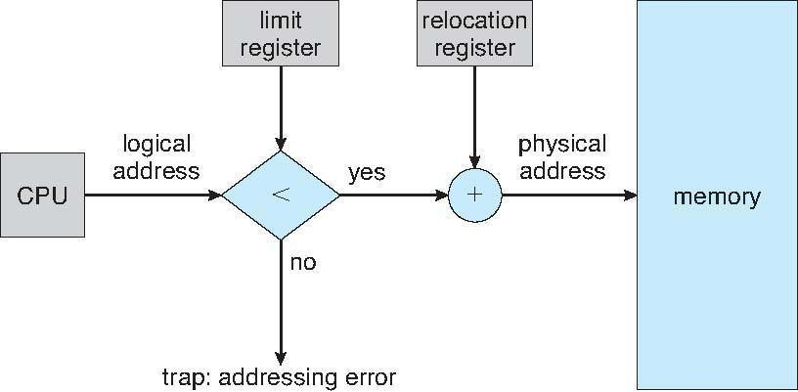

- Multiple-partition allocation
- Hole – block of available memory; holes of various size are scattered throughout memory
- When a process arrives, it is allocated memory from a hole large enough to accommodate it
- Operating system maintains information about:
- a) allocated partitions b) free partitions (hole)

OS
process 5
process 8
process 2

OS
process 5
process 2

OS
process 5
process 9
process 2

OS
process 5
process 9
process 10
process 2

Dynamic Storage-Allocation Problem
- First-fit: Allocate the first hole that is big enough
- Best-fit: Allocate the smallest hole that is big enough; must search entire list, unless ordered by size Produces the smallest leftover hole
- Worst-fit: Allocate the largest hole; must also search entire list
- Produces the largest leftover hole
- First-fit and best-fit better than worst-fit in terms of speed and storage utilization

Fragmentation
- External Fragmentation – total memory space exists to satisfy a request, but it is not contiguous
- Internal Fragmentation – allocated memory may be slightly larger than requested memory; this size difference is memory internal to a partition, but not being used
- Reduce external fragmentation by compaction
- Shuffle memory contents to place all free memory together in one large block
- Compaction is possible only if relocation is dynamic, and is done at execution time.

- I/O problem
Latch job in memory while it is involved in I/O Do I/O only into OS buffers

Paging
- Logical address space of a process can be noncontiguous; process is allocated physical memory whenever the latter is available
- Divide physical memory into fixed-sized blocks called frames (size is power of 2, between 512 bytes and 8,192 bytes)
- Divide logical memory into blocks of same size called pages Keep track of all free frames
- To run a program of size n pages, need to find n free frames and load program
- Set up a page table to translate logical to physical addresses
- Internal fragmentation

Address Translation Scheme
- Address generated by CPU is divided into
- Page number (p) – used as an index into a page table which contains base address of each page in physical memory
- Page offset (d) – combined with base address to define the physical memory address that is sent to the memory unit
- For given logical address space 2m and page size 2n

Paging Hardware
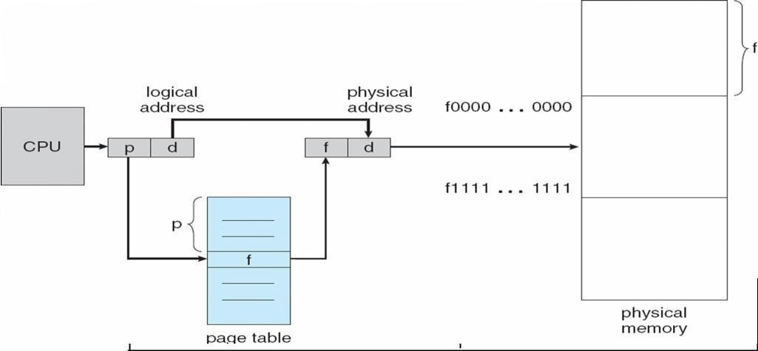
page number
p
page offset
d
m - n n

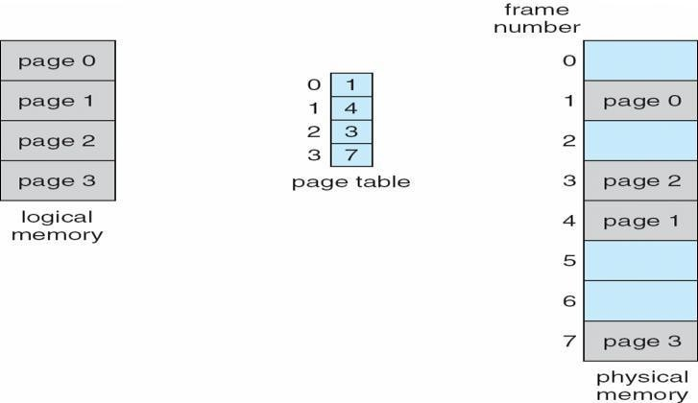
Paging Model of Logical and Physical Memory

Paging Example
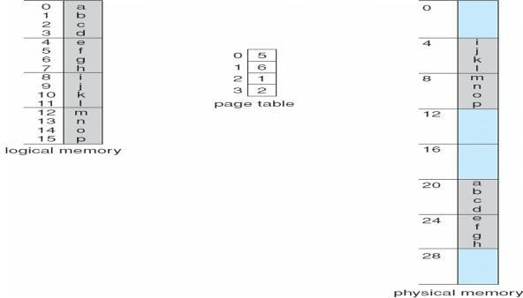
32-byte memory and 4-byte pages

Free Frames

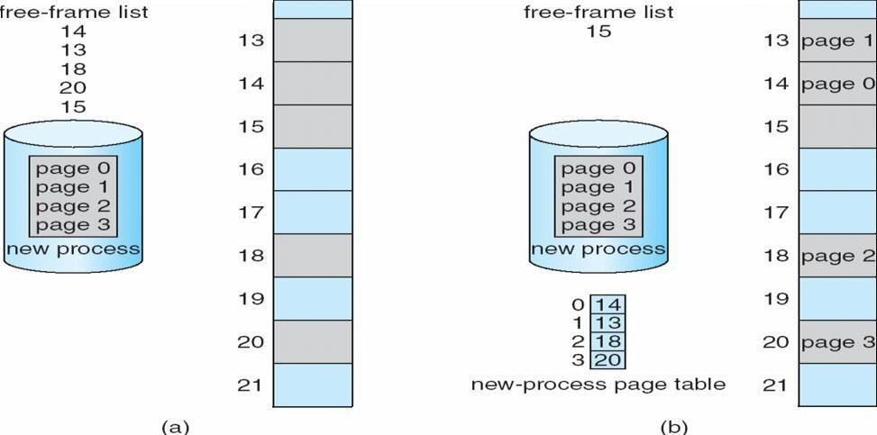

Implementation of Page Table
- Page table is kept in main memory
- Page-table base register (PTBR) points to the page table
- Page-table length register (PRLR) indicates size of the page table
- In this scheme every data/instruction access requires two memory accesses. One for the page table and one for the data/instruction.
- The two memory access problem can be solved by the use of a special fast-lookup hardware cache called associative memory or translation look-aside buffers (TLBs)
- Some TLBs store address-space identifiers (ASIDs) in each TLB entry – uniquely identifies each process to provide address-space protection for that process

Associative Memory
- Associative memory – parallel search
- Address translation (p, d)
- If p is in associative register, get frame # out

- Otherwise get frame # from page table in memory
Page #
Frame #

Paging Hardware With TLB
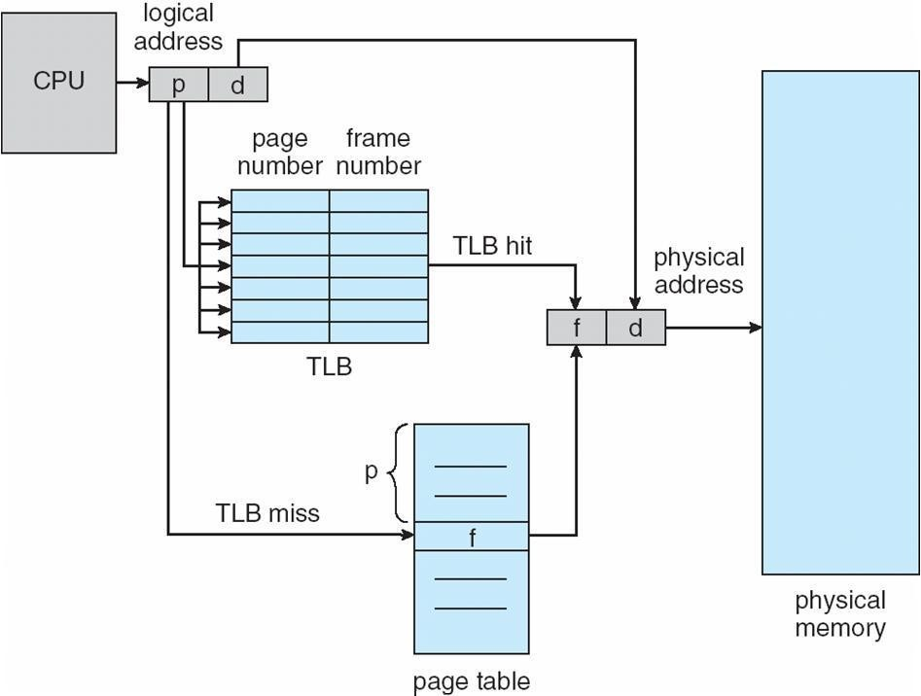

Effective Access Time

- Associative Lookup = e time unit
- Assume memory cycle time is 1 microsecond
- Hit ratio – percentage of times that a page number is found in the associative registers; ratio related to number of associative registers
- Hit ratio = an Effective Access Time (EAT)
EAT = (1 + e) a + (2 + e)(1 –
a) = 2 + e – a

Memory Protection
- Memory protection implemented by associating protection bit with each frame
- Valid-invalid bit attached to each entry in the page table:
- ―valid‖ indicates that the associated page is in the process’ logical address space, and is thus a legal page
- ―invalid‖ indicates that the page is not in the process’ logical address space
- Valid (v) or Invalid (i) Bit In A Page Table

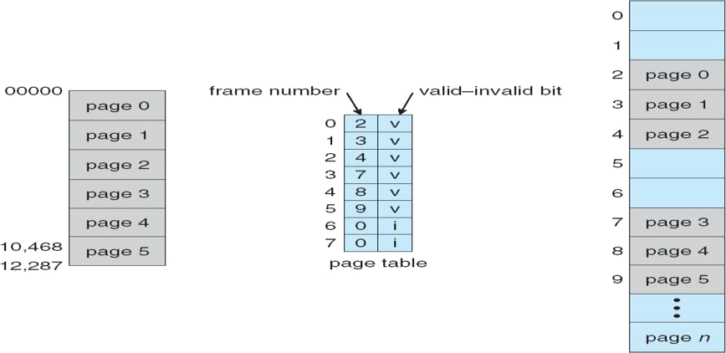

Shared Pages

Shared code
- One copy of read-only (reentrant) code shared among processes (i.e., text editors, compilers, window systems).
- Shared code must appear in same location in the logical address space of all processes

Private code and data
- Each process keeps a separate copy of the code and data
- The pages for the private code and data can appear anywhere in the logical address space

Shared Pages Example
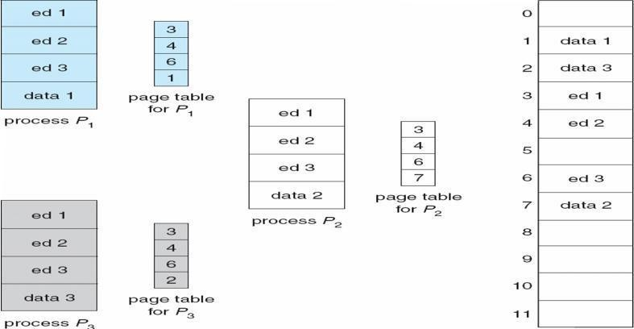

Structure of the Page Table
- Hierarchical Paging
- Hashed Page Tables
- Inverted Page Tables

Hierarchical Page Tables
- Break up the logical address space into multiple page tables
- A simple technique is a two-level page table

Two-Level Page-Table Scheme
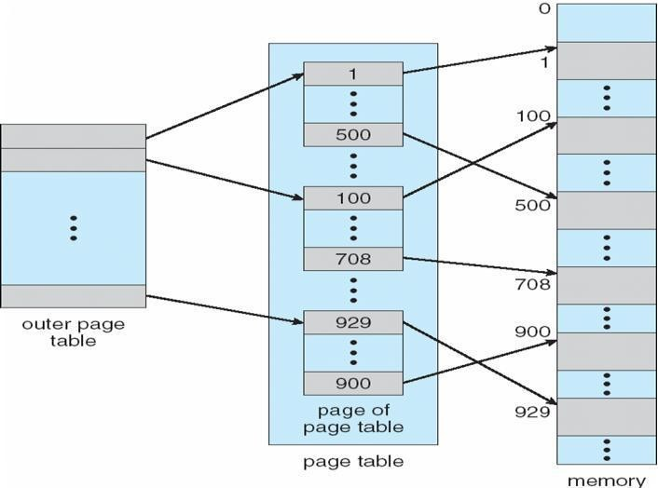
Two-Level Paging Example
- A logical address (on 32-bit machine with 1K page size) is divided into:
- a page number consisting of 22 bits
- a page offset consisting of 10 bits
- Since the page table is paged, the page number is further divided into:
- a 12-bit page number
- a 10-bit page offset
- Thus, a logical address is as follows:

where pi is an index into the outer page table, and p2 is the displacement within the page of the outer page table

page number page offset
pi | p2 | d

12 10 10
Address-Translation Scheme
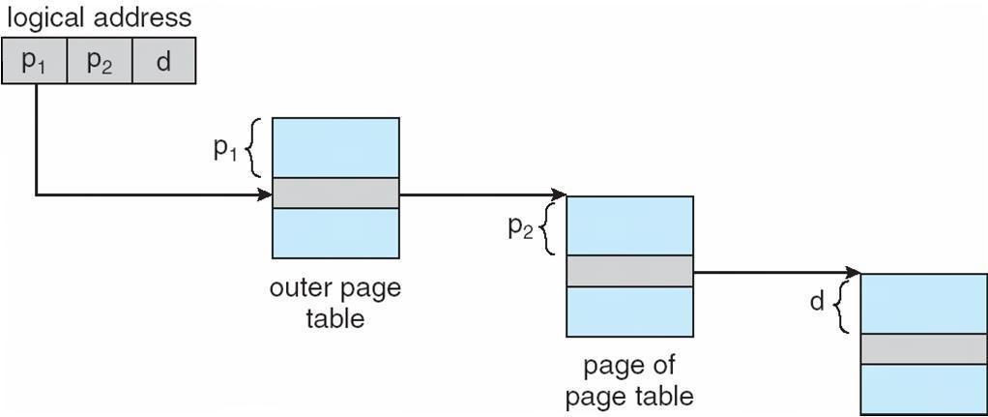

Three-level Paging Scheme
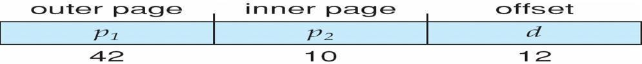

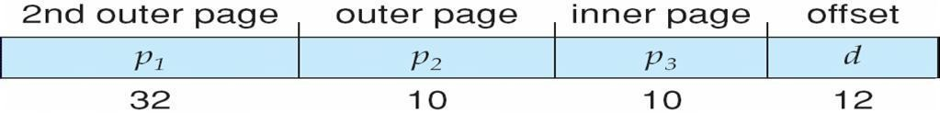

Hashed Page Tables
- Common in address spaces > 32 bits
- The virtual page number is hashed into a page table
- This page table contains a chain of elements hashing to the same location
- Virtual page numbers are compared in this chain searching for a match
- If a match is found, the corresponding physical frame is extracted

Hashed Page Table
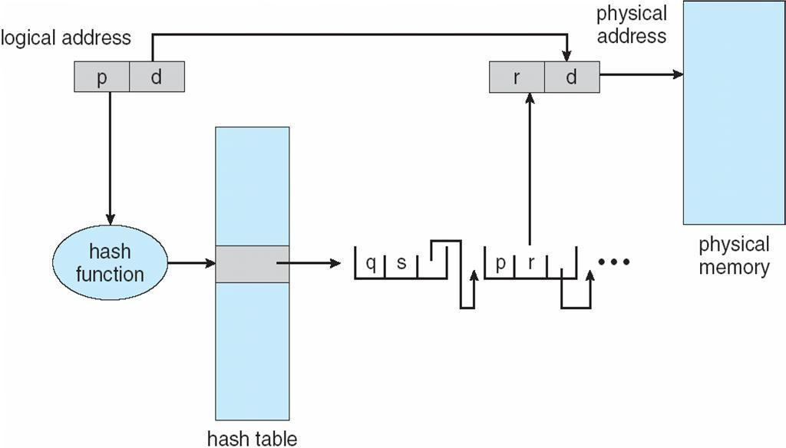

Inverted Page Table
- One entry for each real page of memory
- Entry consists of the virtual address of the page stored in that real memory location, with information about the process that owns that page
- Decreases memory needed to store each page table, but increases time needed to search the table when a page reference occurs
- Use hash table to limit the search to one — or at most a few — page-table entries

Inverted Page Table Architecture
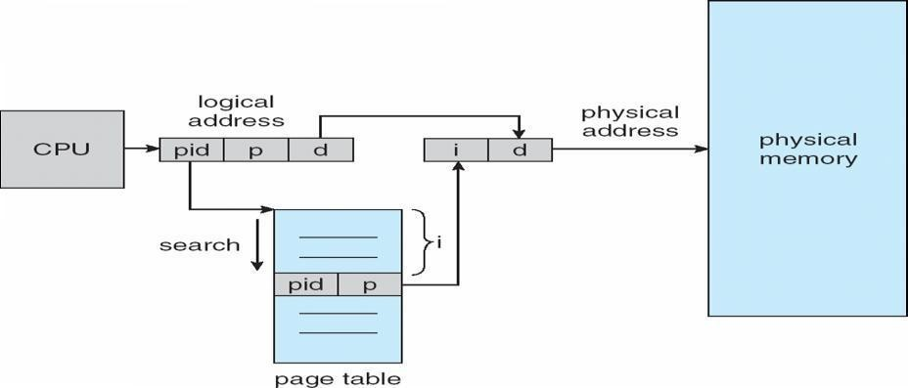

Segmentation
Memory-management scheme that supports user view of memory
- A program is a collection of segments
- A segment is a logical unit such as:
- main program
- procedure function
- method
- object
- local variables, global variables
- common block
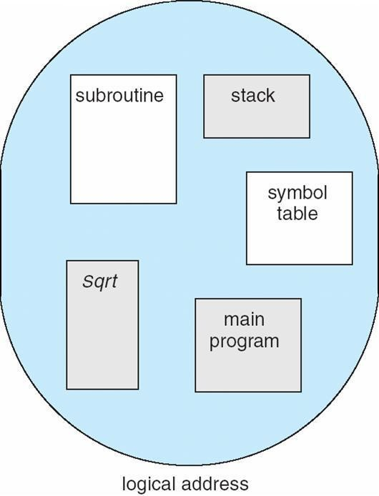
- stack
- symbol table
- arrays

User’s View of a Program

user space
Logical View of Segmentation
 |  |  | 1
1 |  |  | 4
2
3 |  |  | 2
4
 |  |  | 3

physical memory space

Segmentation Architecture
- Logical address consists of a two tuple:
  - <segment-number, offset>,
- Segment table – maps two-dimensional physical addresses; each table entry has:
- base – contains the starting physical address where the segments reside in memory
- limit – specifies the length of the segment
- Segment-table base register (STBR) points to the segment table’s location in memory
- Segment-table length register (STLR) indicates number of segments used by a program; segment number s is legal if s < STLR
- Protection
- With each entry in segment table associate:
- validation bit = 0 Þ illegal segment
- read/write/execute privileges
- Protection bits associated with segments; code sharing occurs at segment level
- Since segments vary in length, memory allocation is a dynamic storage-allocation problem
- A segmentation example is shown in the following diagram

Segmentation Hardware
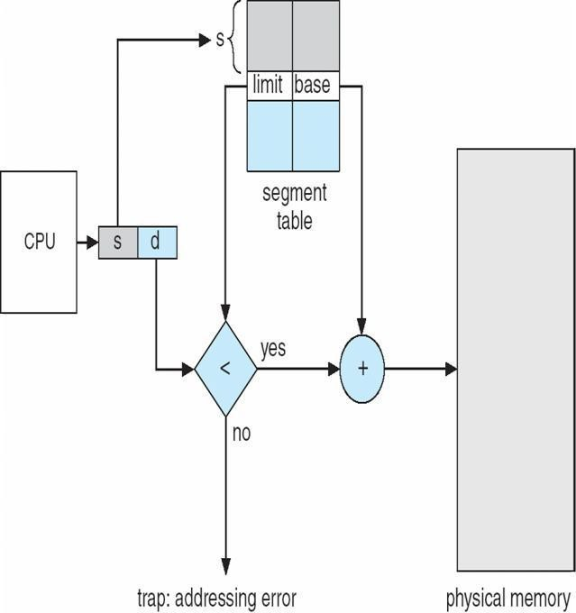

Example of Segmentation
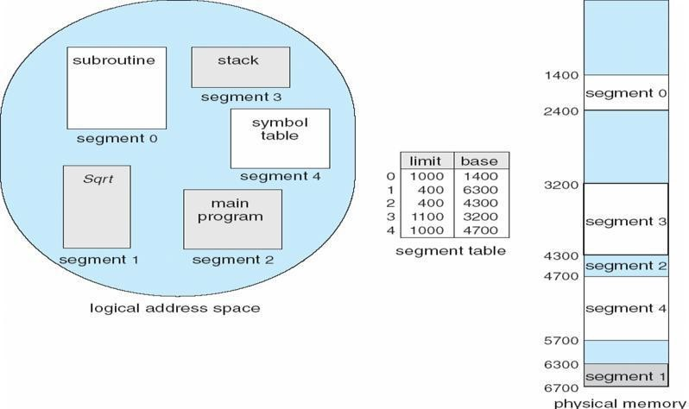

Example: The Intel Pentium
- Supports both segmentation and segmentation with paging
- CPU generates logical address
- Given to segmentation unit Which produces linear addresses
- Linear address given to paging unit
Which generates physical address in main memory Paging units form equivalent of MMU

Logical to Physical Address Translation in Pentium

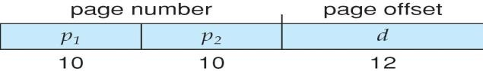
Intel Pentium Segmentation
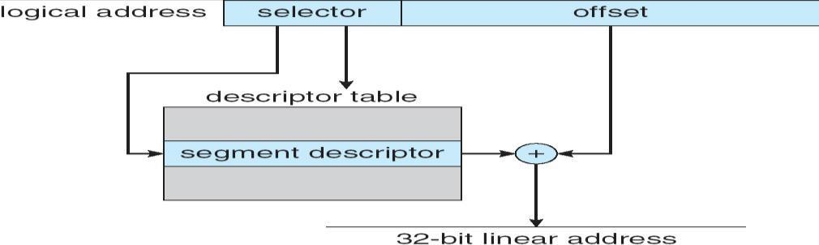

Pentium Paging Architecture
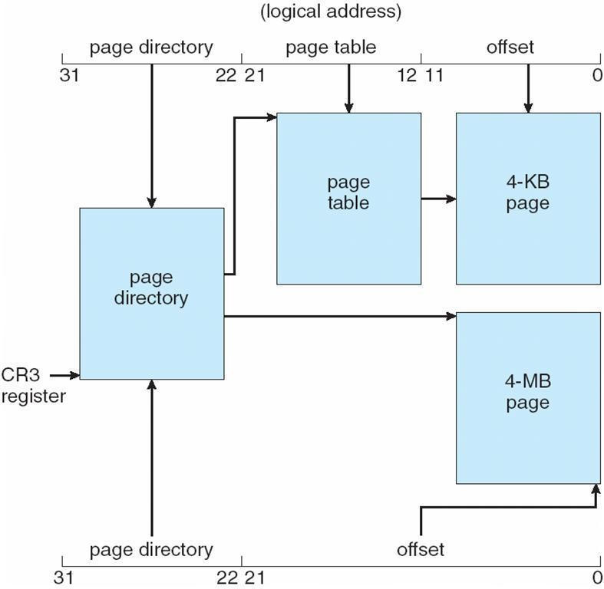

Linear Address in Linux
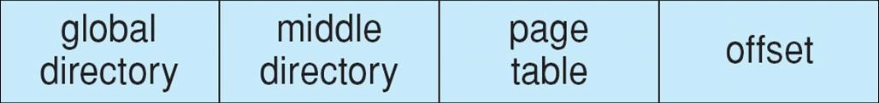

Three-level Paging in Linux
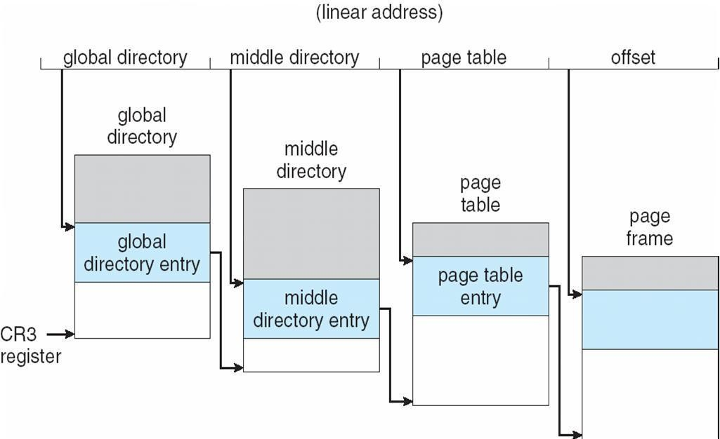

UNIT – IV
File System Implementation

File Concept
- Contiguous logical address spaceand Types:
- Data
- numeric
- character
- binary
- Program

File Structure
- None - sequence of words, bytes
- Simple record structure
- Lines
- Fixed length
- Variable length
- Complex Structures
- Formatted document
- Relocatable load file
- Can simulate last two with first method by inserting appropriate control characters
- Who decides:
- Operating system
- Program

File Attributes
- Name – only information kept in human-readable form
- Identifier – unique tag (number) identifies file within file system
- Type – needed for systems that support different types
- Location – pointer to file location on device
- Size – current file size
- Protection – controls who can do reading, writing, executing
- Time, date, and user identification – data for protection, security, and usage monitoring
- Information about files are kept in the directory structure, which is maintained on the disk

File Operations File is an abstract data type
- Create
- Write
- Read
- Reposition within file
- Delete
- Truncate
- Open(Fi) – search the directory structure on disk for entry Fi, and move the content of entry to memory
- Close (Fi) – move the content of entry Fi in memory to directory structure on disk

Open Files
- Several pieces of data are needed to manage open files:
- File pointer: pointer to last read/write location, per process that has the file open
- File-open count: counter of number of times a file is open – to allow removal of data from open-file table when last processes close it
- Disk location of the file: cache of data access information
- Access rights: per-process access mode information

Open File Locking
- Provided by some operating systems and file systems
- Mediates access to a file
- Mandatory or advisory:
- Mandatory – access is denied depending on locks held and requested
- Advisory – processes can find status of locks and decide what to do

File Types – Name, Extension
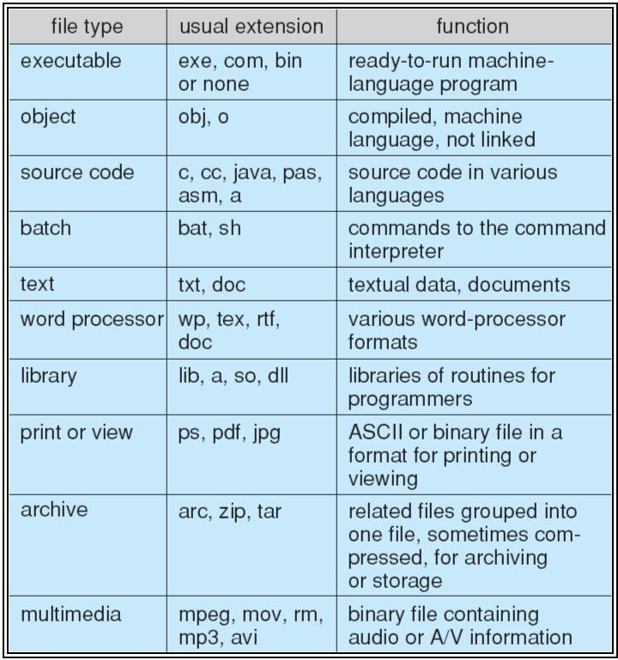

Access Methods Sequential Access
- read next
- write
- reset
- no read after last write
- (rewrite)

Direct Access
- read n
- write n
- position to n
- read next
- write next
- rewrite n
n = relative block number

Sequential-access File
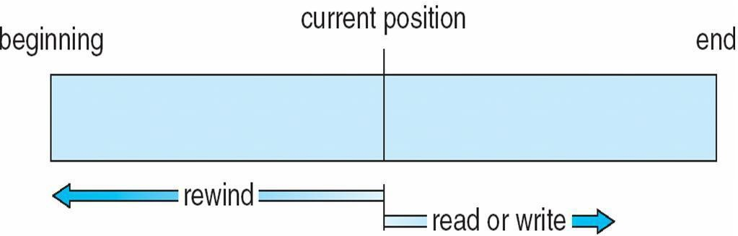

Simulation of Sequential Access on Direct-access File
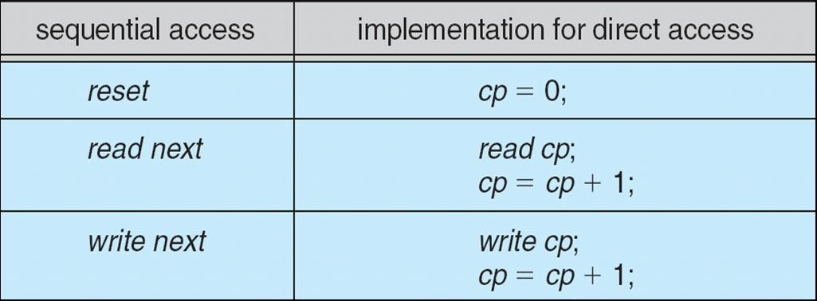
Example of Index and Relative Files

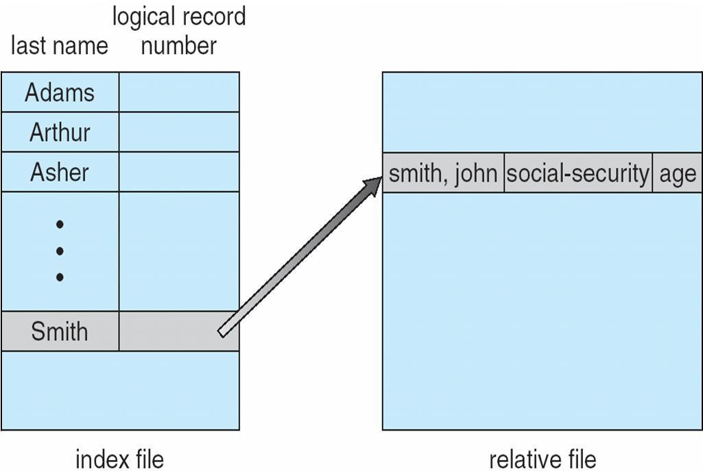

Directory Structure
- A collection of nodes containing information about all files
- Both the directory structure and the files reside on disk
- 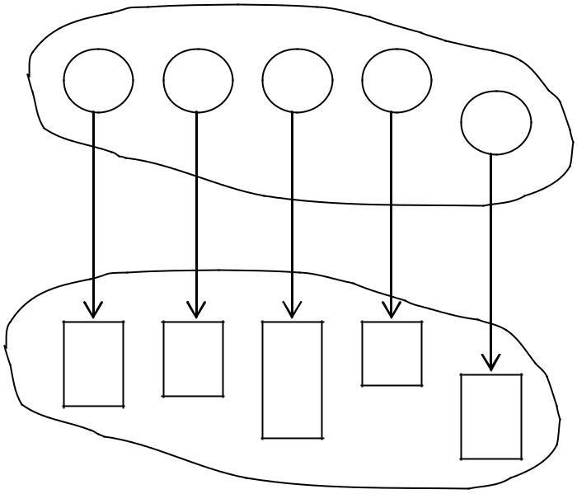Backups of these two structures are kept on tapes
F
F
F
F
F

Files

Disk Structure
- Disk can be subdivided into partitions
- Disks or partitions can be RAID protected against failure
- Disk or partition can be used raw – without a file system, or formatted with a file system
- Partitions also known as minidisks, slices
- Entity containing file system known as a volume
- Each volume containing file system also tracks that file system’s info in device directory or volume table of contents
- As well as general-purpose file systems there are many special-purpose file systems, frequently all within the same operating system or computer

A Typical File-system Organization
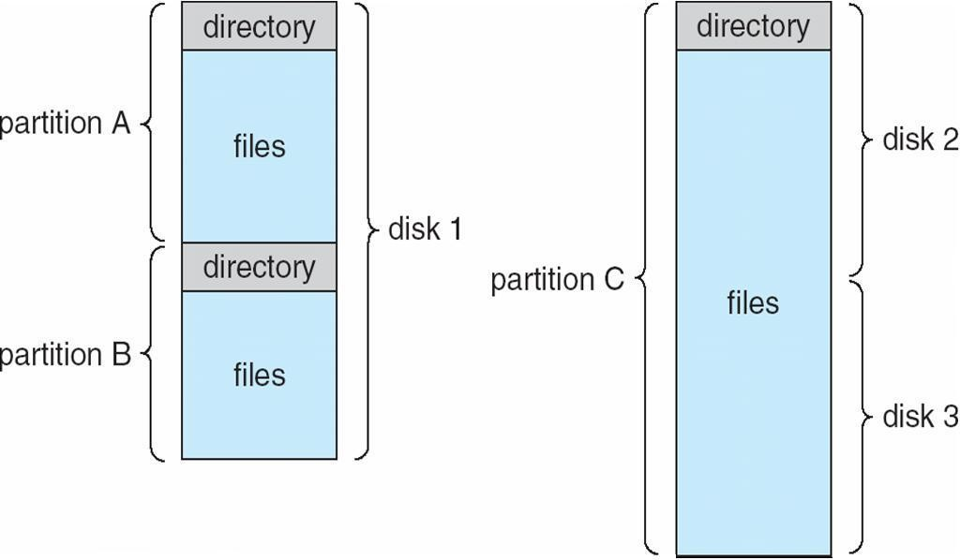

Operations Performed on Directory
- Search for a file
- Create a file
- Delete a file
- List a directory
- Rename a file
- Traverse the file system

Organize the Directory (Logically) to Obtain
- Efficiency – locating a file quickly
- Naming – convenient to users
- Two users can have same name for different files
- The same file can have several different names
- Grouping – logical grouping of files by properties, (e.g., all Java programs, all games, …)
Single-Level Directory
- A single directory for all users

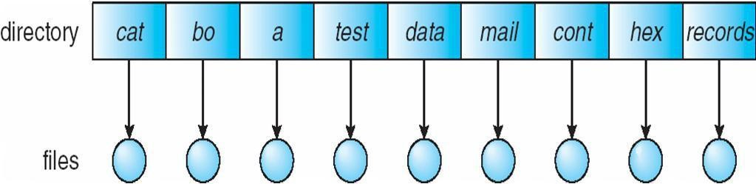

- Naming problem
- Grouping problem
- Two-Level Directory
- Separate directory for each user

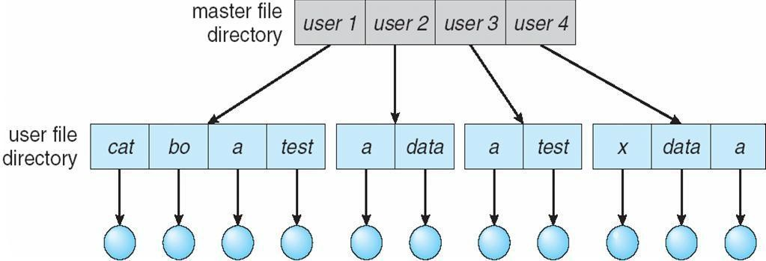

- Path name
- Can have the same file name for different user
- Efficient searching
- No grouping capability

Tree-Structured Directories
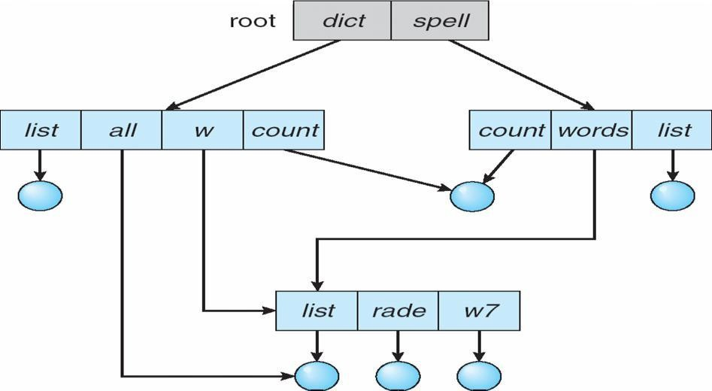

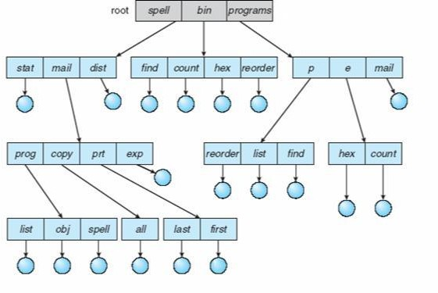

Creating a new file is done in current directory
- Delete a file rm
<file-name>
- Creating a new subdirectory is done in current directory mkdir <dir-name>
Example: if in current directory /mail

mkdir count

- Deleting ―mail‖ Þ deleting the entire subtree rooted by ―mail‖
coun
ex
pr
copy
prog
mail

Acyclic-Graph Directories

- Have shared subdirectories and files

Two different names (aliasing)If dict deletes list Þ dangling pointer
- Solutions:
- Backpointers, so we can delete all pointers Variable size records a problem
- Backpointers using a daisy chain organization
- Entry-hold-count solution
- New directory entry type
- Link – another name (pointer) to an existing file
- Resolve the link – follow pointer to locate the file

General Graph Directory

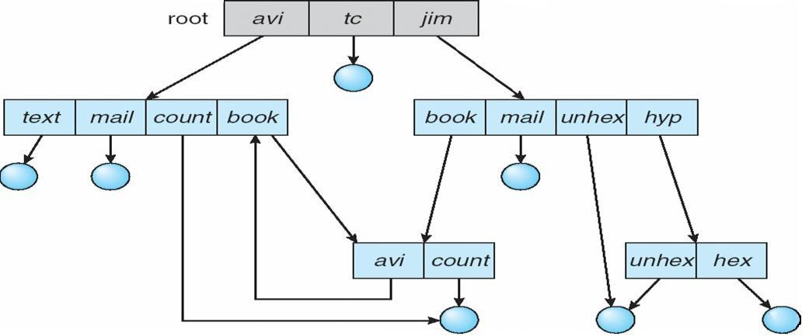

- How do we guarantee no cycles?
- Allow only links to file not subdirectories
- Garbage collection
- Every time a new link is added use a cycle detection algorithm to determine whether it is OK
File System Mounting
- A file system must be mounted before it can be accessed
- A unmounted file system (i.e. Fig. 11-11(b)) is mounted at a mount point

(a) Existing. (b) Unmounted Partition

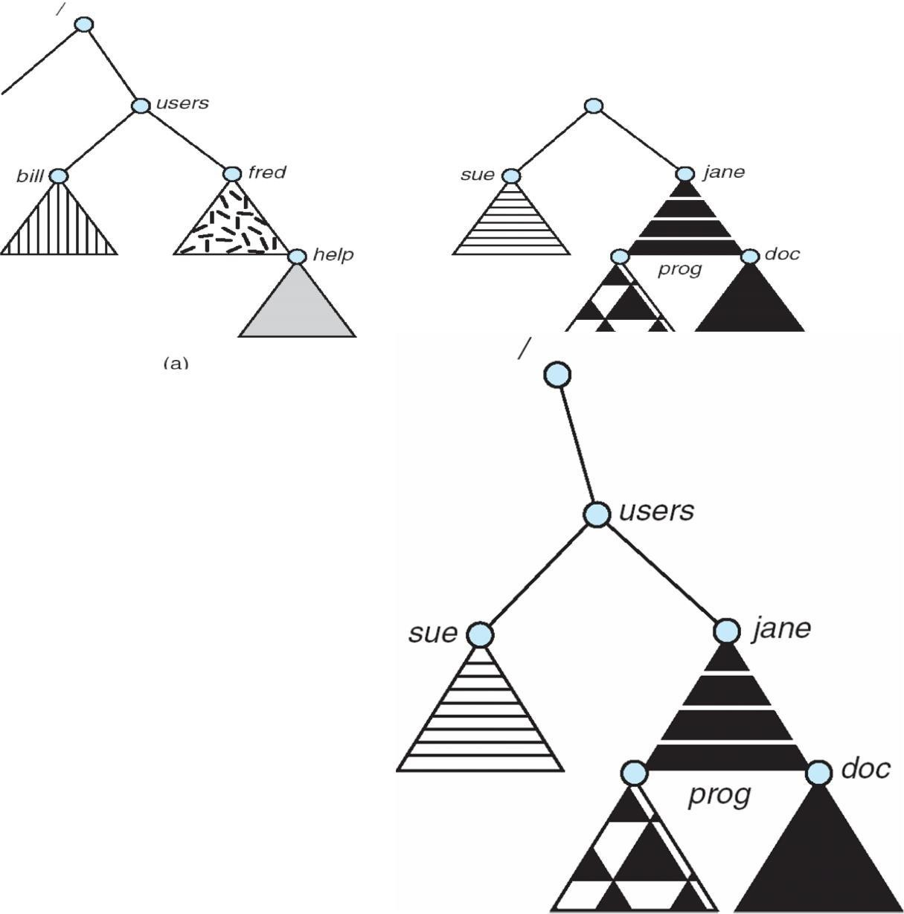
Mount Point

File Sharing
- Sharing of files on multi-user systems is desirable Sharing may be done through a protection scheme On distributed systems, files may be shared across a network Network File System (NFS) is a common distributed file-sharing method

File Sharing – Multiple Users
- User IDs identify users, allowing permissions and protections to be per-user
Group IDs allow users to be in groups, permitting group access rights

File Sharing – Remote File Systems

- Uses networking to allow file system access between systems
- Manually via programs like FTP

- Automatically, seamlessly using distributed file systems
- Semi automatically via the world wide web
- Client-server model allows clients to mount remote file systems from servers
- Server can serve multiple clients
- Client and user-on-client identification is insecure or complicated
- NFS is standard UNIX client-server file sharing protocol
- CIFS is standard Windows protocol
- Standard operating system file calls are translated into remote calls
- Distributed Information Systems (distributed naming services) such as LDAP, DNS, NIS, Active Directory implement unified access to information needed for remote computing
File Sharing – Failure Modes

- Remote file systems add new failure modes, due to network failure, server failure
- Recovery from failure can involve state information about status of each remote request
- Stateless protocols such as NFS include all information in each request, allowing easy recovery but less security
File Sharing – Consistency Semantics
- Consistency semantics specify how multiple users are to access a shared file simultaneously
- Similar to Ch 7 process synchronization algorithms
- Tend to be less complex due to disk I/O and network latency (for remote file systems
- Andrew File System (AFS) implemented complex remote file sharing semantics
- Unix file system (UFS) implements:
- Writes to an open file visible immediately to other users of the same open file
- Sharing file pointer to allow multiple users to read and write concurrently
- AFS has session semantics
- Writes only visible to sessions starting after the file is closed

Protection
- File owner/creator should be able to control:
- what can be done
- by whomTypes of access
- Read
- Write
- Execute
- Append
- Delete
- List

- Access Lists and Groups
- Mode of access: read, write, execute
- Three classes of users
- RWX

a) owner access | 7 | Þ | 1 1 1
RWX
b) group access | 6 | Þ | 1 1 0
RWX
c) public access | 1 | Þ | 0 0 1

- Ask manager to create a group (unique name), say G, and add some users to the group. For a particular file (say game) or subdirectory, define an appropriate access.

owne | grou | publi
chmo | 76 | gam
Attach a group to a file | chgrp | G game

Windows XP Access-control List Management

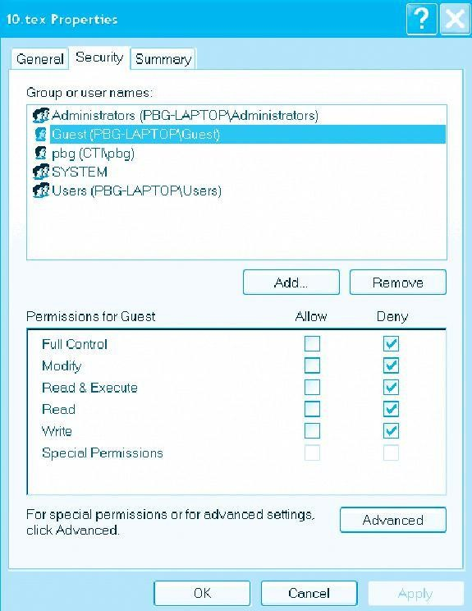

A Sample UNIX Directory Listing

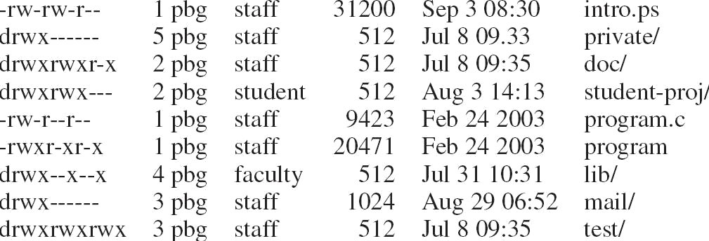

Mass-Storage Systems
Describe the physical structure of secondary and tertiary storage devices and the resulting effects on the uses of the devices Explain the performance characteristics of mass-storage devices Discuss operating-system services provided for mass storage, including RAID and HSM

Overview of Mass Storage Structure
Magnetic disks provide bulk of secondary storage of modern computers Drives rotate at 60 to 200 times per second
Transfer rate is rate at which data flow between drive and computer
Positioning time (random-access time) is time to move disk arm to desired cylinder (seek time) and time for desired sector to rotate under the disk head (rotational latency)
Head crash results from disk head making contact with the disk surface That’s bad
Disks can be removable
Drive attached to computer via I/O bus
Busses vary, including EIDE, ATA, SATA, USB, Fibre Channel, SCSI
Host controller in computer uses bus to talk to disk controller built into drive or storage array

Moving-head Disk Mechanism
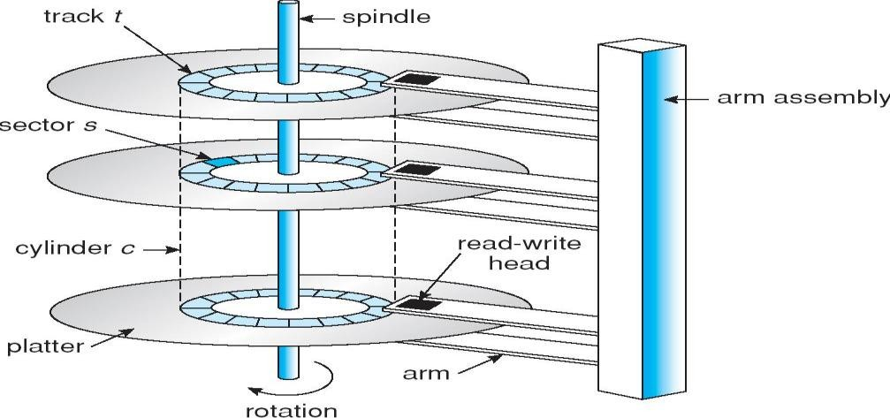

Magnetic tape
Was early secondary-storage medium
Relatively permanent and holds large quantities of data Access time slow
Random access ~1000 times slower than disk
Mainly used for backup, storage of infrequently-used data, transfer medium between systems Kept in spool and wound or rewound past read-write head
Once data under head, transfer rates comparable to disk 20-200GB typical storage
Common technologies are 4mm, 8mm, 19mm, LTO-2 and SDLT

Disk Structure
Disk drives are addressed as large 1-dimensional arrays of logical blocks, where the logical block is the smallest unit of transfer The 1-dimensional array of logical blocks is mapped into the sectors of the disk sequentially Sector 0 is the first sector of the first track on the outermost cylinder

Mapping proceeds in order through that track, then the rest of the tracks in that cylinder, and then through the rest of the cylinders from outermost to innermost

Disk Attachment
Host-attached storage accessed through I/O ports talking to I/O busses
SCSI itself is a bus, up to 16 devices on one cable, SCSI initiator requests operation and SCSI targets perform tasks
Each target can have up to 8 logical units (disks attached to device controller FC is high-speed serial architecture
Can be switched fabric with 24-bit address space – the basis of storage area networks (SANs) in which many hosts attach to many storage units
Can be arbitrated loop (FC-AL) of 126 devices

Network-Attached Storage
Network-attached storage (NAS) is storage made available over a network rather than over a local connection (such as a bus)
NFS and CIFS are common protocols
Implemented via remote procedure calls (RPCs) between host and storage New SCSI protocol uses IP network to carry the SCSI protocol

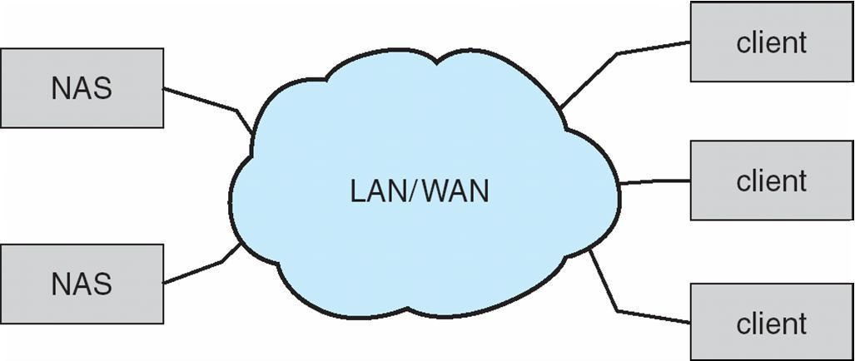

Storage Area Network
Common in large storage environments (and becoming more common) Multiple hosts attached to multiple storage arrays - flexible
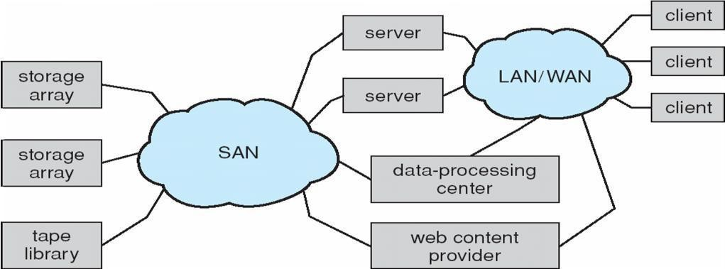

Disk Scheduling

The operating system is responsible for using hardware efficiently — for the disk drives, this means having a fast access time and disk bandwidth
Access time has two major components
Seek time is the time for the disk are to move the heads to the cylinder containing the desired sector Rotational latency is the additional time waiting for the disk to rotate the desired sector to the disk head Minimize seek time
Seek time » seek distance
Disk bandwidth is the total number of bytes transferred, divided by the total time between the first request for service and the completion of the last transfer
Several algorithms exist to schedule the servicing of disk I/O requests .We illustrate them with a request queue (0-199)

FCFS
98, 183, 37, 122, 14, 124, 65, 67
Head pointer 53

Illustration shows total head movement of 640 cylinders

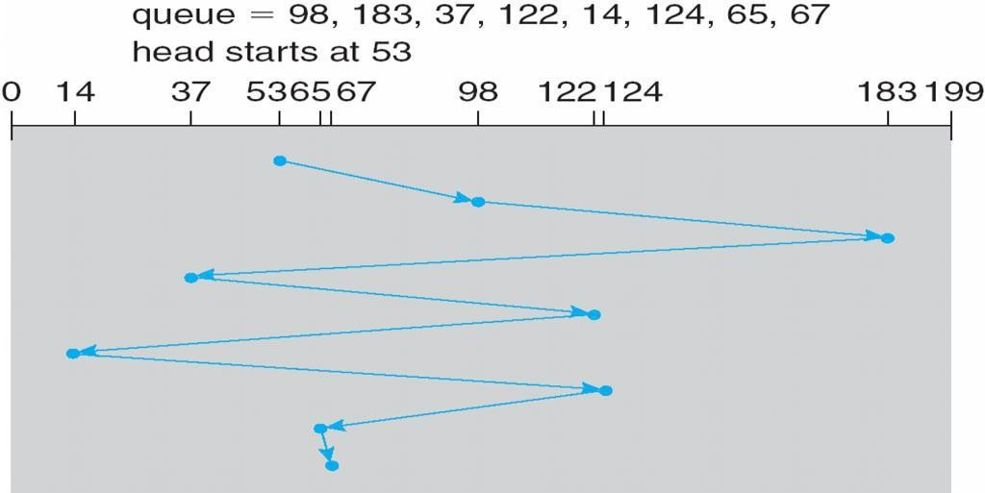

SSTF
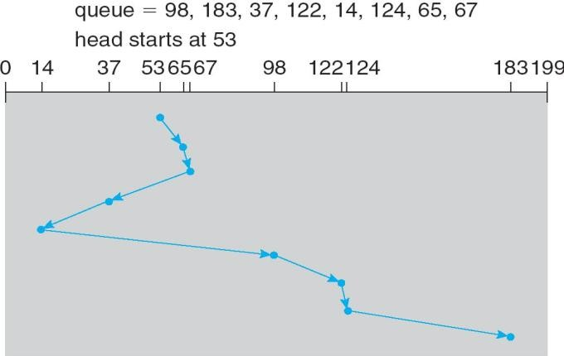
Selects the request with the minimum seek time from the current head position SSTF scheduling is a form of SJF scheduling; may cause starvation of some requests Illustration shows total head movement of 236 cylinders

SCAN

The disk arm starts at one end of the disk, and moves toward the other end, servicing requests until it gets to the other end of the disk, where the head movement is reversed and servicing continues. SCAN algorithm Sometimes called the elevator algorithm
Illustration shows total head movement of 208 cylinders

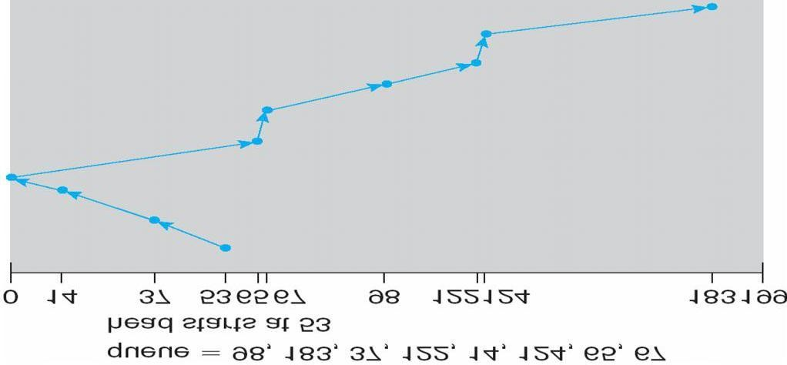

C-SCAN
Provides a more uniform wait time than SCAN
The head moves from one end of the disk to the other, servicing requests as it goes
When it reaches the other end, however, it immediately returns to the beginning of the disk, without servicing any requests on the return trip
Treats the cylinders as a circular list that wraps around from the last cylinder to the first one
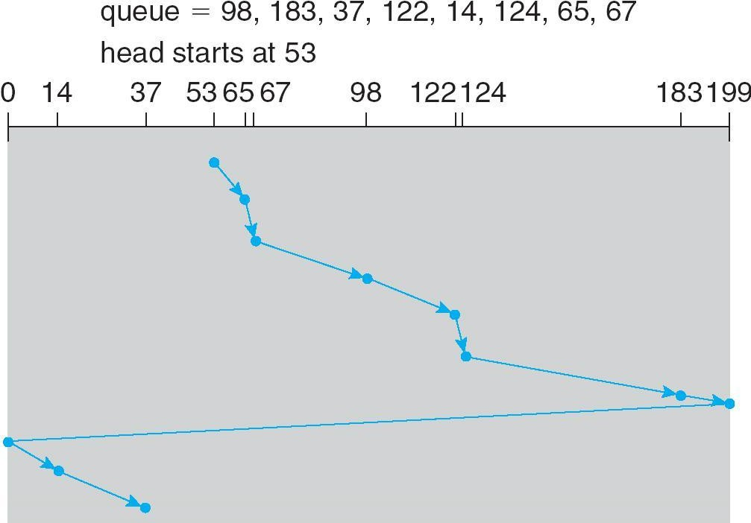

C-LOOK

Version of C-SCAN
Arm only goes as far as the last request in each direction, then reverses direction immediately, without first going all the way to the end of the disk
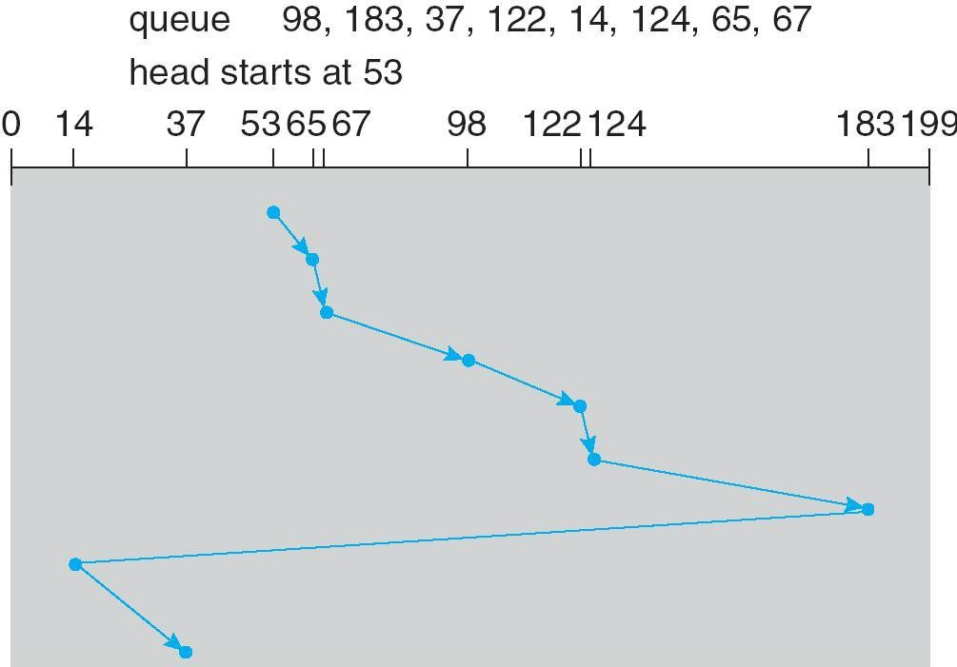

Selecting a Disk-Scheduling Algorithm
SSTF is common and has a natural appeal
SCAN and C-SCAN perform better for systems that place a heavy load on the disk Performance depends on the number and types of requests
Requests for disk service can be influenced by the file-allocation method
The disk-scheduling algorithm should be written as a separate module of the operating system, allowing it to be replaced with a different algorithm if necessary
Either SSTF or LOOK is a reasonable choice for the default algorithm

Disk Management
Low-level formatting, or physical formatting — Dividing a disk into sectors that the disk controller can read and write
To use a disk to hold files, the operating system still needs to record its own data structures on the disk Partition the disk into one or more groups of cylinders
Logical formatting or ―making a file system‖
To increase efficiency most file systems group blocks into clusters Disk I/O done in blocks
File I/O done in clusters Boot block initializes system
The bootstrap is stored in ROM Bootstrap loader program
Methods such as sector sparing used to handle bad blocks

Booting from a Disk in Windows 2000
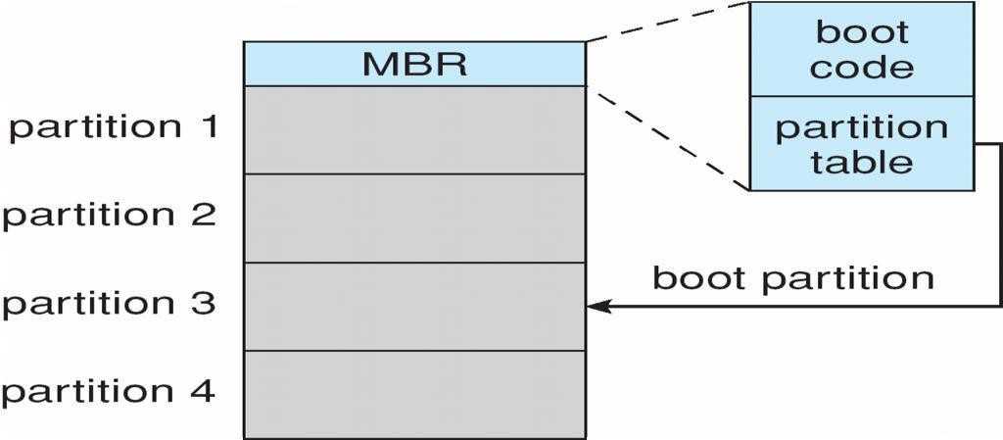

Swap-Space Management
Swap-space — Virtual memory uses disk space as an extension of main memory
Swap-space can be carved out of the normal file system, or, more commonly, it can be in separate disk partition Swap-space management
4.3BSD allocates swap space when process starts; holds text segment (the program) and data segment Kernel uses swap maps to track swap-space use
Solaris 2 allocates swap space only when a page is forced out of physical memory, not when the virtual memory page is first created

Data Structures for Swapping on Linux Systems

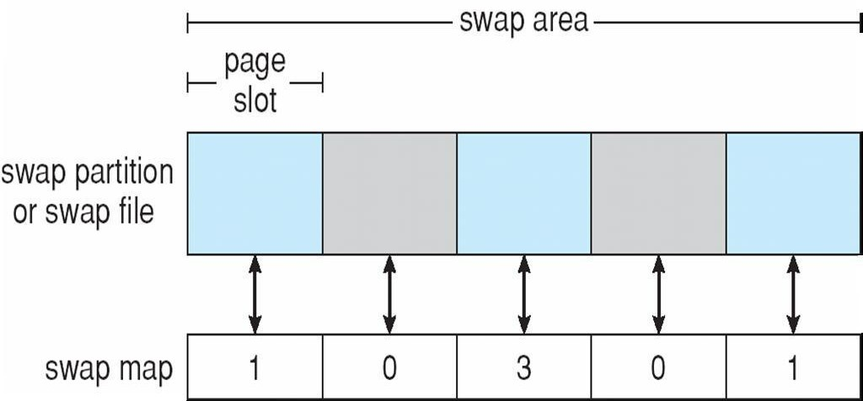
RAID Structure

RAID – multiple disk drives provides reliability via redundancy Increases the mean time to failure Frequently combined with NVRAM to improve write performance
RAID is arranged into six different levels
Several improvements in disk-use techniques involve the use of multiple disks working cooperatively Disk striping uses a group of disks as one storage unit RAID schemes improve performance and improve the reliability of the storage system by storing redundant data
Mirroring or shadowing (RAID 1) keeps duplicate of each disk
Striped mirrors (RAID 1+0) or mirrored stripes (RAID 0+1) provides high performance and high reliability Block interleaved parity (RAID 4, 5, 6) uses much less redundancy
RAID within a storage array can still fail if the array fails, so automatic replication of the data between arrays is common

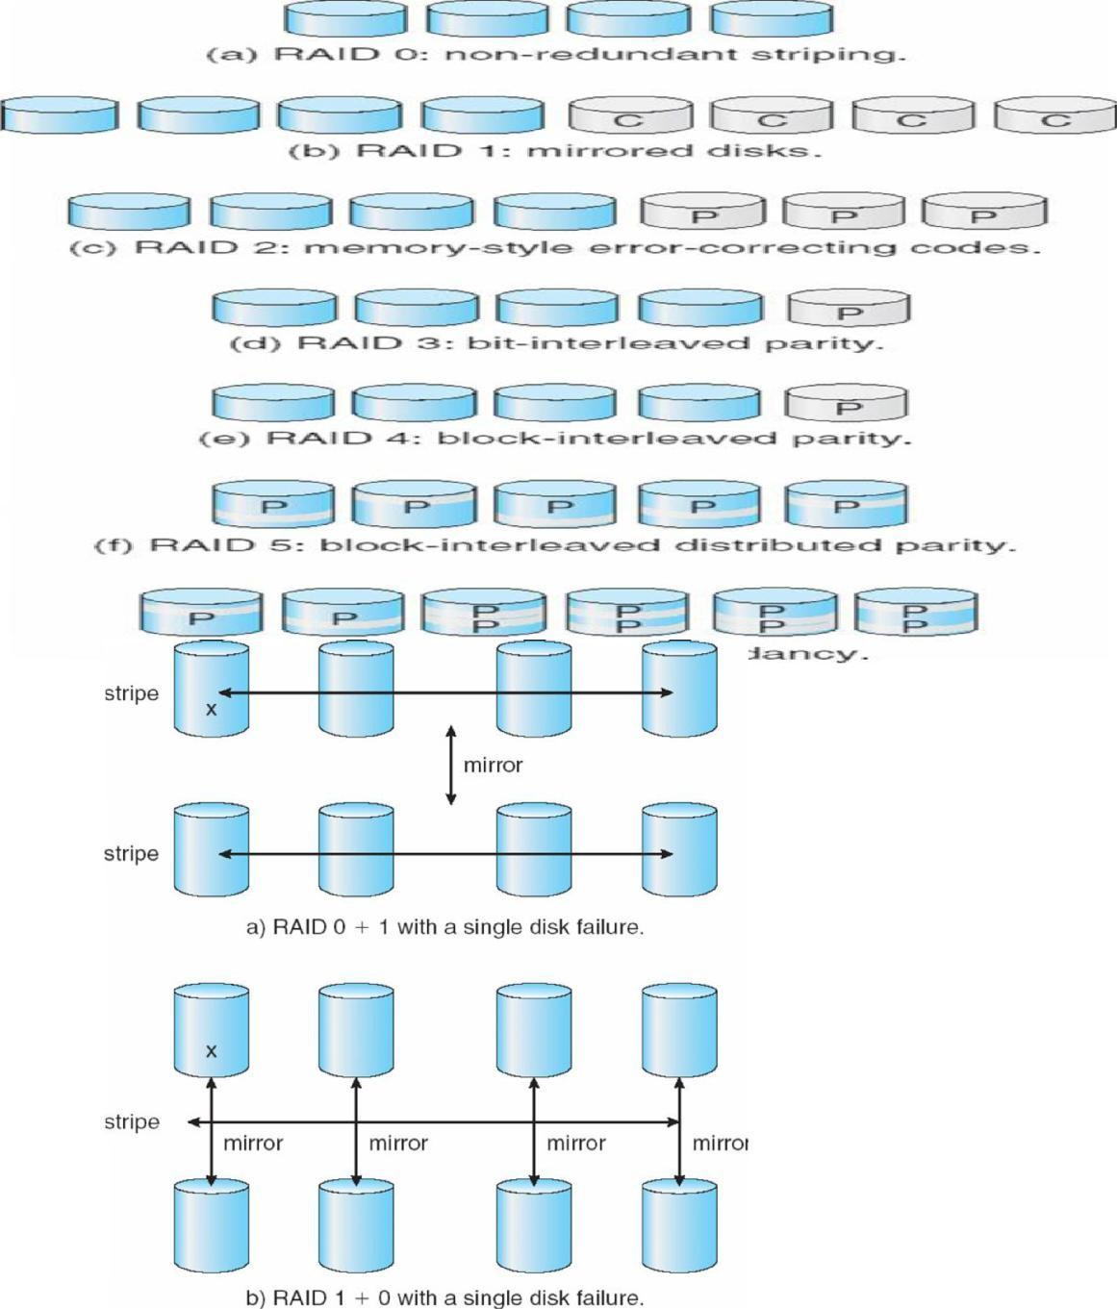Frequently, a small number of hot-spare disks are left unallocated, automatically replacing a failed disk and having data rebuilt onto them
+ 1) and (1 + 0)

RAID (0

Extensions
RAID alone does not prevent or detect data corruption or other errors, just disk failures Solaris ZFS adds checksums of all data and metadata
Checksums kept with pointer to object, to detect if object is the right one and whether it changed Can detect and correct data and metadata corruption
ZFS also removes volumes, partitions. Disks allocated in pools
File systems with a pool share that pool, use and release space like ―malloc‖ and ―free‖ memory allocate / release calls

ZFS Checksums All Metadata and Data
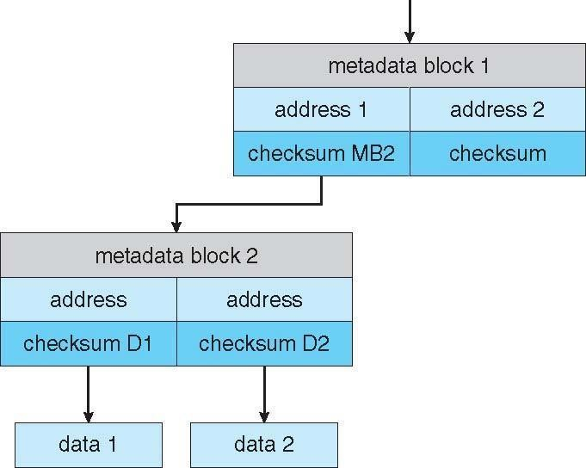

Traditional and Pooled Storage
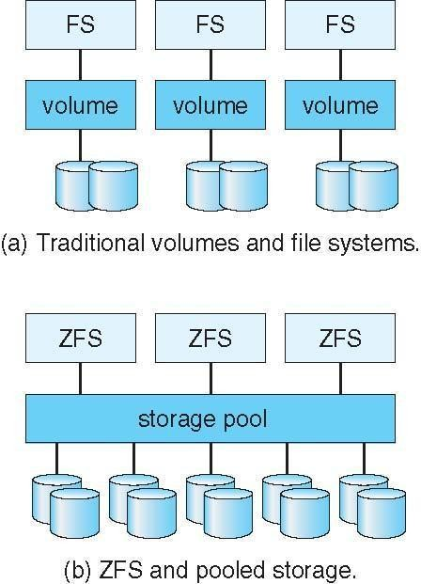
Stable-Storage Implementation
Write-ahead log scheme requires stable storage To implement stable storage:
Replicate information on more than one nonvolatile storage media with independent failure modes
Update information in a controlled manner to ensure that we can recover the stable data after any failure during data transfer or recovery

Tertiary Storage Devices
Low cost is the defining characteristic of tertiary storage Generally, tertiary storage is built using removable media Common examples of removable media are floppy disks and CD-ROMs; other types are available

Removable Disks
Floppy disk — thin flexible disk coated with magnetic material, enclosed in a protective plastic case Most floppies hold about 1 MB; similar technology is used for removable disks that hold more than 1 GB
Removable magnetic disks can be nearly as fast as hard disks, but they are at a greater risk of damage from exposure
A magneto-optic disk records data on a rigid platter coated with magnetic material Laser heat is used to amplify a large, weak magnetic field to record a bit Laser light is also used to read data (Kerr effect)
The magneto-optic head flies much farther from the disk surface than a magnetic disk head, and the magnetic material is covered with a protective layer of plastic or glass; resistant to head crashes Optical disks do not use magnetism; they employ special materials that are altered by laser light

WORM Disks
The data on read-write disks can be modified over and over
WORM (―Write Once, Read Many Times‖) disks can be written only once Thin aluminum film sandwiched between two glass or plastic platters
To write a bit, the drive uses a laser light to burn a small hole through the aluminum; information can be destroyed by not altered
Very durable and reliable
Read-only disks, such ad CD-ROM and DVD, com from the factory with the data pre-recorded

Tapes
Compared to a disk, a tape is less expensive and holds more data, but random access is much slower
Tape is an economical medium for purposes that do not require fast random access, e.g., backup copies of disk data, holding huge volumes of data
Large tape installations typically use robotic tape changers that move tapes between tape drives and storage slots in a tape library
stacker – library that holds a few tapes silo – library that holds thousands of tapes
A disk-resident file can be archived to tape for low cost storage; the computer can stage it back into disk storage for active use

Operating System Support
Major OS jobs are to manage physical devices and to present a virtual machine abstraction to applications For hard disks, the OS provides two abstraction:
Raw device – an array of data blocks
File system – the OS queues and schedules the interleaved requests from several applications

Application Interface
Most OSs handle removable disks almost exactly like fixed disks — a new cartridge is formatted and an empty file system is generated on the disk
Tapes are presented as a raw storage medium, i.e., and application does not not open a file on the tape, it opens the whole tape drive as a raw device
Usually the tape drive is reserved for the exclusive use of that application
Since the OS does not provide file system services, the application must decide how to use the array of blocks Since every application makes up its own rules for how to organize a tape, a tape full of data can generally only be used by the program that created it

Tape Drives
The basic operations for a tape drive differ from those of a disk drive
locate() positions the tape to a specific logical block, not an entire track (corresponds to seek())

The read position() operation returns the logical block number where the tape head is The space() operation enables relative motion
Tape drives are ―append-only‖ devices; updating a block in the middle of the tape also effectively erases everything beyond that block
An EOT mark is placed after a block that is written

File Naming
The issue of naming files on removable media is especially difficult when we want to write data on a removable cartridge on one computer, and then use the cartridge in another computer
Contemporary OSs generally leave the name space problem unsolved for removable media, and depend on applications and users to figure out how to access and interpret the data. Some kinds of removable media (e.g., CDs) are so well standardized that all computers use them the same way

Hierarchical Storage Management (HSM)
A hierarchical storage system extends the storage hierarchy beyond primary memory and secondary storage to incorporate tertiary storage — usually implemented as a jukebox of tapes or removable disks
Usually incorporate tertiary storage by extending the file system Small and frequently used files remain on disk Large, old, inactive files are archived to the jukebox
HSM is usually found in supercomputing centers and other large installations that have enormous volumes of data

Speed
Two aspects of speed in tertiary storage are bandwidth and latency Bandwidth is measured in bytes per second Sustained bandwidth – average data rate during a large transfer; # of bytes/transfer time Data rate when the data stream is actually flowing
Effective bandwidth – average over the entire I/O time, including seek() or locate(), and cartridge switching Drive’s overall data rate
Access latency – amount of time needed to locate data
Access time for a disk – move the arm to the selected cylinder and wait for the rotational latency; < 35 milliseconds
Access on tape requires winding the tape reels until the selected block reaches the tape head; tens or hundreds of seconds
Generally say that random access within a tape cartridge is about a thousand times slower than random access on disk
The low cost of tertiary storage is a result of having many cheap cartridges share a few expensive drives
A removable library is best devoted to the storage of infrequently used data, because the library can only satisfy a relatively small number of I/O requests per hour

Reliability
A fixed disk drive is likely to be more reliable than a removable disk or tape drive An optical cartridge is likely to be more reliable than a magnetic disk or tape A head crash in a fixed hard disk generally destroys the data, whereas the failure of a tape drive or optical disk drive often leaves the data cartridge unharmed

Cost
Main memory is much more expensive than disk storage The cost per megabyte of hard disk storage is competitive with magnetic tape if only one tape is used per drive The cheapest tape drives and the cheapest disk drives have had about the same storage capacity over the years Tertiary storage gives a cost savings only when the number of cartridges is considerably larger than the number of drives

UNIT – V DEADLOCKS

To develop a description of deadlocks, which prevent sets of concurrent processes from completing their tasks. To present a number of different methods for preventing or avoiding deadlocks in a computer system.

The Deadlock Problem
A set of blocked processes each holding a resource and waiting to acquire a resource held by another process in the set
Example
System has 2 disk drives
P1 and P2 each hold one disk drive and each needs another one Example
semaphores A and B, initialized to 1

P0 P1
wait (A); wait(B)
wait (B); wait(A)

Bridge Crossing Example
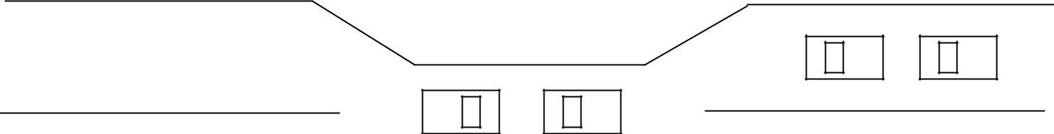

- Traffic only in one direction
- Each section of a bridge can be viewed as a resource
- If a deadlock occurs, it can be resolved if one car backs up (preempt resources and rollback)
- Several cars may have to be backed up if a deadlock occurs
- Starvation is possible
- Note – Most OSes do not prevent or deal with deadlocks

System Model
- Resource types R1, R2, . . ., Rm
- CPU cycles, memory space, I/O devices

- Each resource type Ri has Wi instances. Each process utilizes a resource as follows:

request use release

Deadlock Characterization
Deadlock can arise if four conditions hold simultaneously
Mutual exclusion: only one process at a time can use a resource
Hold and wait: a process holding at least one resource is waiting to acquire additional resources held by other processes
No preemption: a resource can be released only voluntarily by the process holding it, after that process has completed its task
Circular wait: there exists a set {P0, P1, …, P0} of waiting processes such that P0 is waiting for a resource that is held by P1, P1 is waiting for a resource that is held by
P2, …, Pn–1 is waiting for a resource that is held by
Pn, and P0 is waiting for a resource that is held by P0.

Resource-Allocation Graph
A set of vertices V and a set of edges
E V is partitioned into two types:
P = {P1, P2, …, Pn}, the set consisting of all the processes in the system R = {R1, R2, …, Rm}, the set consisting of all resource types in the system request edge – directed edge P1 ® Rj
assignment edge – directed edge Rj ® Pi

Process

Resource Type with 4 instances

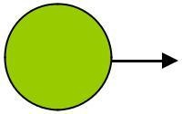Pi requests instance of Rjn
P
i

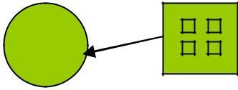
Rj

Pi is holding an instance of Rj | Pi

Example of a Resource Allocation Graph

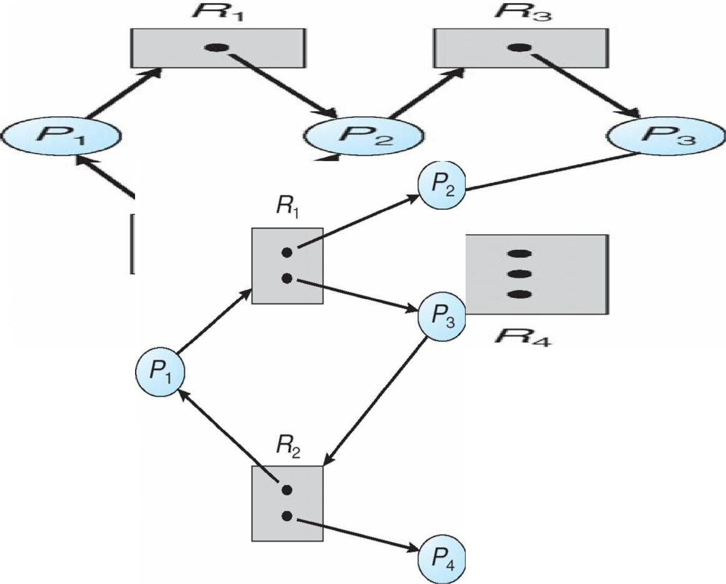
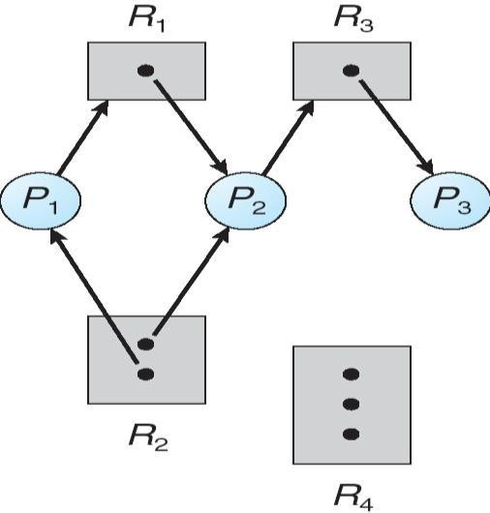Resource Allocation Graph With A Deadlock
Rj

Graph With A Cycle But No Deadlock

Basic Facts
If graph contains no cycles no deadlock If graph contains a cycle if only one instance per resource type, then deadlock
if several instances per resource type, possibility of deadlock

Methods for Handling Deadlocks
Ensure that the system will never enter a deadlock state Allow the system to enter a deadlock state and then recover Ignore the problem and pretend that deadlocks never occur in the system; used by most operating systems, including UNIX

Deadlock Prevention
Restrain the ways request can be made

Mutual Exclusion – not required for sharable resources; must hold for non sharable resources

Hold and Wait – must guarantee that whenever a process requests a resource, it does not hold any other resources
Require process to request and be allocated all its resources before it begins execution, or allow process to request resources only when the process has none
Low resource utilization; starvation possible

No Preemption –
If a process that is holding some resources requests another resource that cannot be immediately allocated to it, then all resources currently being held are released Preempted resources are added to the list of resources for which the process is waiting Process will be restarted only when it can regain its old resources, as well as the new ones that it is requesting

Circular Wait – impose a total ordering of all resource types, and require that each process requests resources in an increasing order of enumeration

Deadlock Avoidance
Requires that the system has some additional a priori information available
Simplest and most useful model requires that each process declare the maximum number of resources of each type that it may need
The deadlock-avoidance algorithm dynamically examines the resource-allocation state to ensure that there can never be a circular-wait condition
Resource-allocation state is defined by the number of available and allocated resources, and the maximum demands of the processes

Safe State
When a process requests an available resource, system must decide if immediate allocation leaves the system in a safe state
System is in safe state if there exists a sequence <P1, P2, …, Pn> of ALL the processes is the systems such that for each Pi, the resources that Pi can still request can be satisfied by currently available resources + resources held by all the Pj, with j < in That is:
If Pi resource needs are not immediately available, then Pi can wait until all Pj have finished When Pj is finished, Pi can obtain needed resources, execute, return allocated resources, and terminate When Pi terminates, Pi +1 can obtain its needed resources, and so on

Basic Facts
If a system is in safe state Þ no deadlocks. If a system is in unsafe state Þ possibility of deadlock Avoidance Þ ensure that a system will never enter an unsafe state.

Safe, Unsafe , Deadlock State
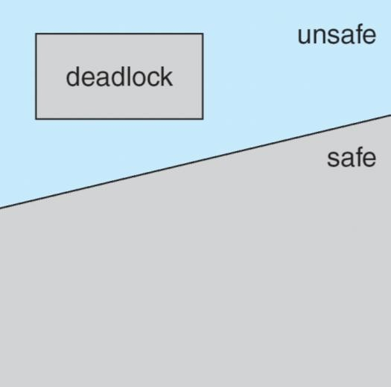
Avoidance algorithms
- Single instance of a resource type
- Use a resource-allocation graph
- Multiple instances of a resource type
- Use the banker’s algorithm

Resource-Allocation Graph Scheme
Claim edge Pi ® Rj indicated that process Pj may request resource Rj; represented by a dashed linen Claim edge converts to request edge when a process requests a resource Request edge converted to an assignment edge when the resource is allocated to the process
When a resource is released by a process, assignment edge reconverts to a claim edge Resources must be claimed a priori in the system

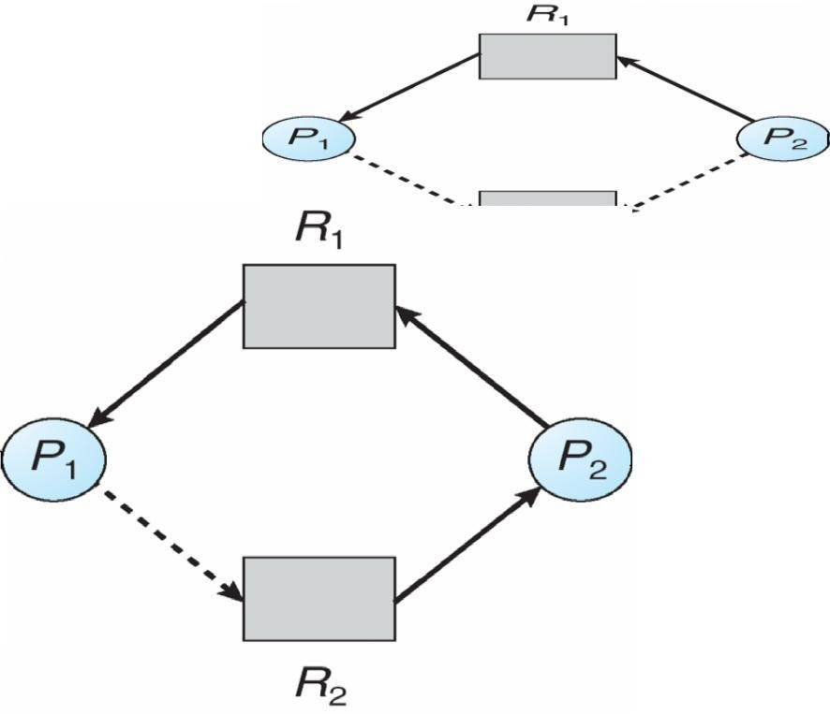
Resource-Allocation Graph

Unsafe State In Resource-Allocation Graph

Resource-Allocation Graph Algorithm
Suppose that process Pi requests a resource Rj
The request can be granted only if converting the request edge to an assignment edge does not result in the formation of a cycle in the resource allocation graph

Banker’s Algorithm
Multiple instances Each process must a priori claim maximum use When a process requests a resource it may have to wait When a process gets all its resources it must return them in a finite amount of time

Data Structures for the Banker’s Algorithm
Let n = number of processes, and m = number of resources types.
Available: Vector of length m. If available [j] = k, there are k instances of resource type Rj available
Max: n x m matrix. If Max [i,j] = k, then process Pi may request at most k instances of resource type Rj Allocation: n x m matrix. If Allocation[i,j] = k then Pi is currently allocated k instances of RjNeed: n x m matrix. If Need[i,j] = k, then Pi may need k more instances of Rj to complete its task

Need [i,j] = Max[i,j] – Allocation [i,j]

Safety Algorithm
- Let Work and Finish be vectors of length m and n, respectively. Initialize:
Work = Available
Finish [i] = false for i = 0, 1, …, n- 1
- Find and i such that both:
(a) Finish [i] = false(b) Needi £ Work
If no such i exists, go to step 4

- Work = Work + Allocationi Finish[i] = true
go to step 2

- If Finish [i] == true for all i, then the system is in a safe state

Resource-Request Algorithm for Process Pi
- Request = request vector for process Pi. If Requesti [j] = k then process Pi wants k instances of resource type Rj1. If Requesti £ Needi go to step 2. Otherwise, raise error condition, since process has exceeded its maximum claim
- If Requesti £ Available, go to step 3. Otherwise Pi must wait, since resources are not available
- Pretend to allocate requested resources to Pi by modifying the state as follows:
Available = Available – Request; Allocationi = Allocationi + Requesti; Needi = Needi – Requesti;
If safe Þ the resources are allocated to Pi
If unsafe Þ Pi must wait, and the old resource-allocation state is restored

Example of Banker’s Algorithm
n5 processes P0 through P4;

3 resource types:

A (10 instances), B (5instances), and C (7 instances) Snapshot at time T0:

Allocation | Max | Available | A B C A B C | A B
C
P0 | 0 1 0 | 7 5 3 | P1 2 0 0 | 3 2
2
P2 | 3 0 2 | 9 0 2
P3 | 2 1 1 | 2 2 2
P4 | 0 0 2 | 4 3 3
The content of the matrix Need is defined to be Max – Allocation
Need | A B C
 | P0 7 4 3
 | P1 1 2 2
 | P2 6 0 0
P3 0 1 1
P4 4 3 1
The system is in a safe state since the sequence < P1, P3, P4, P2, P0> satisfies safety criteria

Example: P1 Request (1,0,2)
Check that Request £ Available (that is, (1,0,2) £ (3,3,2) Þ true

 | Allocation | Need | Available
 | ABC | ABC | ABC
P0 | 010 | 743 | 230
P1 | 302 | 020
P2 | 301 | 600
P3 | 211 | 011
P4 | 002 | 431

Executing safety algorithm shows that sequence < P1, P3, P4, P0, P2> satisfies safety requirement Can request for (3,3,0) by P4 be granted?
Can request for (0,2,0) by P0 be granted?

Deadlock Detection
Allow system to enter deadlock state Detection algorithm Recovery scheme

Single Instance of Each Resource Type
Maintain wait-for graph Nodes are processes
Pi ® Pj if Pi is waiting for Pj Periodically invoke an algorithm that searches for a cycle in the graph. If there is a cycle, there exists a deadlock
An algorithm to detect a cycle in a graph requires an order of n2 operations, where n is the number of vertices in the graph

Resource-Allocation Graph and Wait-for Graph

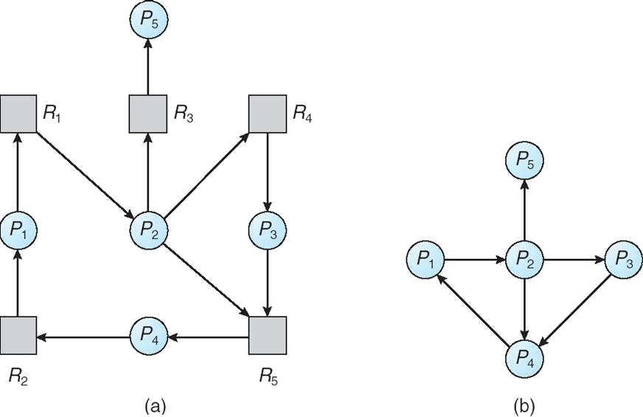

Resource-Allocation Graph Corresponding wait-for graph

Several Instances of a Resource Type
Available: A vector of length m indicates the number of available resources of each type. Allocation: An n x m matrix defines the number of resources of each type currently allocated to each process. Request: An n x m matrix indicates the current request of each process. If Request [ij] = k, then process Pi is requesting k more instances of resource type. Rj.

Detection Algorithm

1. Let Work and Finish be vectors of length m and n, respectively Initialize:
(a) Work = Available(b) For i = 1,2, …, n, if Allocationi ¹ 0, then
Finish[i] = false; otherwise, Finish[i] = true2. Find an index i such that both:
(a) Finish[i] == false(b) Requesti £ Work If no such i exists, go to step 4
3. Work = Work + Allocationi Finish[i] = true
go to step 24. If Finish[i] == false, for some i, 1 £ i £ n, then the system is in deadlock state. Moreover, if
Finish[i] == false, then Pi is deadlocked

Algorithm requires an order of O(m x n2) operations to detect whether the system is in deadlocked state Example of Detection Algorithm
nFive processes P0 through P4; three resource types A (7 instances), B (2 instances), and C (6 instances) nSnapshot at time T0:

 | Allocation | Need | Available
 | ABC | ABC | ABC
P0 | 010 | 000 | 000
P1 | 200 | 202
P2 | 303 | 000
P3 | 211 | 100
P4 | 002 | 002

Sequence <P0, P2, P3, P1, P4> will result in Finish[i] = true for all i

P2 requests an additional instance of type C
Request A B C P0 0 0 0
P1 2 0 1
P2 0 0 1
P3 1 0 0
P4 0 0 2

State of system?
Can reclaim resources held by process P0, but insufficient resources to fulfill other processes; requests Deadlock exists, consisting of processes P1, P2, P3, and P4

Detection-Algorithm Usage
When, and how often, to invoke depends on:
How often a deadlock is likely to occur?
How many processes will need to be rolled back?
one for each disjoint cycle If detection algorithm is invoked arbitrarily, there may be many cycles in the resource graph and so we would not be able to tell which of the many deadlocked processes ―caused‖ the deadlock.

Recovery from Deadlock: Process Termination
Abort all deadlocked processes Abort one process at a time until the deadlock cycle is eliminated. In which order should we choose to abort?
Priority of the process
How long process has computed, and how much longer to completion Resources the process has used
Resources process needs to complete How many processes will need to be terminated Is process interactive or batch?

Recovery from Deadlock: Resource Preemption
Selecting a victim – minimize cost Rollback – return to some safe state, restart process for that state Starvation – same process may always be picked as victim, include number of rollback in cost factor

I/O Systems
Explore the structure of an operating system’s I/O subsystem Discuss the principles of I/O hardware and its complexity
Provide details of the performance aspects of I/O hardware and software

I/O Hardware
Incredible variety of I/O devices Common concepts
Port
Bus (daisy chain or shared direct access) Controller (host adapter)
I/O instructions control devices Devices have addresses, used by

Direct I/O instructions Memory-mapped I/O

A Typical PC Bus Structure
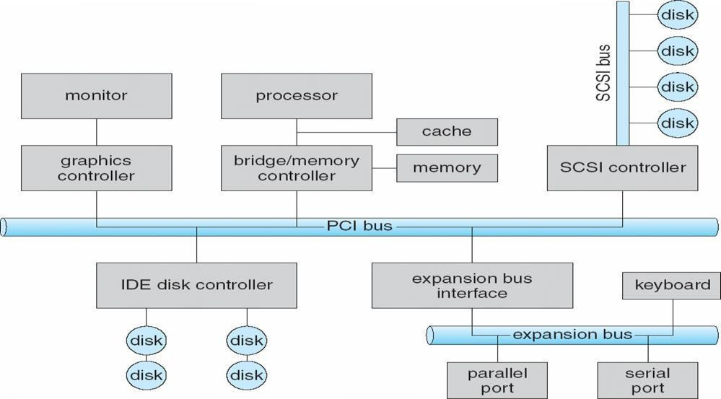

Device I/O Port Locations on PCs (partial)

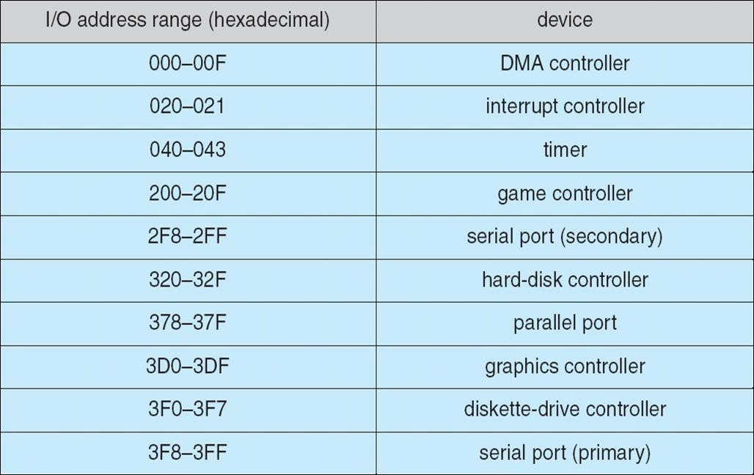

Polling
Determines state of device command-ready busy
Error Busy-wait cycle to wait for I/O from device

Interrupts
CPU Interrupt-request line triggered by I/O device Interrupt handler receives interrupts Markable to ignore or delay some interrupts Interrupt vector to dispatch interrupt to correct handler Based on priority Some nonmarkable Interrupt mechanism also used for exceptions

Interrupt-Driven I/O Cycle
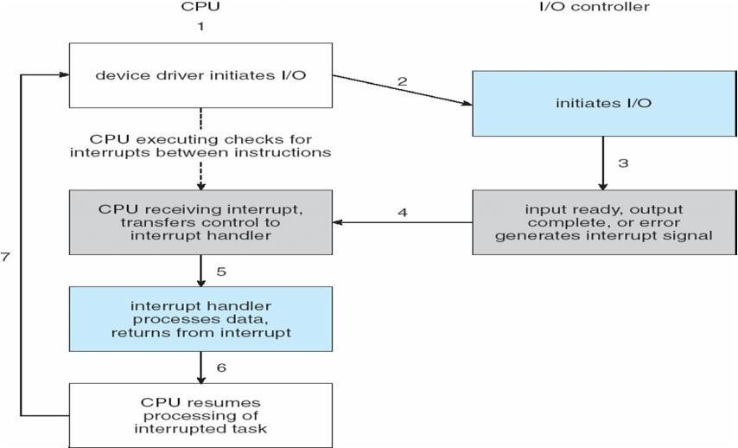

Intel Pentium Processor Event-Vector Table
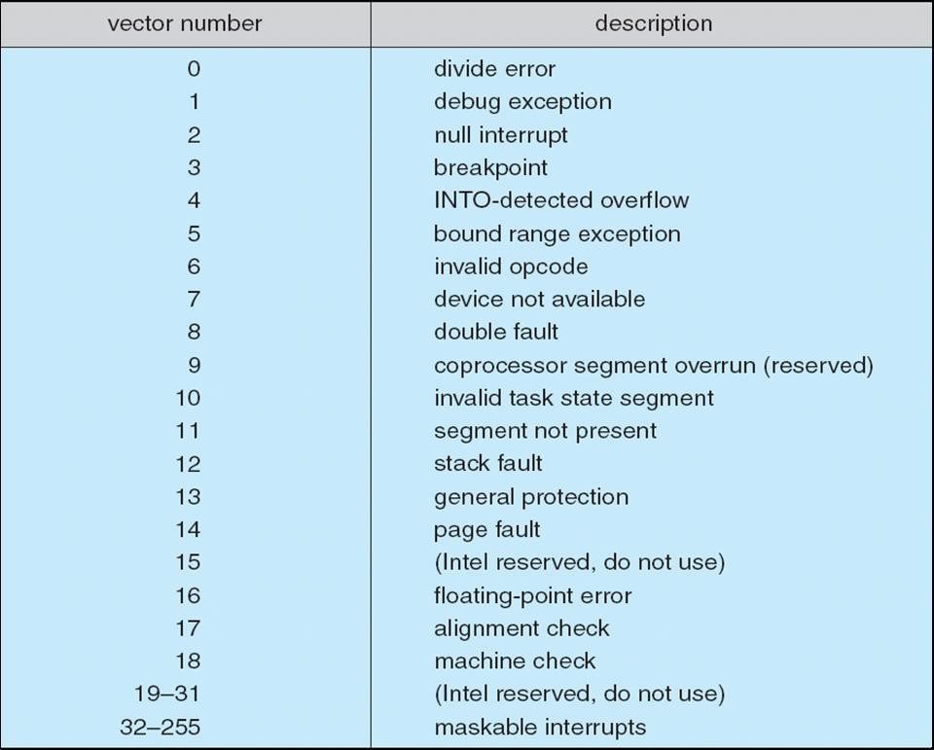

Direct Memory Access
Used to avoid programmed I/O for large data movement Requires DMA controller Bypasses CPU to transfer data directly between I/O device and memory.

Six Step Process to Perform DMA Transfer

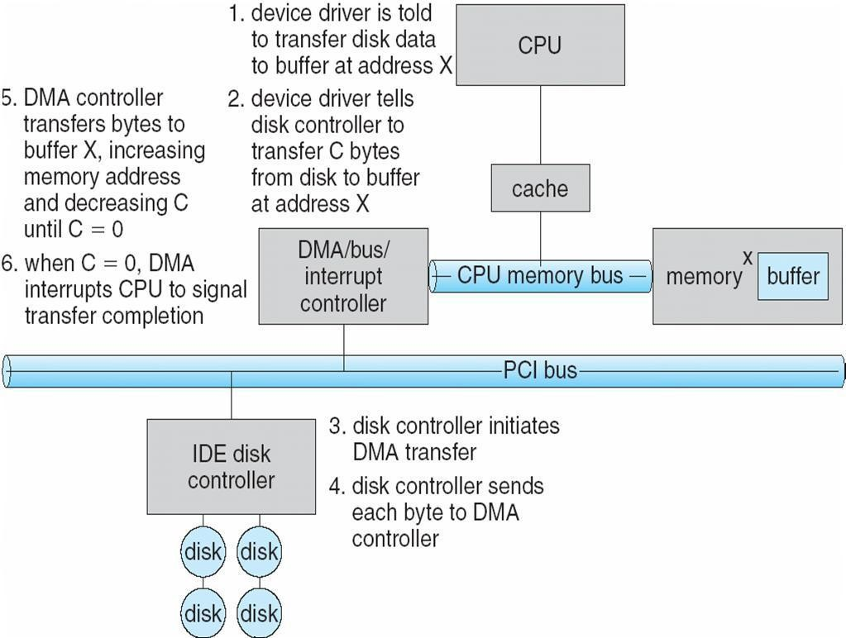

Application I/O Interface

I/O system calls encapsulate device behaviors in generic classes Device-driver layer hides differences among I/O controllers from kernel Devices vary in many dimensions
Character-stream or block Sequential or random-access Sharable or dedicated Speed of operation
read-write, read only, or write only

A Kernel I/O Structure
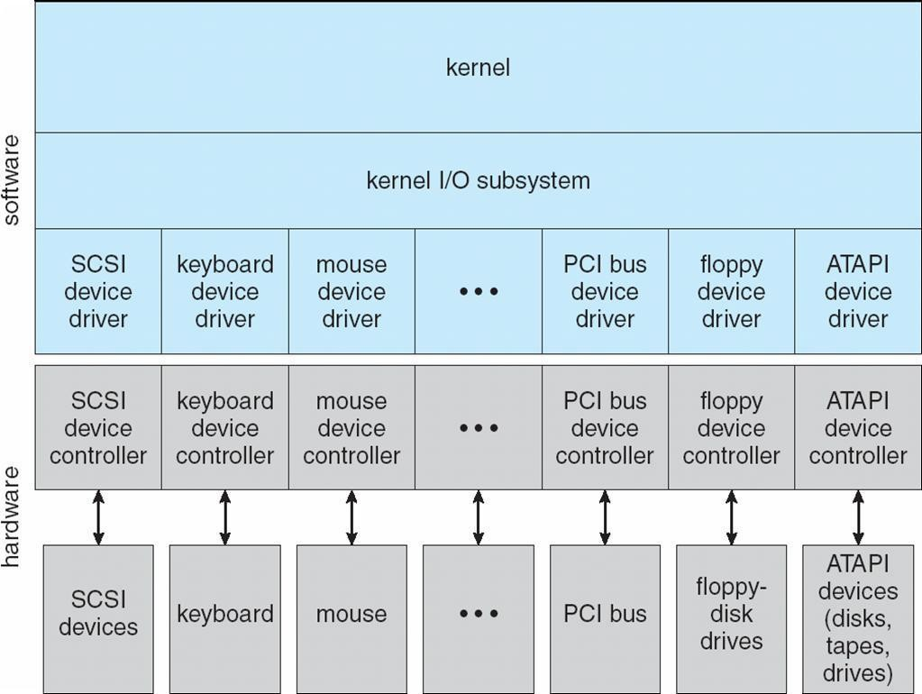

Characteristics of I/O Devices
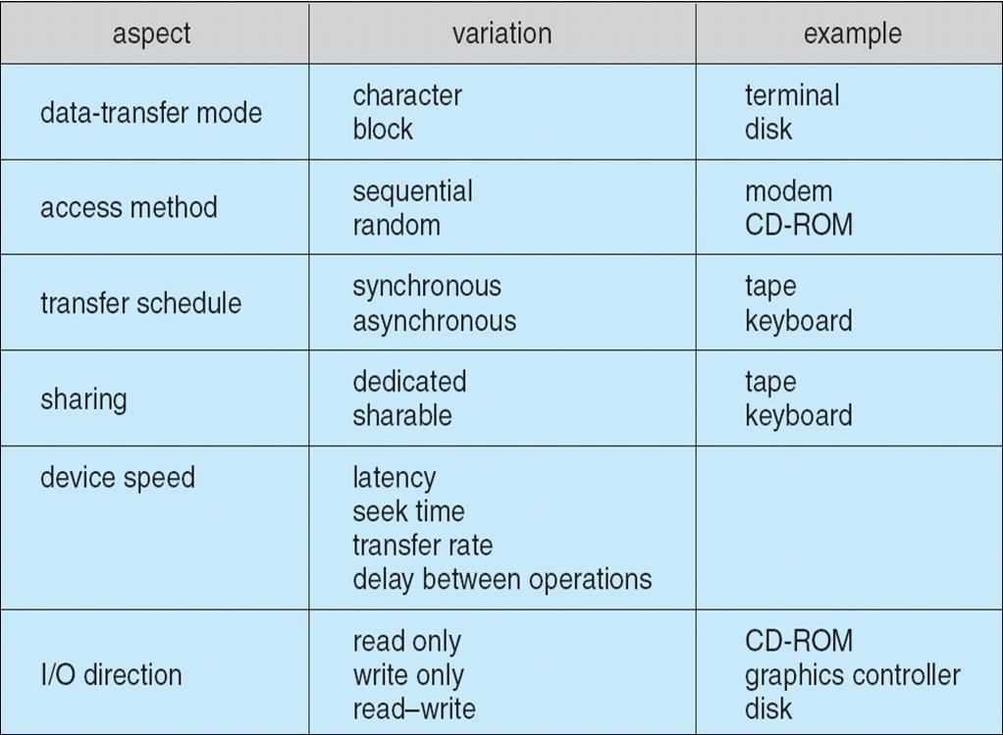

Block and Character Devices Block devices include disk drives Commands include read, write, seek Raw I/O or file-system access
Memory-mapped file access possible Character devices include keyboards, mice, serial ports Commands include get(), put()Libraries layered on top allow line editing

Network Devices
Varying enough from block and character to have own interface Unix and Windows NT/9x/2000 include socket interface
Separates network protocol from network operation
Includes select() functionality Approaches vary widely (pipes, FIFOs, streams, queues, mailboxes)

Clocks and Timers
Provide current time, elapsed time, timer Programmable interval timer used for timings, periodic interruptsnioctl() (on UNIX) covers odd aspects of I/O such as clocks and timers

Blocking and Non blocking I/O

Blocking - process suspended until I/O completed Easy to use and understand
Insufficient for some needs Nonblocking - I/O call returns as much as available User interface, data copy (buffered I/O)
Implemented via multi-threading
Returns quickly with count of bytes read or written Asynchronous - process runs while I/O executes Difficult to use
I/O subsystem signals process when I/O completed

Two I/O Methods
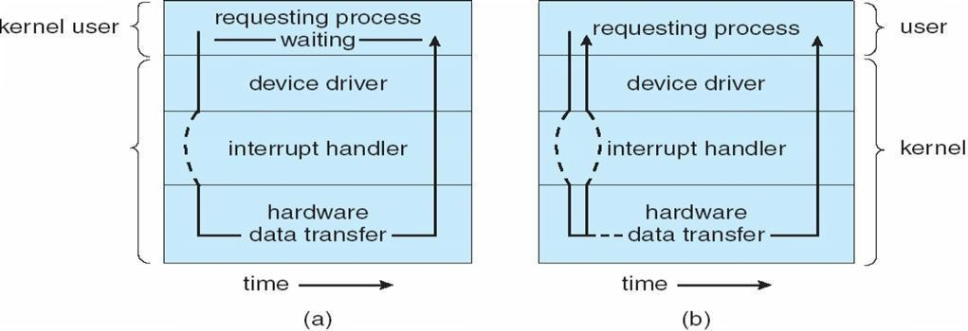

Synchronous Asynchronous

Kernel I/O Subsystem
Scheduling
Some I/O request ordering via per-device queue
Some OSs try fairness Buffering - store data in memory while transferring between devices To cope with device speed mismatch

To cope with device transfer size mismatch To maintain ―copy semantics‖
Device-status Table
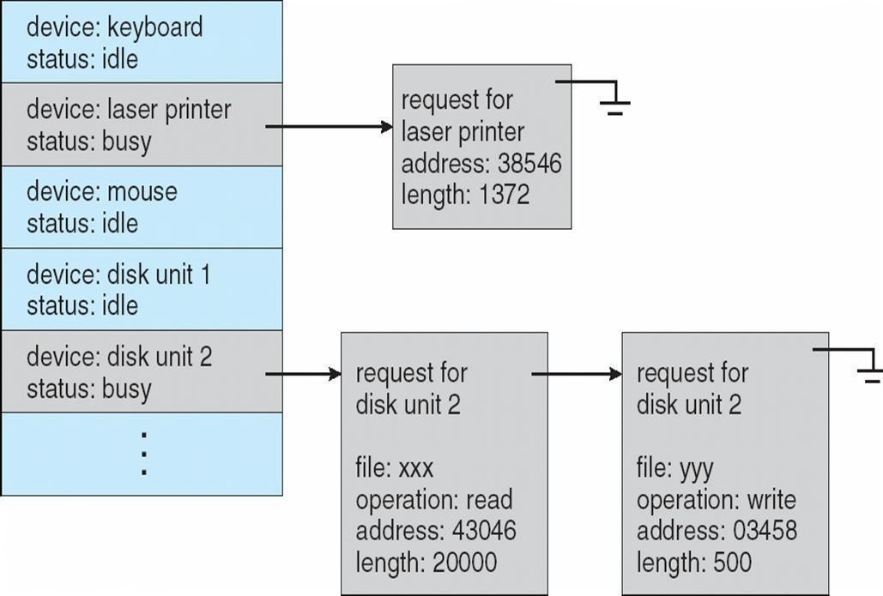

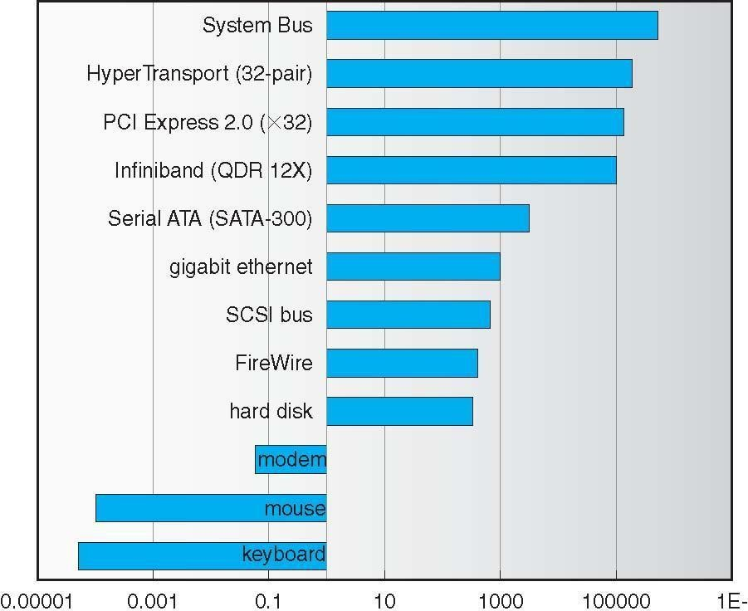
Sun Enterprise 6000 Device-Transfer Rates

Kernel I/O Subsystem
Caching - fast memory holding copy of data Always just a copy
Key to performance Spooling - hold output for a device If device can serve only one request at a time
i.e., Printing Device reservation - provides exclusive access to a device System calls for allocation and deallocation
Watch out for deadlock

Error Handling
OS can recover from disk read, device unavailable, transient write failures Most return an error number or code when I/O request fails System error logs hold problem reports

I/O Protection
User process may accidentally or purposefully attempt to disrupt normal operation via illegal I/O instructions All I/O instructions defined to be privileged
I/O must be performed via system calls
Memory-mapped and I/O port memory locations must be protected too

Use of a System Call to Perform I/O
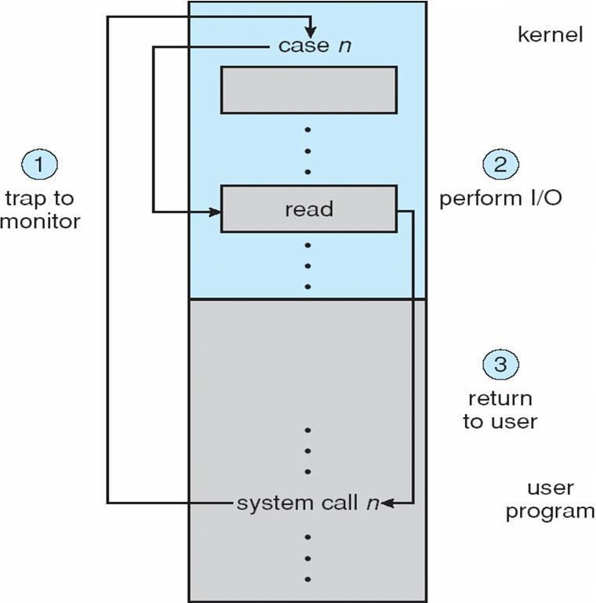

Kernel Data Structures
Kernel keeps state info for I/O components, including open file tables, network connections, character device state Many, many complex data structures to track buffers, memory allocation, ―dirty‖ blocks Some use object-oriented methods and message passing to implement I/O

UNIX I/O Kernel Structure
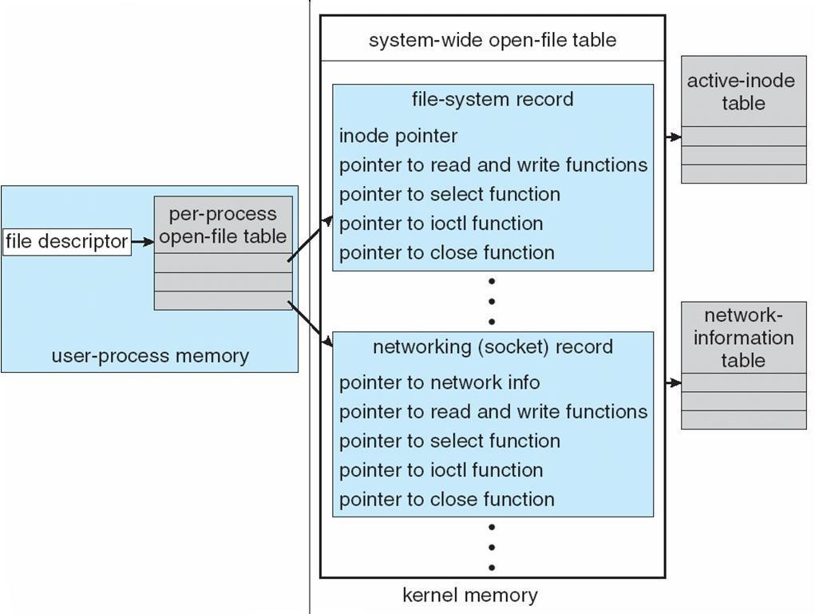

I/O Requests to Hardware Operations
Consider reading a file from disk for a process:

Determine device holding file Translate name to device representation
Physically read data from disk into buffer Make data available to requesting process Return control to process

Life Cycle of An I/O Request
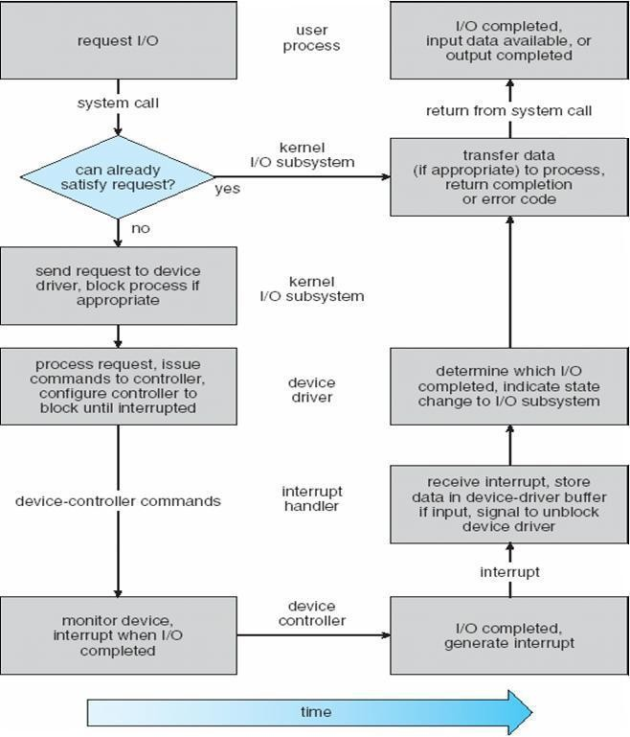

STREAMS

STREAM – a full-duplex communication channel between a user-level process and a device in Unix System V and beyond
A STREAM consists of:
- STREAM head interfaces with the user process
- driver end interfaces with the device
- zero or more STREAM modules between them. Each module contains a read queue and a write queue
Message passing is used to communicate between queues

The STREAMS Structure
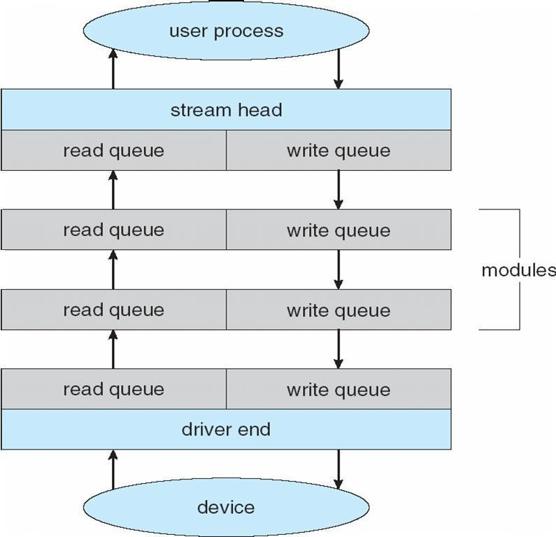

Performance

I/O a major factor in system performance: Demands CPU to execute device driver, kernel I/O code Context switches due to interrupts
Data copying
Network traffic especially stressful

Intercomputer Communications
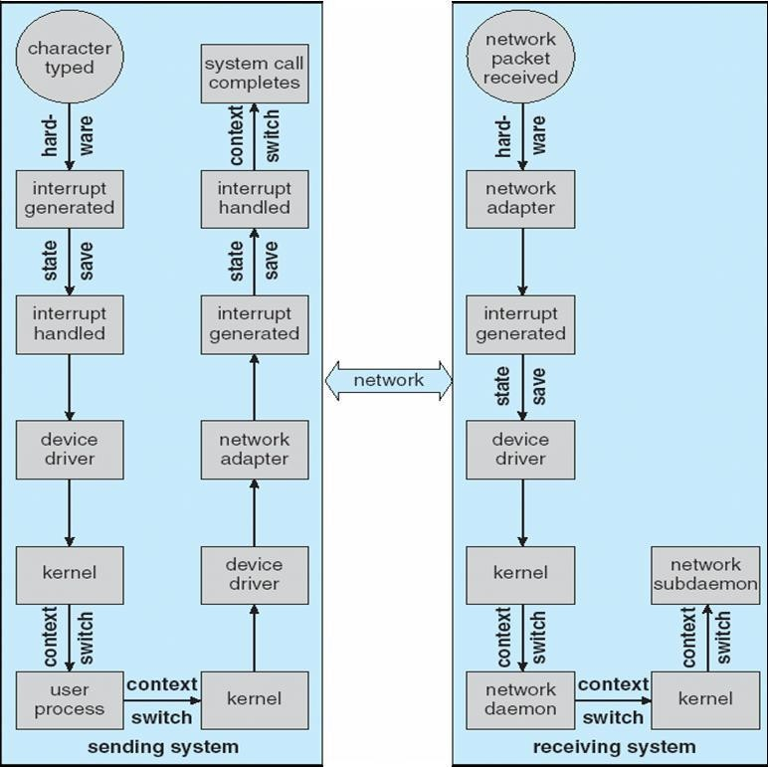

Improving Performance

Reduce number of context switches Reduce data copying
Reduce interrupts by using large transfers, smart controllers, polling Use DMA
Balance CPU, memory, bus, and I/O performance for highest throughput

Device-Functionality Progression

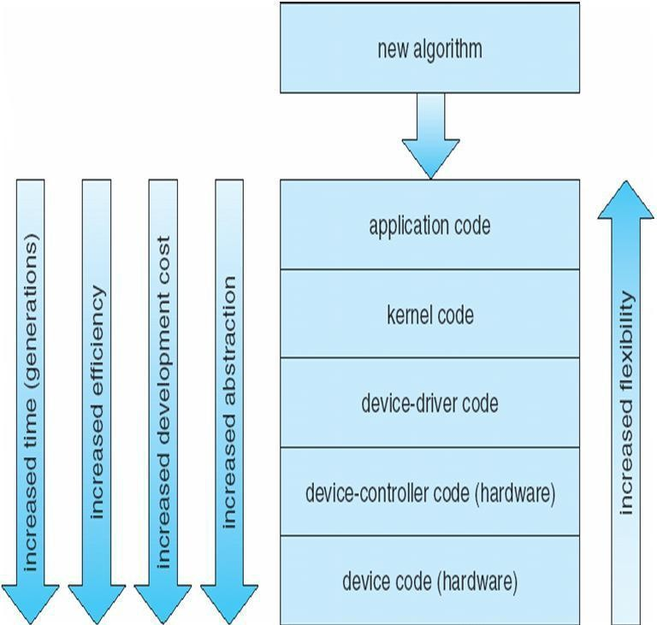

P R O T E C T I O N

Goals of Protection
Operating system consists of a collection of objects, hardware or software. Each object has a unique name and can be accessed through a well-defined set of operations Protection problem - ensure that each object is accessed correctly and only by those processes that are allowed to do son

Principles of Protection
Guiding principle – principle of least privilege
Programs, users and systems should be given just enough privileges to perform their tasks

Domain Structure
Access-right = <object-name, rights-set>
where rights-set is a subset of all valid operations that can be performed on the object. Domain = set of access-rights
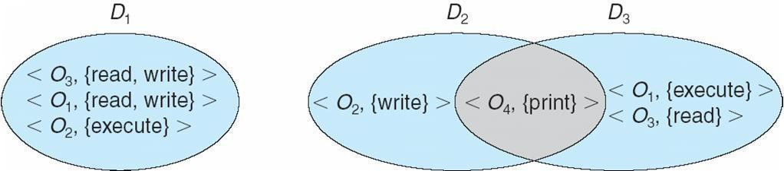

System consists of 2 domains:
- User
- Supervisor UNIX Domain = user-id
Domain switch accomplished via file system
Each file has associated with it a domain bit (setuid bit)
When file is executed and setuid = on, then user-id is set to owner of the file being executed. When execution completes user-id is reset
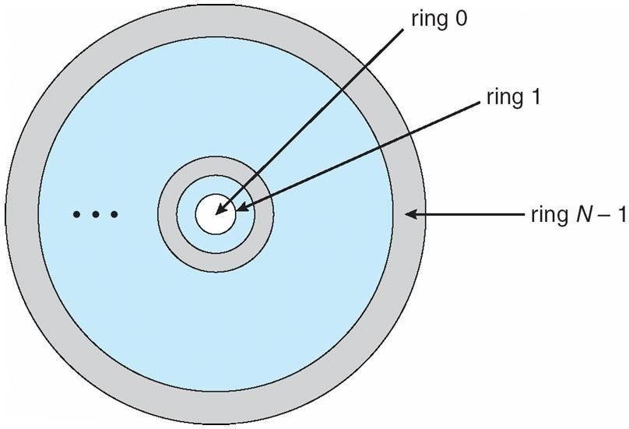
Domain Implementation (MULTICS) Let Di and Dj be any two domain rings If j < I Þ Di Í Dj

Access Matrix
View protection as a matrix (access matrix) Rows represent domains
Columns represent objects

Access(i, j) is the set of operations that a process executing in Domaini can invoke on Objectj
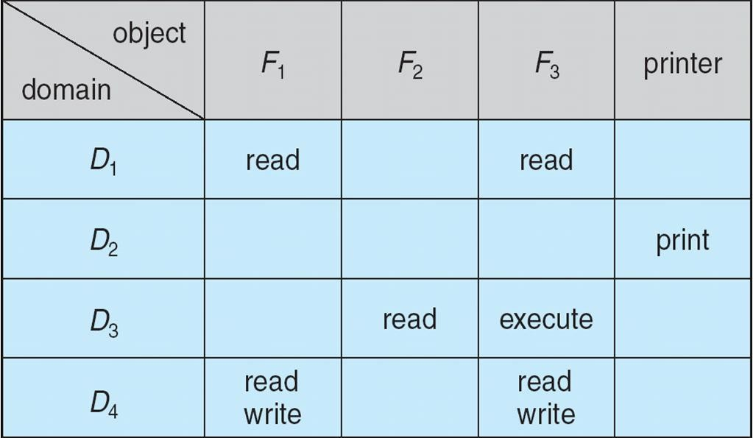

Use of Access Matrix

If a process in Domain Di tries to do ―op‖ on object Oj, then ―op‖ must be in the access matrix Can be expanded to dynamic protection
Operations to add, delete access rights Special access rights:
- Owner of Oi
- Copy op from Oi to Oj
- Control – Di can modify Dj access rights
- Transfer – switch from domain Di to Dj

Access matrix design separates mechanism from policy

Mechanism
Operating system provides access-matrix + rules
If ensures that the matrix is only manipulated by authorized agents and that rules are strictly enforced

Policy
User dictates policy
Who can access what object and in what mode

Implementation of Access Matrix
Each column = Access-control list for one object Defines who can perform what operation.

Domain 1 = Read, Write Domain 2 = Read Domain 3 = Read

M Each Row = Capability List (like a key)
Fore each domain, what operations allowed on what objects. Object 1 – Read
Object 4 – Read, Write, Execute

Object 5 – Read, Write, Delete, Copy

Access Matrix of Figure A With Domains as Objects
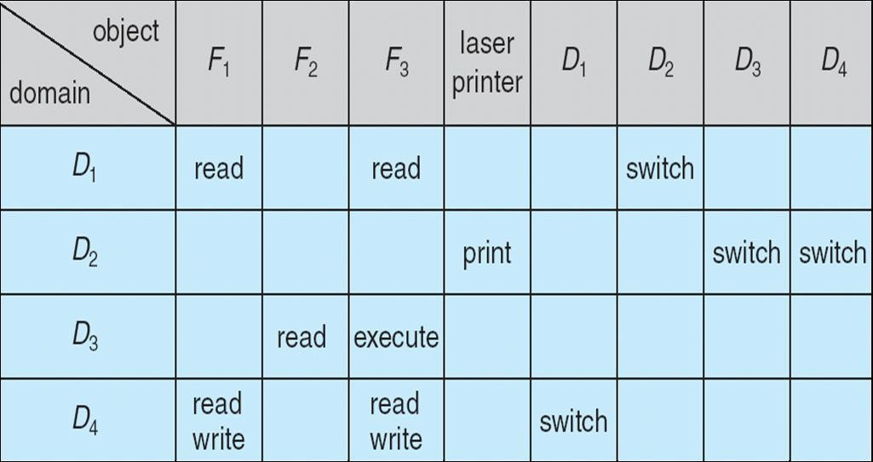

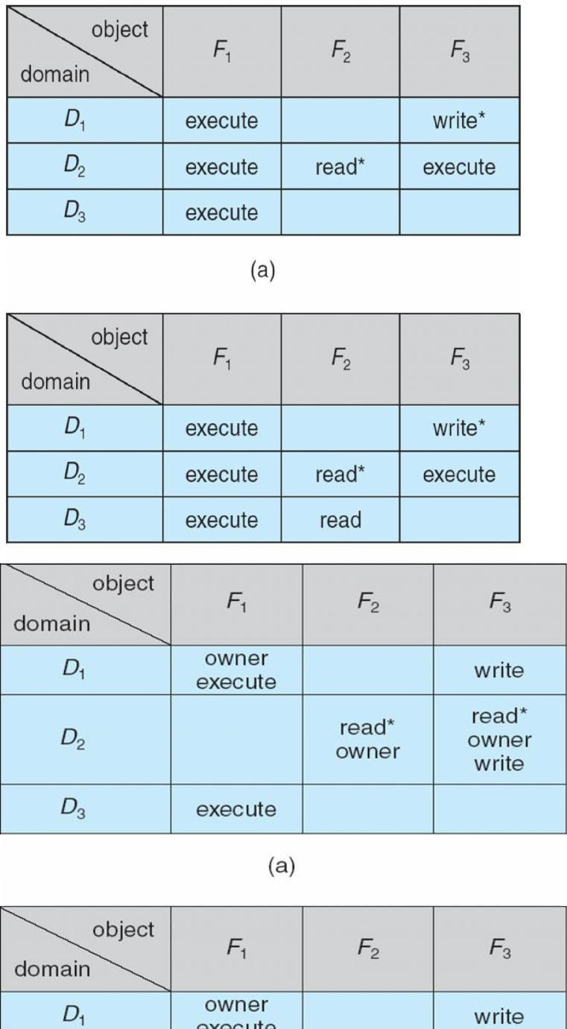
Access Matrix with Copy Rights

Access Matrix With Owner Rights

Modified Access Matrix of Figure B

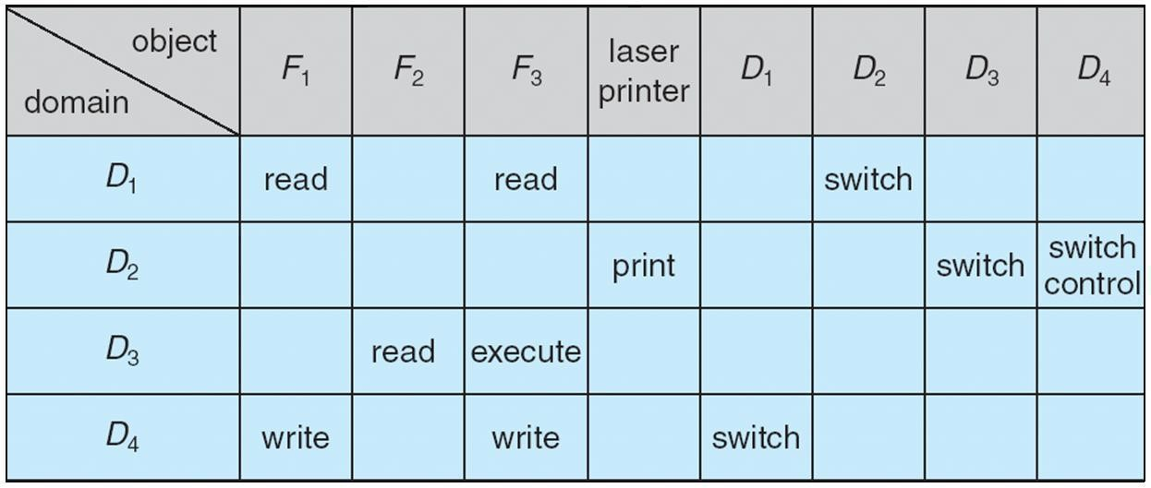

Access Control
Protection can be applied to non-file resources
Solaris 10 provides role-based access control (RBAC) to implement least privilege Privilege is right to execute system call or use an option within a system call
Can be assigned to processes
Users assigned roles granting access to privileges and programs

Role-based Access Control in Solaris 10
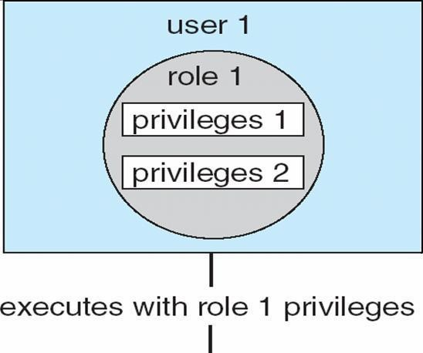

Revocation of Access Rights Access List – Delete access rights from access list Simple
Immediate Capability List – Scheme required to locate capability in the system before capability can be revoked Reacquisition

Capability-Based Systems
Hydra
Fixed set of access rights known to and interpreted by the system
Interpretation of user-defined rights performed solely by user's program; system provides access protection for use of these rights Cambridge CAP System
Data capability - provides standard read, write, execute of individual storage segments associated with object Software capability -interpretation left to the subsystem, through its protected procedures

Language-Based Protection
Specification of protection in a programming language allows the high-level description of policies for the allocation and use of resources Language implementation can provide software for protection enforcement when automatic hardware-supported checking is unavailable Interpret protection specifications to generate calls on whatever protection system is provided by the hardware and the operating system

Protection in Java 2
nProtection is handled by the Java Virtual Machine (JVM)nA class is assigned a protection domain when it is loaded by the JVMnThe protection domain indicates what operations the class can (and cannot) performnIf a library method is invoked that performs a privileged operation, the stack is inspected to ensure the operation can be performed by the library

Stack Inspection

